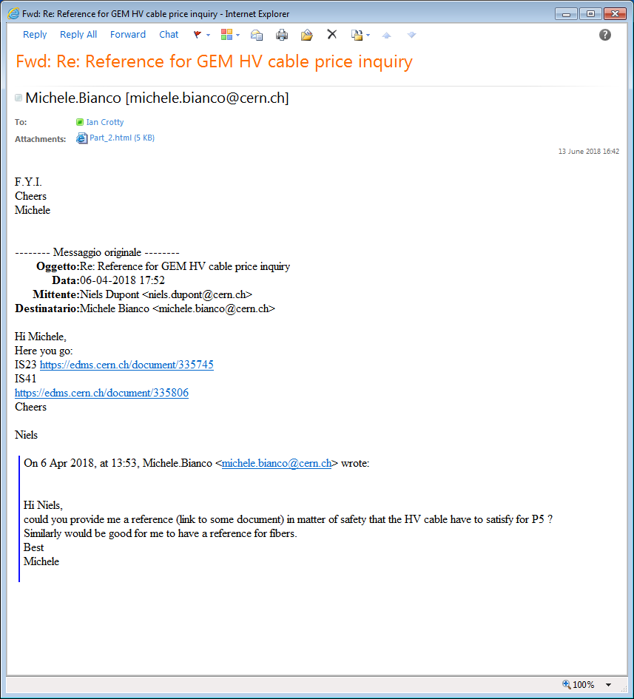

IS41

<https://edms.cern.ch/ui/#!master/navigator/document?D:1070560327:1070560327:subDocs>

IS23

<https://edms.cern.ch/ui/#!master/navigator/document?D:1206811045:1206811045:subDocs>