Patch Panel for RE3/1 and RE4/1

Ian Crotty

3 May 20017

First approach

**2 x Cooling Bulkhead Unions 8mm od**

https://edh.cern.ch/edhcat/Browser?command=showPage&argument=13302&top=13302&objid=%24%24EDH73pgioepi&showAdvanced=&scem=&keywords=

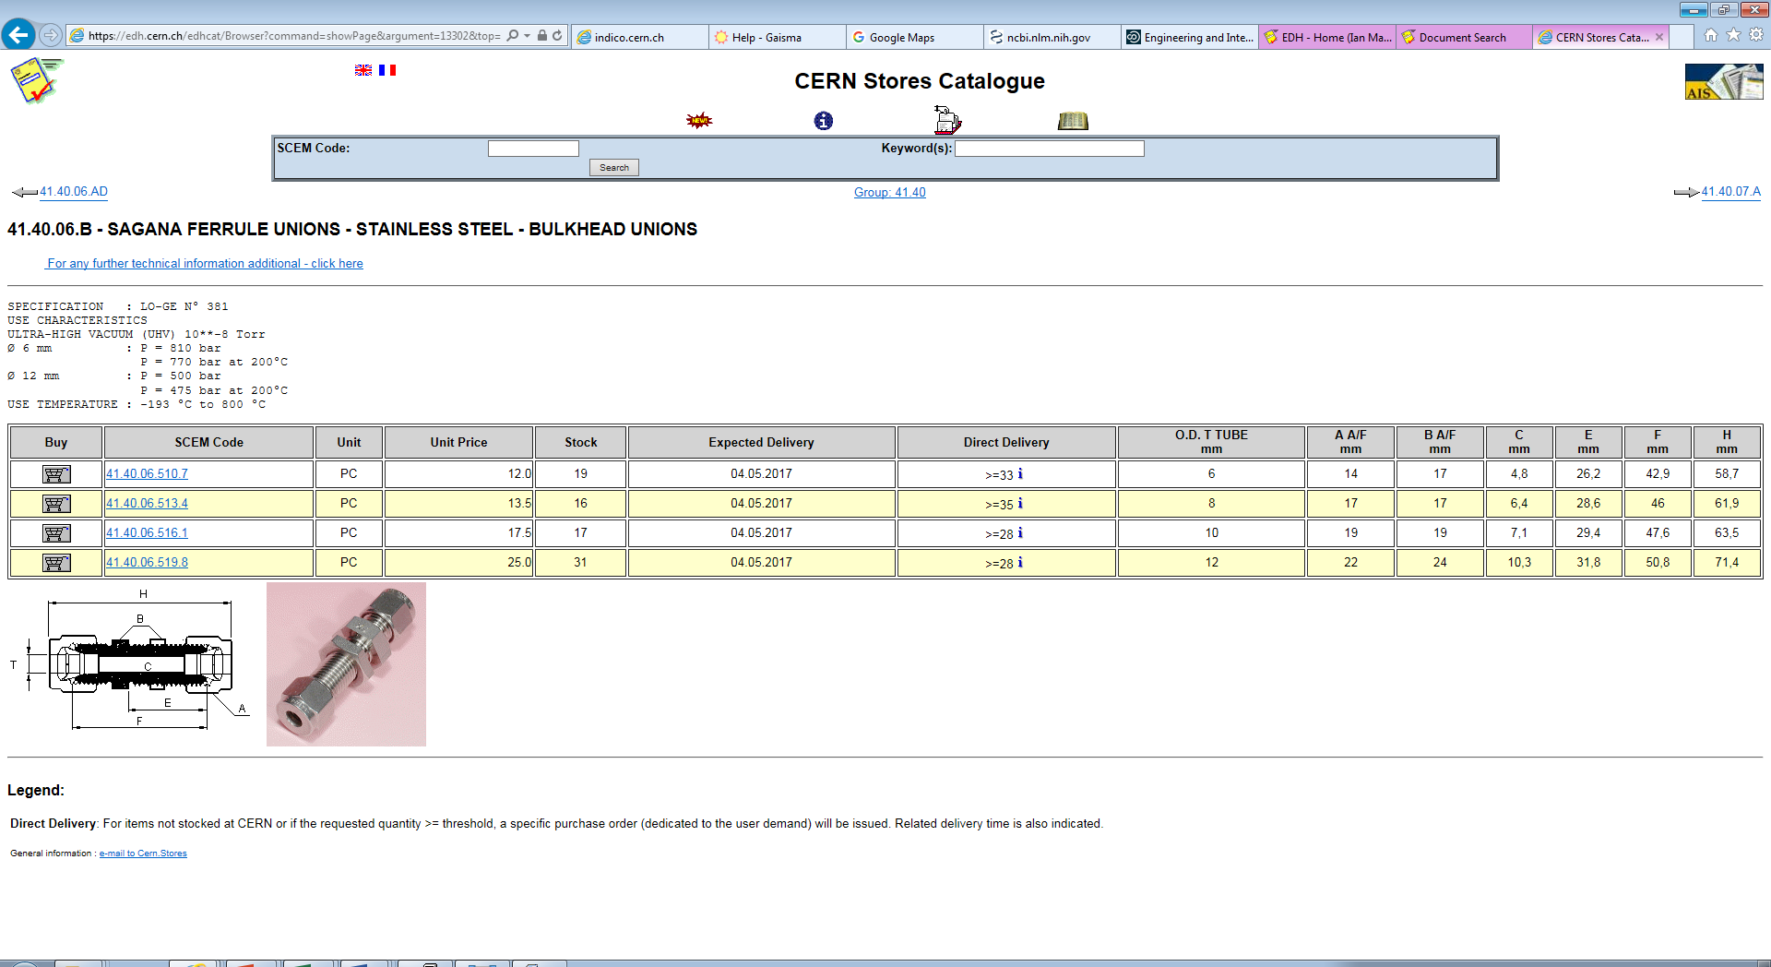



**Gas Unions**

X4 bulkhead unions 6mm od

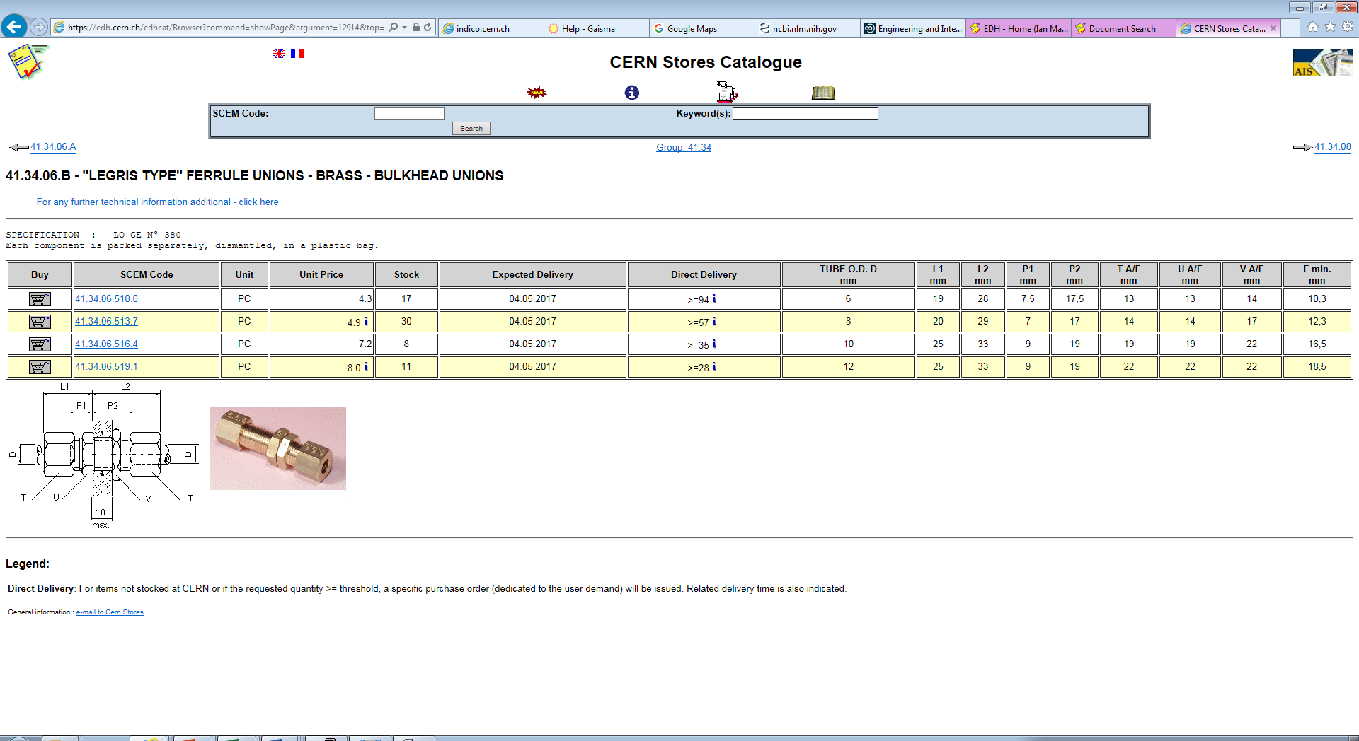



**X2 HV Chassis connectors**

Jupiter from CPE

https://rpc-cms-re4-upscope.web.cern.ch/rpc-cms-re4-upscope/RPC/Services/HV/CPE/HighVoltageConnector.pdf

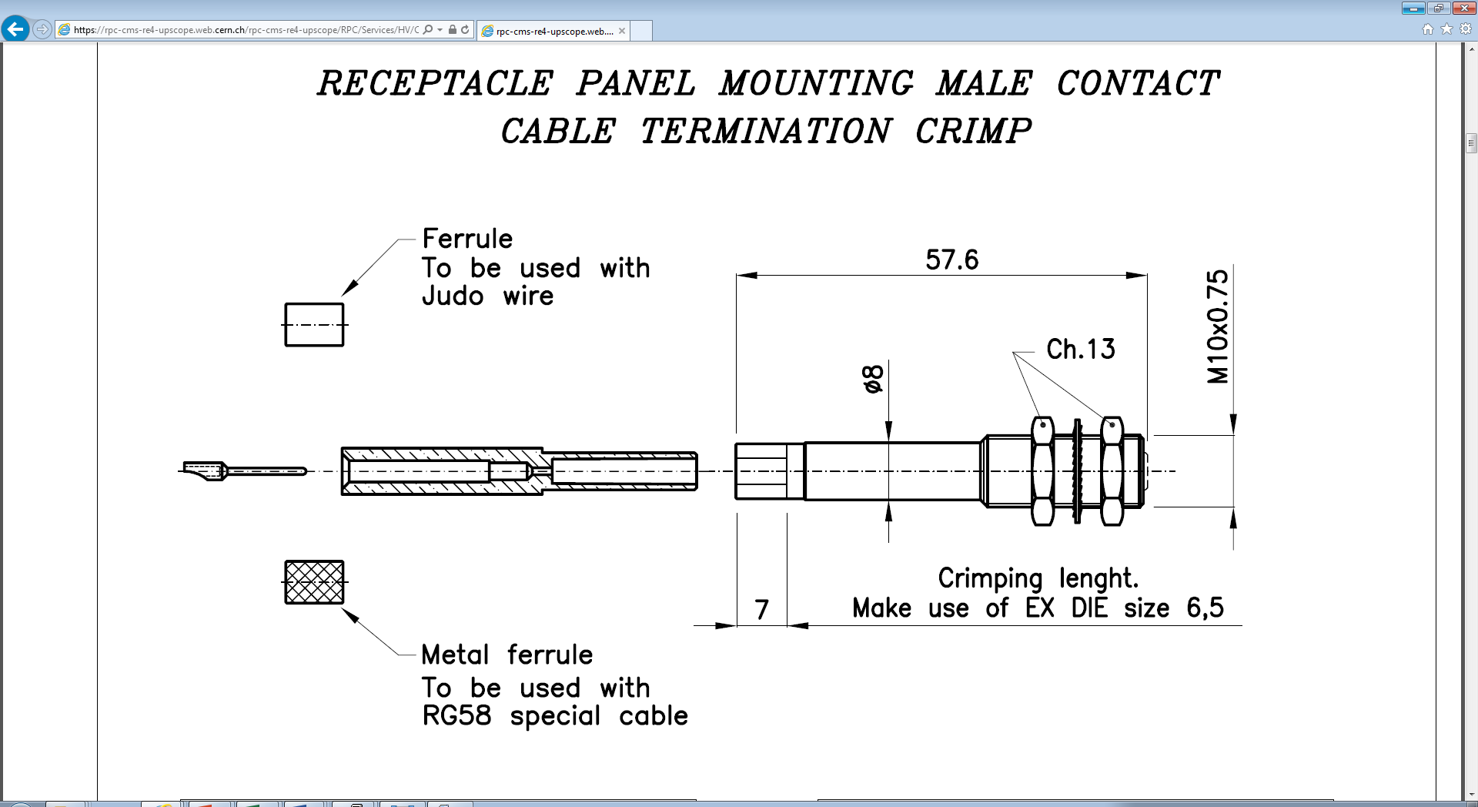

Fibre optics

LV connectors