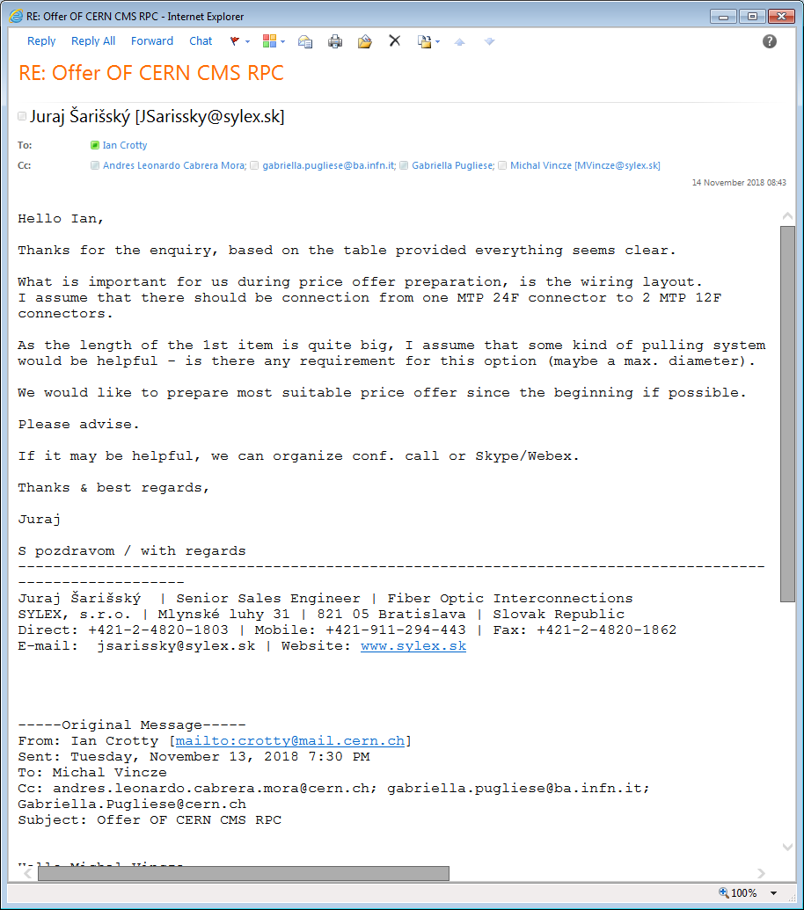

Tel call 15 Nov from fixed line;

0042 1248 20 1803 from Juraj (?)

Original contact was same as CSC offer Michal Vincze

Date: Tue, 13 Nov 2018 19:30:14 +0100

From: Ian Crotty <crotty@mail.cern.ch>

To: mvincze@sylex.sk

Cc: andres.leonardo.cabrera.mora@cern.ch, gabriella.pugliese@ba.infn.it,

Gabriella.Pugliese@cern.ch

Subject: Offer OF CERN CMS RPC

Hello Michal Vincze

You made an offer to our CSC colleagues in August this year.

We are in need of some trunk cables with MTP connectors as indicted below.

http://project-cms-rpc-endcap.web.cern.ch/project-cms-rpc-endcap/rpc/Upscope

HighEta/RPCDevelopements/RE31and41/Services/OpticalFibres/Andres/TrunkCables

/Offers/Request/Andres8Nov2018/SummaryTable8Nov2018.pptx

The lengths are APPROXIMATE today.

We request an offer from you and a delivery delay, by the end of the week

Etc……….