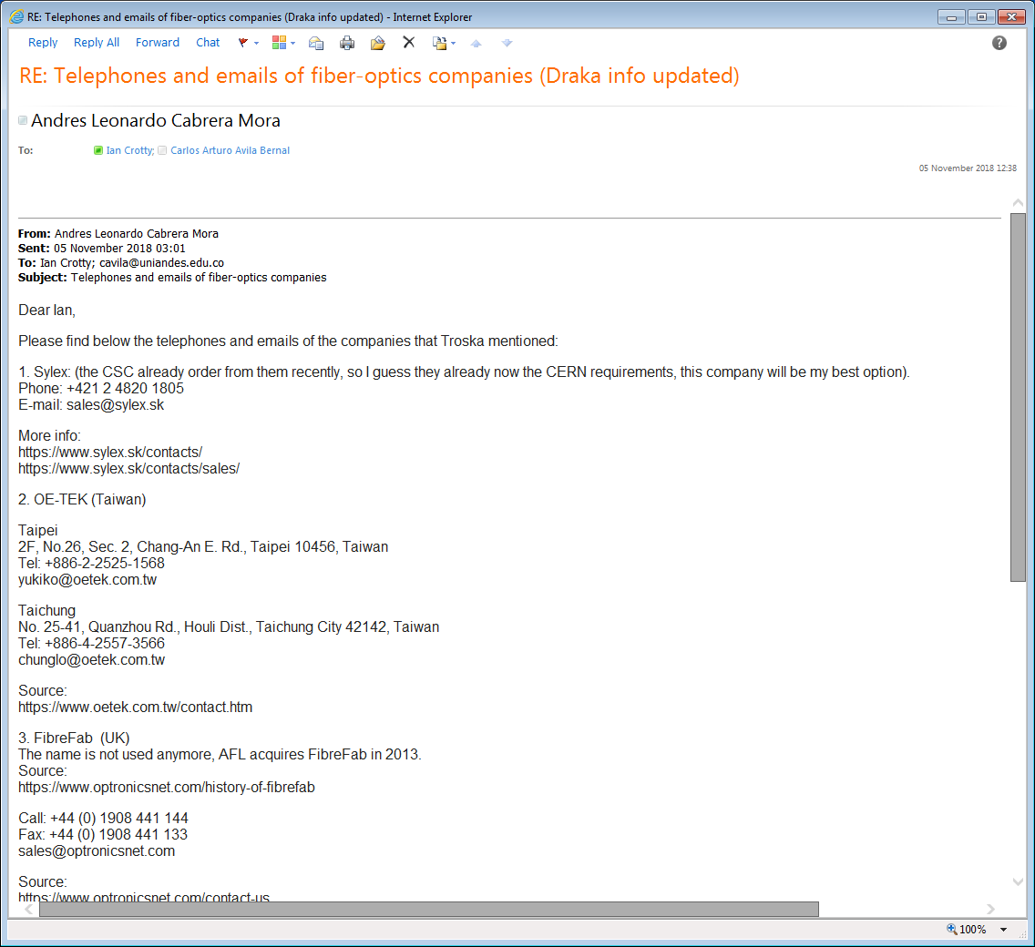

Source:

https://osi.rosenberger.com/contact/contact-us/

5. Draka at CERN..

**Email:** [Daniel.Ricci@cern.ch](https://mmm.cern.ch/owa/redir.aspx?C=8_Haow3uQCld4IqewSEpliO5LczqFh9TqTIKkDbvb_w4FKng0ETWCA..&URL=mailto%3aDaniel.Ricci%40cern.ch)

**Office:** [54/1-033](https://mmm.cern.ch/owa/redir.aspx?C=S44uKh2bUnSjdMGx9S2wcNNZvGxlLza8w993sXI-bH04FKng0ETWCA..&URL=https%3a%2f%2fmaps.cern.ch%2fmapsearch%2fmapsearch.htm%3fn%3d%5b%252754%2f1-033%2527%5d)

**Postbox:** A20000

Best regards, Andres.