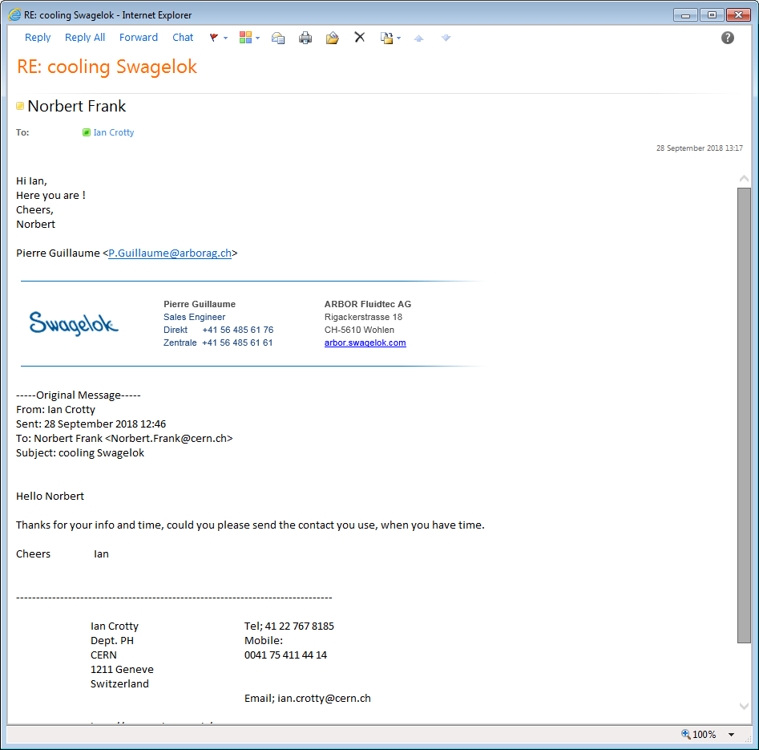

P.Guillaume@arborag.ch

And perhaps But rejected by Microsoft

pg@arborgag.ch

Pierre Guillaume, fix; 0041 56 485 61 61.

Mobil; 079 678 8329

Direct 0041 56 485 6176

Contact from Alexander Bulgaria

Aleksandar Aleksandrov‎

Christian Brünisholz [c.bruenisholz@arborag.ch](mailto:c.bruenisholz@arborag.ch) and cb@arborag.ch

Direct +41 56 485 61 94

Also mentioned

Kira Häcki

Senthuri Balendran

This name was on a quote for cooling