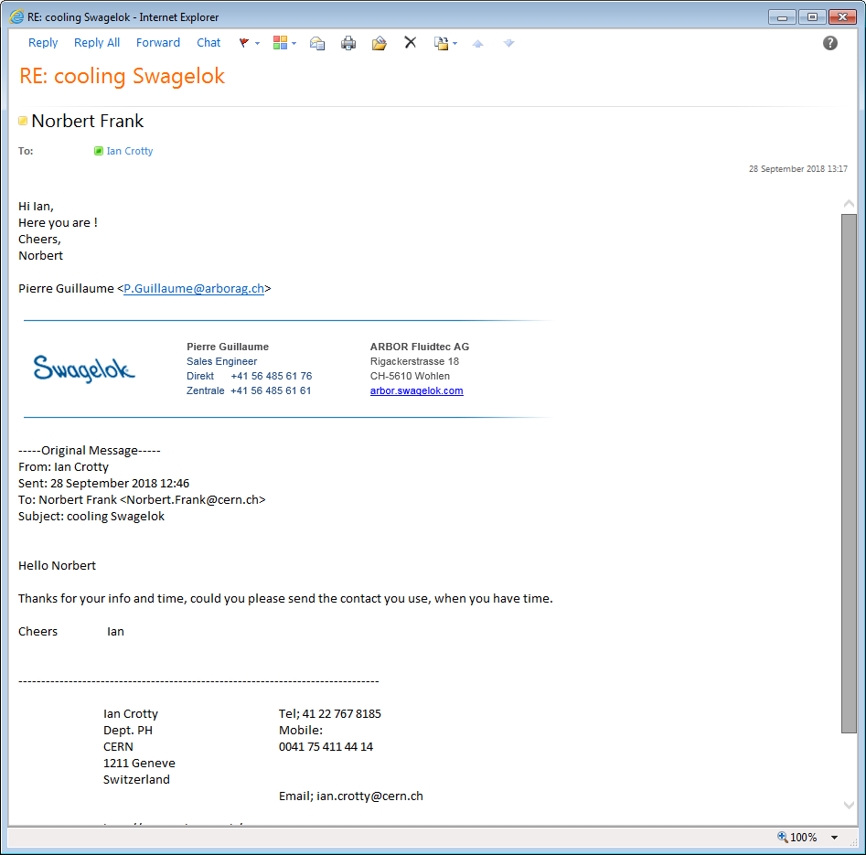

[P.Guillaume@arborag.ch](mailto:P.Guillaume@arborag.ch)

And perhaps But rejected by Microsoft

pg@arborgag.ch

Pierre Guillaume, fix; 0041 56 485 61 61. Mobil; 079 678 8329

Direct 0041 56 485 6176