**X section schematic for RE4/1**

Proposal for two scenarios for the chamber layout as a function of the chamber body thickness and coverage of “High Eta” versions.

The Integration x-section view of CMS

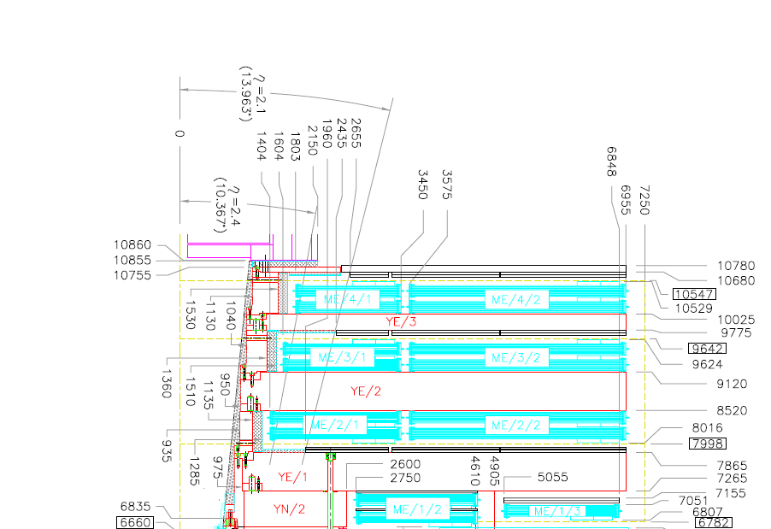

The tricky high radius mounting under the presently installed RE4/2 & RE4/3 Super Module (SM).

RE4 SM



RE4/1 short eta shown

CSC Mounting Posts

Photo of the RE4 SM mounting blocks (every 10deg) attached to the back of the SM “A” frame. These mounting blocs are visible and it should be possible to attach to them using 2 of the 4 M8 screws that secure the block to the rear of the “A” frame.

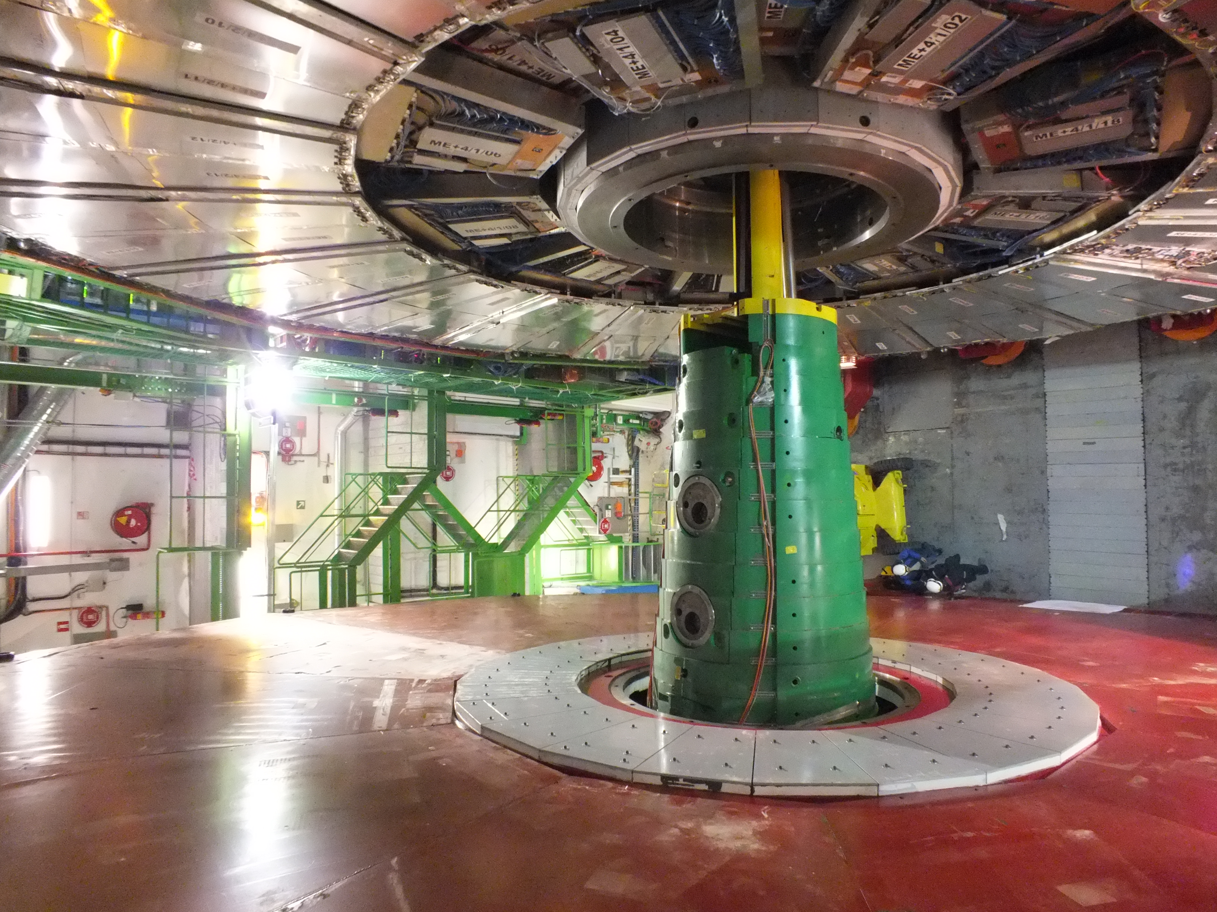

Mounting block for low radius point on RE4 SM

***Detail of the area of interest.***





The alignment system at Z= 10547mm is no longer in use and so can be disregarded.

10680 represents the YE4 IP side while 10529 represents the CSC envelope.

This leaves an envelope in the lower radius below 2508 approx ( extended high eta ) of 10680 – 10529 = 151mm

Minus the shield Z = 63 ( according to the model given to Pino) if heads of the screws (~10mm) attaching the shielding are counter sunk.

Final envelope 151 – 63 = 88mm. This value is in good agreement with the 85mm as given by the aforementioned model.

***The RE4/1 overlap case***

Assuming the electronics are outside this radius

Shield

85mm

CSC Z = 10529

RPC Body 30mm

RPC Body 30mm

Clearance to mobile YE4 = 25mm

It is assumed that a flat plate, as used in the RE4 SM design, will be necessary to establish a plane to mount the RPCs to as the outer radius mounting post is hidden under the present RE4/2 & RE4/3.

Summing the dimensions in Z

Clearance CSC 5

Alu Frame 8

RPC Body 30

RPC Body 30

Clearance 25

Total 98mm

This value is in excess of the 85mm available with the assumed 30mm for the RPC body. To stick to this layout the RPC body would have to be reduced to 23mm. Given the estimated similar chamber weight to RE type3 (70kg) the mechanics should be kept more or less as they are are for reasons of rigidity and so gap integrity.

***The RE4/1 non overlapped case, as per RE1/3.***

Assuming the electronics are inside the shield radius.

CSC Z= 10559mm

RPC Body 30mm

RPC Body 30mm

RPC electronics

85mm

Clearance = 22mm

Shield

It is assumed that a flat plate, as used in the RE4 SM design, will be necessary to establish a plane to mount the RPCs to as the outer radius mounting post is hidden under the present RE4/2 & RE4/3.

Summing the dimensions in Z

Clearance CSC 5

Alu Frame 8

RPC Body 30

RPC Electronics 20

Clearance 22

Total 85mm

With a clearance of 22mm and with the assumed 30mm for the RPC body the layout fits the 85mm available. Given the estimated similar chamber weight to RE type3 (70kg) the mechanics should be kept more or less as they are for reasons of rigidity and so gap integrity .

The distinction between envelope and as built real dimensions is a tricky subject and will need further investigation in situ. There are questions of cables and other services that will have to be clarified.

An example of cables that may reduce the available space in “Z”

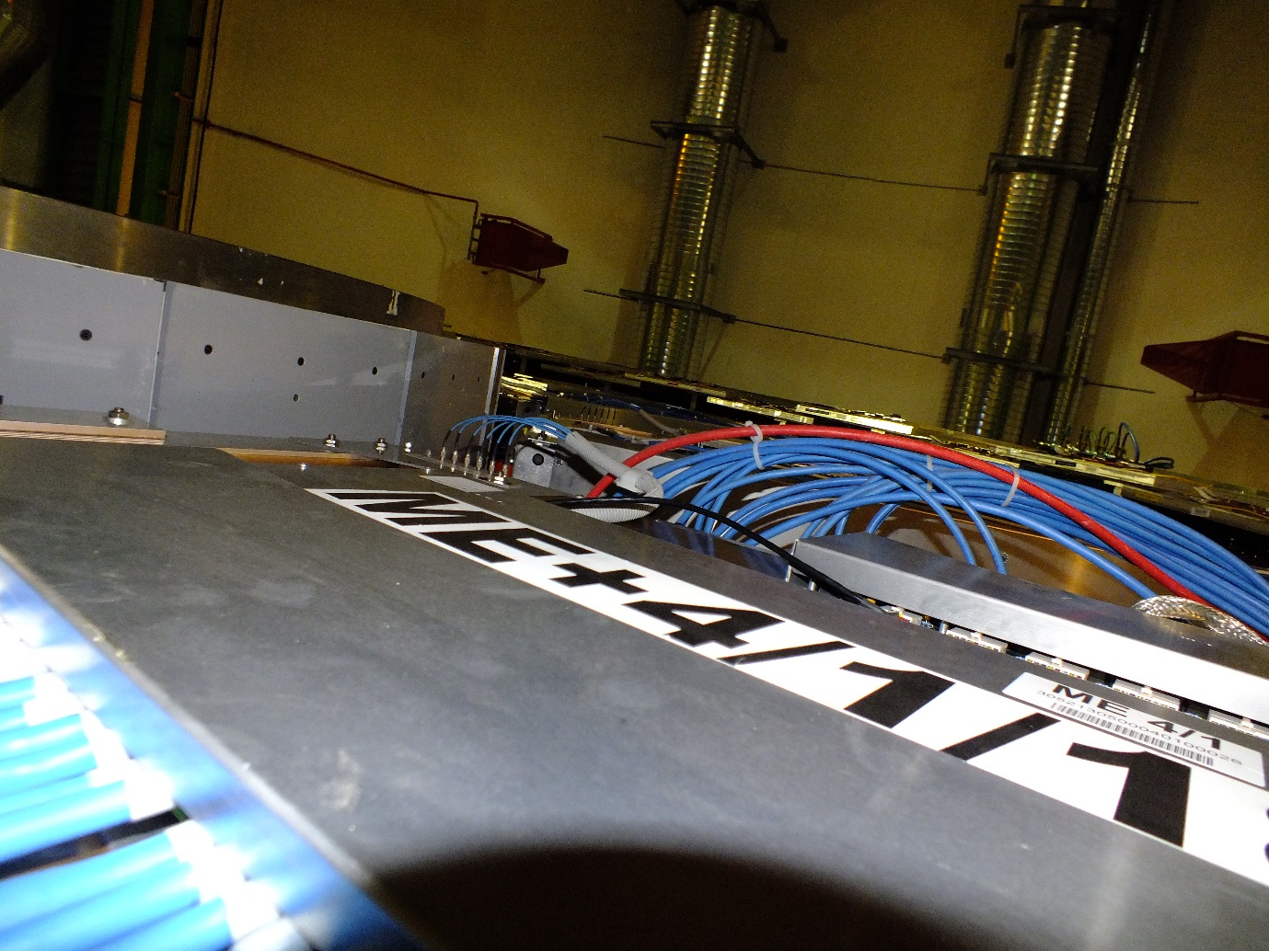

Prepared by I. Crotty with input from Pino (Giuseppe.Passeggio@na.infn.it)

5 Feb 2015