**RE3/1 Parameter Space**  Ian Crotty, 24 May 2016

2002 Version

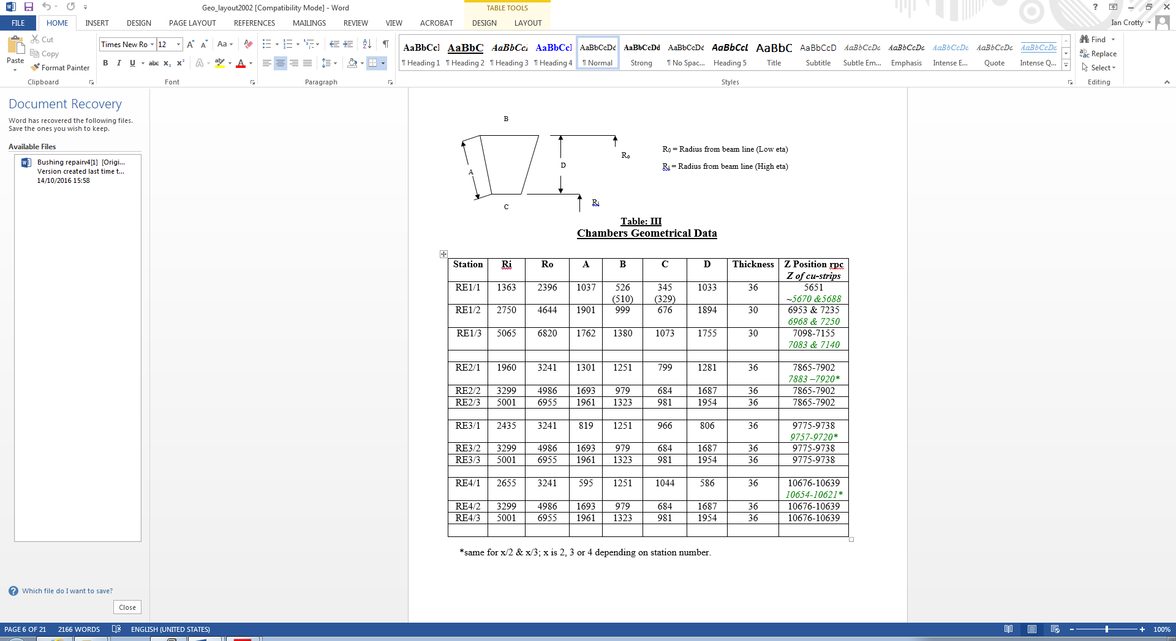

Todays version 2002 Version

R inner 1526mm 2435mm

R outer 3302mm 3241mm There is a discrepancy here !

Delta R 1776mm 806mm

Straight line Delta R 1805mm

Original (2002) chamber dimensions;

966mm

1251mm

806mm

Outer most envelope 06/06/2016



**Z values**

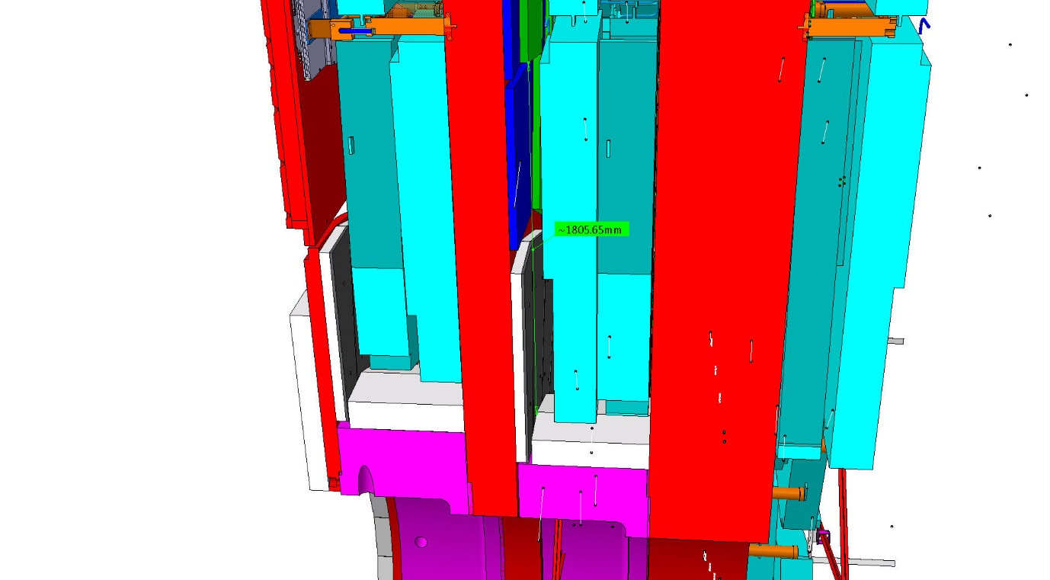

Distance froom off yoke RE3/1 to CSC off yoke = 34mm

RPC package of two overlapped chambers (old model) = 75.8mm

Shield to CSC at low “R” = 57.7mm

Conclude that space from Yoke to CSC = 110mm

Conclude, keeping same 34mm clearance, at low R = 110 – 58 = 52

= 76-52 = 24mm

Space for extended RE3/1 over shielding = 24mm !

This could be increased by 20mm if 14mm clearance accepted as for GE2/1.

Total space in “Z” = 24 + 34 – 14 = 44mm