First Envelope for Integration (Not Active area) 06.06.2016 Ian Crotty

Z Space

152mm from YE3 to CSC envelope. Shielding is 63mm thick. Leaves 88mm.

25+5+25 = 55. 88-55 = 33. On RE4 we have 25mm to the YE4 from RE4 SM. Notice the electronics for the off chamber is underneath !

First optimistic version with overlap using 25mm thick chambers

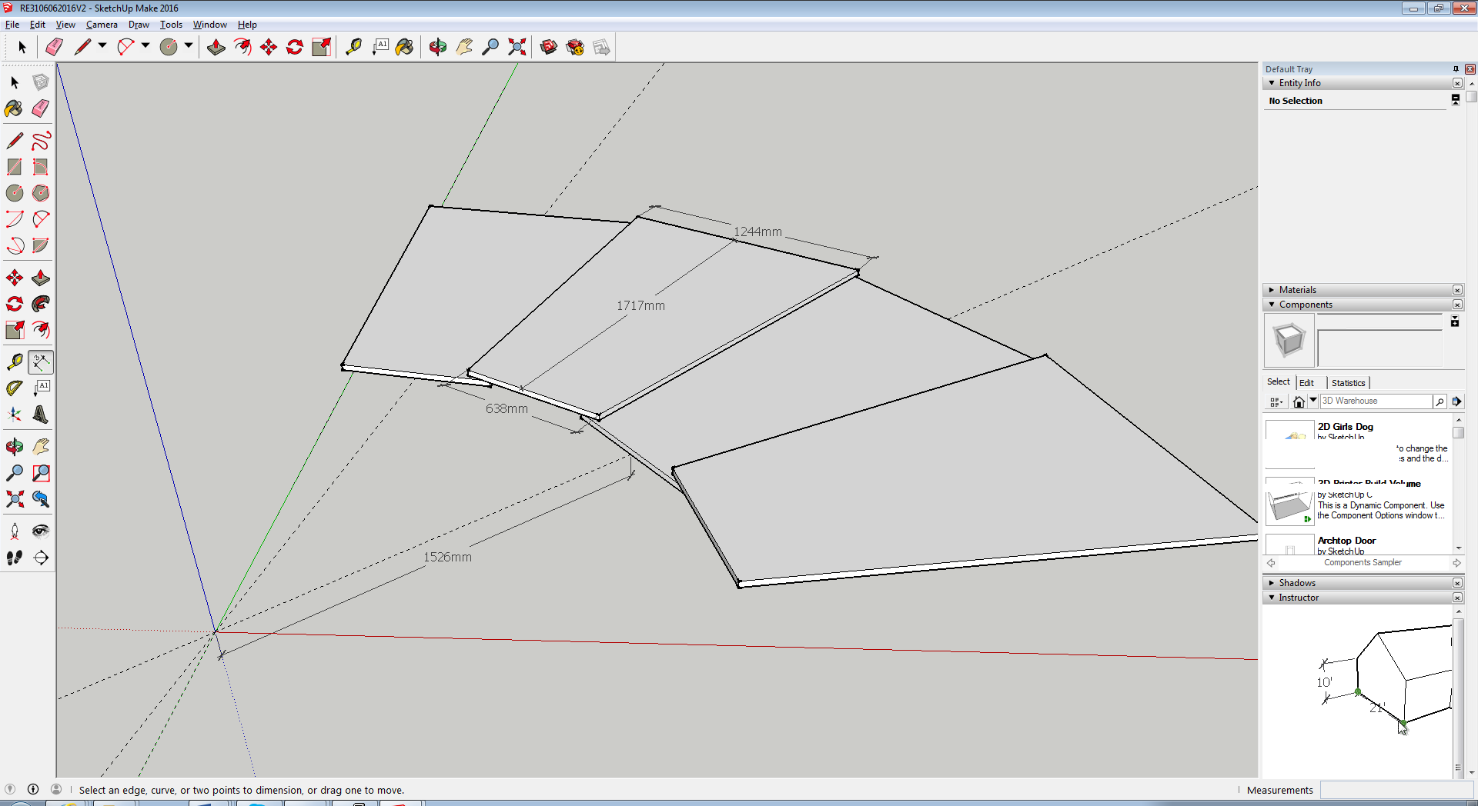

Trapezoid; Delta R = 1717mm, Long Base 1244mm, Short base 638mm. Overlap is 50mm on each side for structure and internal service passage.

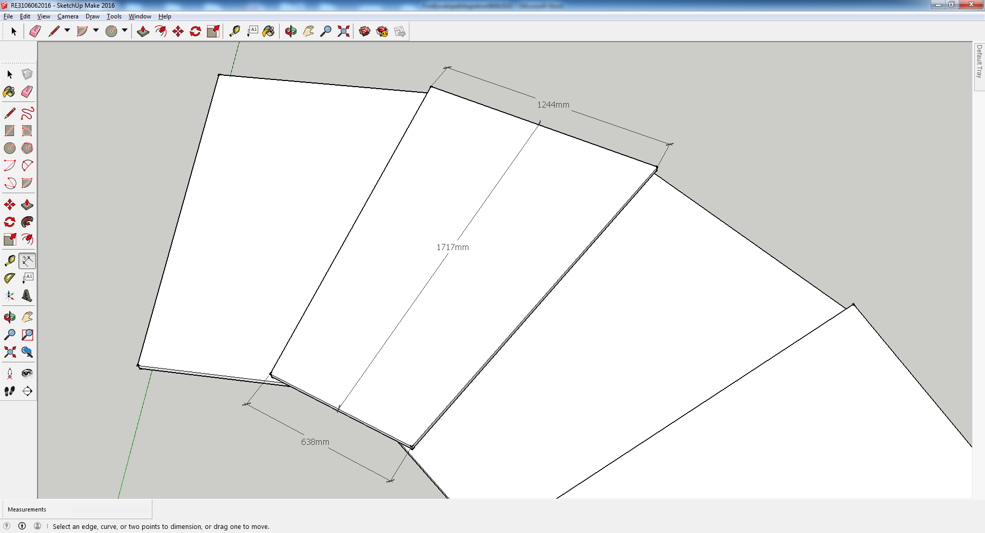

http://project-cms-rpc-endcap.web.cern.ch/project-cms-rpc-endcap/rpc/UpscopeHighEta/RPCDevelopements/RE31and41/RE31/Drawings/IanIntegrationJune2016/RE3106062016.skb