Connectors for FEB adapter board

11 Jan 2018

Dear collegues,

please find below the links for datasheet/drawings of the connecturs on the 88 and 44 channels return pcbs :

for the 88 strips, female connector :

[https://www.digikey.fr/product-detail/fr/panasonic-electric-works/AXK750347G/255-3011-6-ND/2364765](https://mmm.cern.ch/owa/redir.aspx?C=F1DLVtKgiC-SKopUEq2UyAVahCfibHrTsAEfivypt-dkmlUo7WfVCA..&URL=https%3a%2f%2fwww.digikey.fr%2fproduct-detail%2ffr%2fpanasonic-electric-works%2fAXK750347G%2f255-3011-6-ND%2f2364765)

for the 88 strips, male connector :

[https://www.digikey.fr/product-detail/fr/panasonic-electric-works/AXK850245WA/255-5607-ND/4842927](https://mmm.cern.ch/owa/redir.aspx?C=raI2V8BONXaa048qIns6eWK0f2l1Rm2lzQM6E-iTk9NkmlUo7WfVCA..&URL=https%3a%2f%2fwww.digikey.fr%2fproduct-detail%2ffr%2fpanasonic-electric-works%2fAXK850245WA%2f255-5607-ND%2f4842927)

for the 44 strips, female connector :

[http://fr.rs-online.com/web/p/products/7676395/?cm_mmc=FR-PPC-_-google-_-3_FR_FR_BM_IP_and_E_Exact-_-ERNI%257CEmbases_de_circuit_imprim%25C3%25A9&mkwid=sEemWGfPQ_dc%257Cpcrid%257C95446342128%257Cpkw%257Cerni%2B244838%257Cpmt%257Ce%257Cprd%257C&gclid=EAIaIQobChMI2ezCyZy71QIVASjTCh1rMw-_EAAYASAAEgLijPD_BwE](https://mmm.cern.ch/owa/redir.aspx?C=EWQ-5eelR9vZTyd8f7rFKXotqCIp1e3qTTpHOBcBG8dkmlUo7WfVCA..&URL=http%3a%2f%2ffr.rs-online.com%2fweb%2fp%2fproducts%2f7676395%2f%3fcm_mmc%3dFR-PPC-_-google-_-3_FR_FR_BM_IP_and_E_Exact-_-ERNI%257CEmbases_de_circuit_imprim%25C3%25A9%26mkwid%3dsEemWGfPQ_dc%257Cpcrid%257C95446342128%257Cpkw%257Cerni%2b244838%257Cpmt%257Ce%257Cprd%257C%26gclid%3dEAIaIQobChMI2ezCyZy71QIVASjTCh1rMw-_EAAYASAAEgLijPD_BwE)

for the 44 strips, male connector :

[http://fr.rs-online.com/web/p/fiches-femelles-pour-ci/6133005/?origin=PSF_435705|acc](https://mmm.cern.ch/owa/redir.aspx?C=_OUGRt0Tum7rcvx-5-n_jEPO82hGKQE30trKn9EwDUd0wVUo7WfVCA..&URL=http%3a%2f%2ffr.rs-online.com%2fweb%2fp%2ffiches-femelles-pour-ci%2f6133005%2f%3forigin%3dPSF_435705%7cacc)

cheers,

C.

PTO

for the 88 strips, female connector :

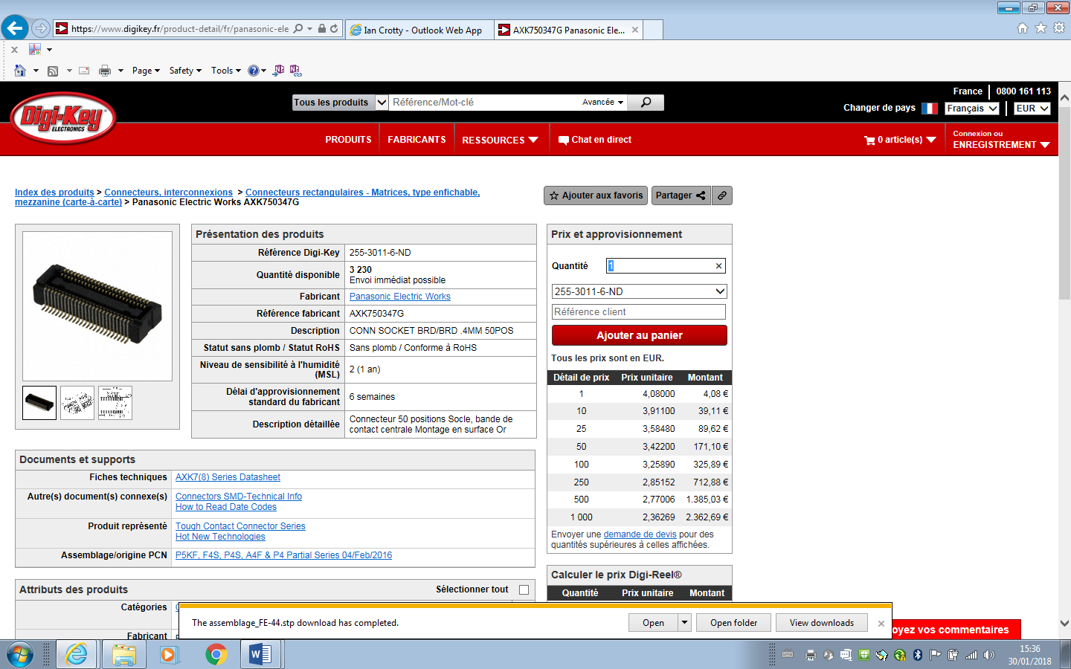

for the 88 strips, male connector :

No illustrations

for the 44 strips, female connector :

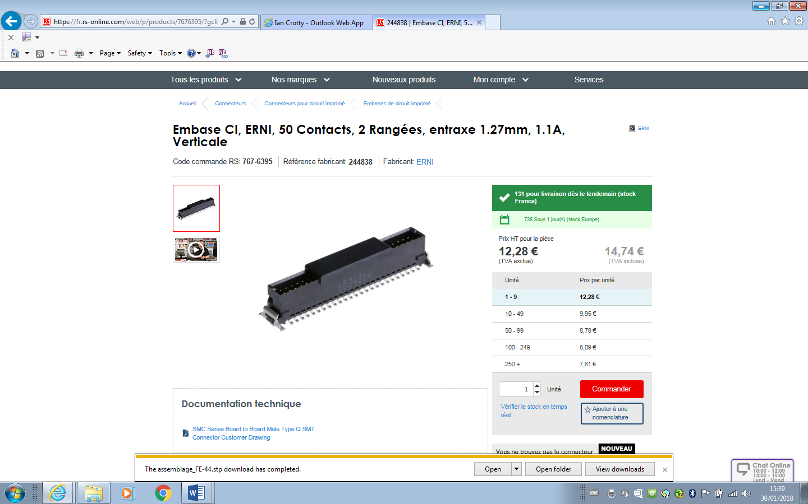

for the 44 strips, male connector :

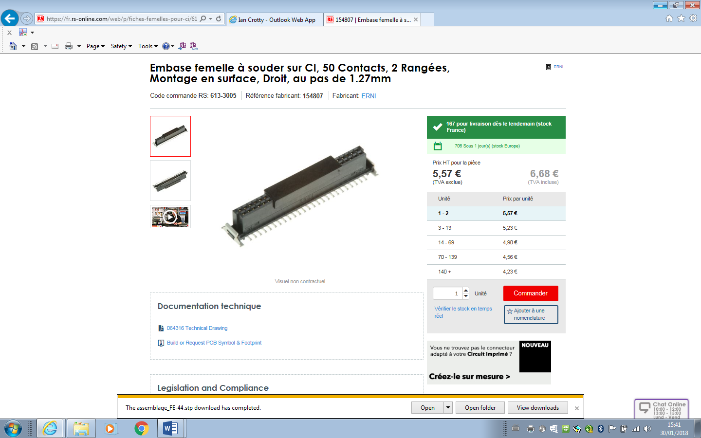

I think the titles aare inversed, male and female !!