Coaxial cable stripper

There was one in a WS in CERN Meyrin…………

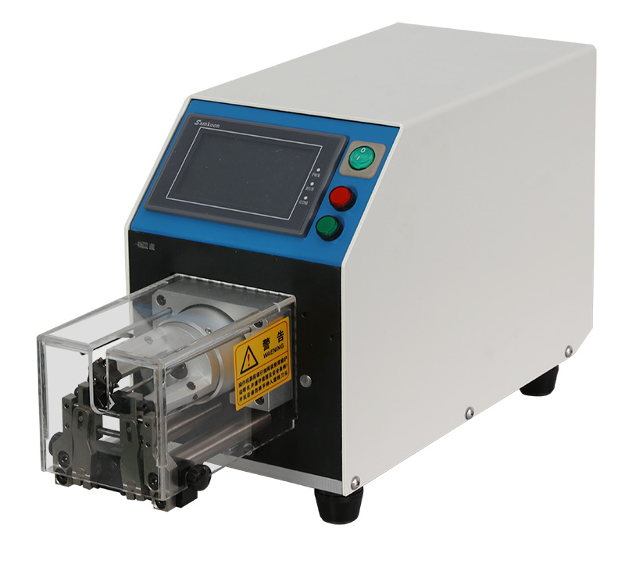

It does a perfect job every time and quickly.

Does Lyon have one, or rather where is the one Lyon has ?

If you are good there is the simple thermal version;

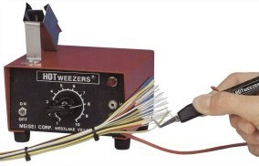

http://www.series4.co.uk/product/anti-static-hotweezer-thermal-wire-strippers/

Ian 3 Oct 2017

Ref;

<http://www.ew-wirestripping.com/en_cp_view.asp?ID=161&ClassID=2&gclid=EAIaIQobChMIjKOK0MXU1gIVg7DtCh27fQQlEAAYASAAEgKiA_D_BwE>

<http://www.schleuniger-na.com/en-us/products/p/coaxstrip-5200-4/>