**Coaxial Cable**  Ian. Crotty

3 Oct 2017

Small coal cable from CERN stores, hundreds of meters available.

*C-50-1-1*

[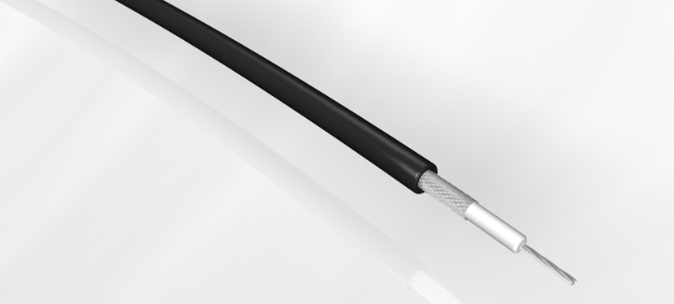](https://www.google.fr/url?sa=i&rct=j&q=&esrc=s&source=images&cd=&ved=0ahUKEwj26rvNztTWAhVGIcAKHW5NC7wQjRwIBw&url=https://www.prysmiangroup.com/en/product-finder-mms&psig=AOvVaw1RXy9kBX2kP3rnpVVZ1AFy&ust=1507125587499559)

**04.61.11.A - COAXIAL CABLE 50 OHM - TYPE C-50-1-1**

[For any further technical information additional - click here](https://cern.service-now.com/service-portal/report-ticket.do?name=details-on-catalogue-item&fe=product-management&scem_code=04)

SPECIFICATION : LO-GE Nº461

CONDUCTOR Copper

CONSTRUCTION 7 x 0.10 dia. dia : 0.30 mm

INSULATION Solid XL-PE dia : 0.88 mm

SCREENING Tinned copper braid 16x3x0.1mm dia : 1.33 mm

SHEATH Brown polyolefine max. dia : 2.10 mm

SPECIFICATIONS CHARACTERISTIC IMPEDANCE 50 ± 2 Ohm

RATED CAPACITANCE 101 pF/m

PROPAGATION RATE 0.66

RATED DELAY 5.03 ns/m

MAX. ATTENUATION MHz 10 100 200

dB/100 m 15 46 66

DC RES. OF INNER CONDUCTOR 323 mOhm/m

DC RES. OF SCREEN 53 mOhm/m

MAX. RATED VOLTAGE 1.2 kV r.m.s.

TEST VOLTAGE PART. DISCH.<1pC 1.3 kV r.m.s.

DIELECTRIC STRENGTH TEST VOLT. 3 kV d.c.

OPERATING TEMPERATURE -10 to +70°C

ANTI-FIRE TEST IEC 332-1

ACCORDING TO SAFETY INSTRUCTION IS 23

CERN Stores SCEM 04.61.11.105.3

Cost 0.88chf/m

<https://edh.cern.ch/edhcat/Browser?command=showPage&argument=719&top=719&objid=%24%24EDH75gc96hf3&showAdvanced=&scem=&keywords>=

OR

*C-50-1-1A*

**04.61.11.AD - COAXIAL CABLE 50 OHM - TYPE C-50-1-1A**

[For any further technical information additional - click here](https://cern.service-now.com/service-portal/report-ticket.do?name=details-on-catalogue-item&fe=product-management&scem_code=04)

SPECIFICATION : LO-GE Nº515

CONDUCTOR Silver-plated copper

CONSTRUCTION 7 x 0.10 mm dia. dia. 0.30 mm

INSULATION SILTEM dia. 1.10 mm

SCREENING Silver-plated copper braid dia. 1.55 mm

16 x 3 x 0.10 mm

SHEATH Grey SILTEM

SPECIFICATIONS CHARACTERITIC IMPEDANCE 50 ± 2 Ohm

RATED CAPACITANCE 120 pF/m

PROPAGATION RATE 0.66

RATED DELAY 5.03 ns/m

MAX. ATTENUATION MHz 10 100 200 400

dB/100 m -- -- -- 113

SWITCH-OFF FREQUENCY 70 GHz

DC RES. OF INNER CONDUCTOR 300 mOhm/m

DC RES. OF SCREEN 53 mOhm/m

MAX. RATED VOLTAGE 2 kV r.m.s

TEST VOLTAGE PART. DISCH.<1pC 1 kV r.m.s

DIELECTRIC STRENGTH TEST VOLT.3 kV r.m.s

OPERATING TEMPERATURE -40 to +135ºC

ANTI-FIRE TEST IEC 332-1

CERN Stores SCEM 04.61.11.090.3

Cost 3.6chf/m

https://edh.cern.ch/edhcat/Browser?command=showPage&argument=721&top=721&objid=%24%24EDH75gc96hf3&showAdvanced=&scem=&keywords=

From outside CERN, Draka which is the same as the C-50-1-1 available from CERN.

<http://prsmn.com/en/business_markets/markets/multimedia/downloads/datasheets/hf31e.pdf>