**GT Chamber 1.8mm**

In this report the intervention with the GT chamber gas gap HV connection is discussed. This was done due to the rising current problem of the top gap. Before going further there was a question that should be addressed and also raised in the discussion.

**If the top gap is not working with the same HV connection, then how bottom gap is stable with the same HV connection?**

One suggestion was to test the Gap outside the chamber. Testing of the Gap outside chamber with the same HV connection has not been done yet. Within the chamber it always tripped.

This cannot be done now as the insulation Pad of the HV connection is removed but not completely. If we still go for the Gap test, then we have to reestablish the same HV connection. It can be restored but will not be in exact state as before.

The other thing can be done is to compare the level of protection between the Top and the bottom HV connection to see any difference. Further step could be to make the HV connection as the Kodel and then test the gap outside and inside chamber.

However, the observations are compiled in the following pages. The information about HV connection of the Kodel gap is also added in the form of pictures which are taken from one of the gap present at 904 RPC lab.

# Insufficient Mylar around HV connection

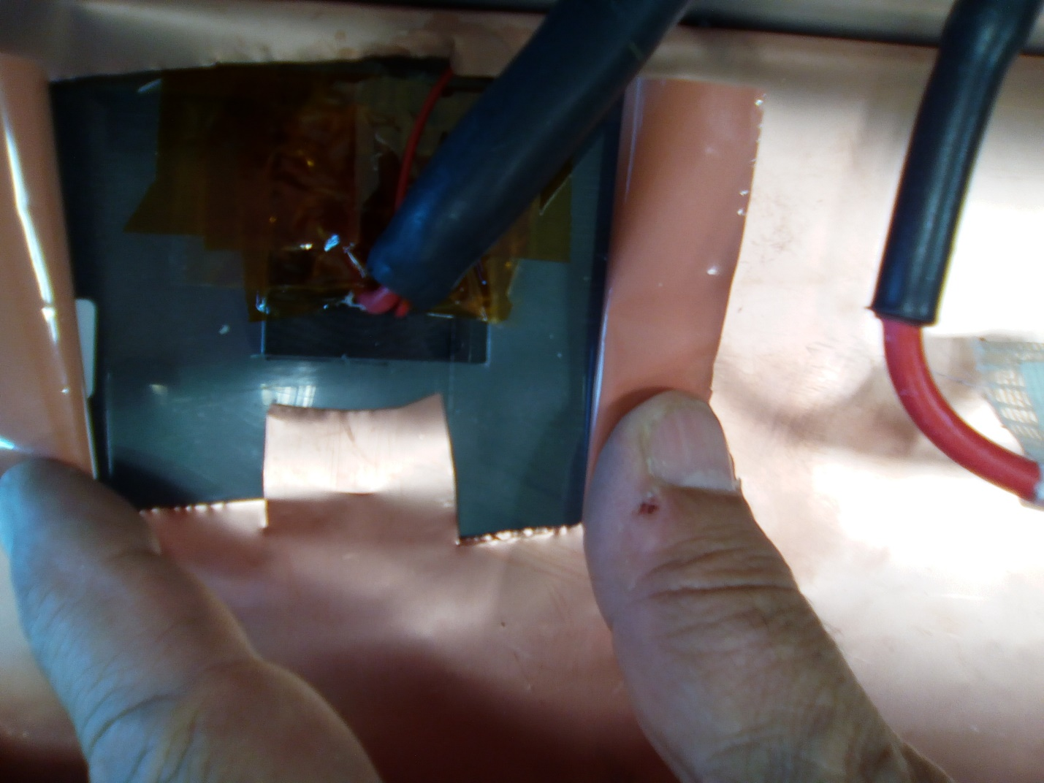

**Gap is covered by Kapton tape instead of Mylar that is being cut away**

# Direction of the HV cable

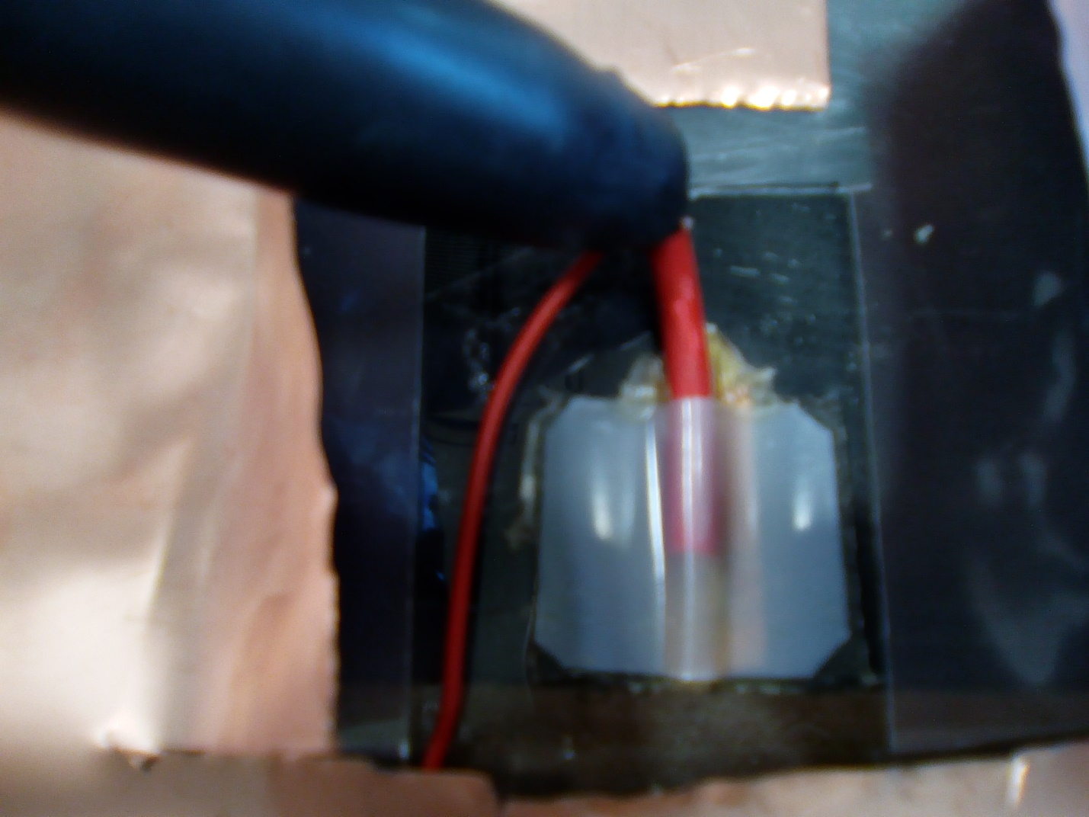

**Direction of the cable is towards the center of the Gap.**

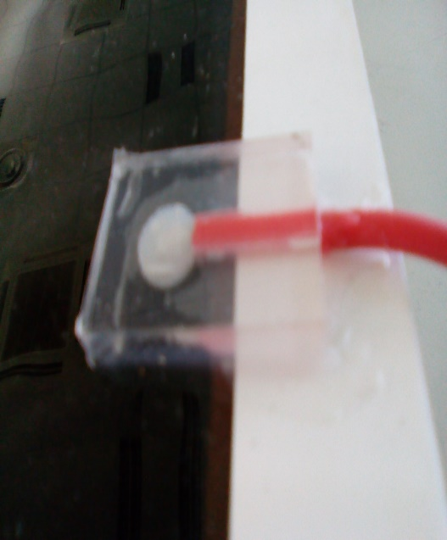 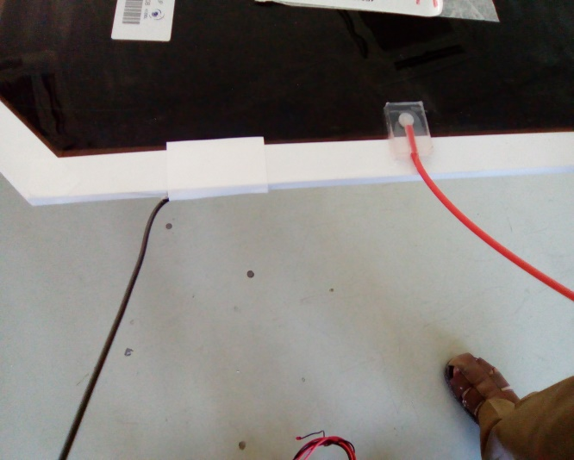

**Kodel Gap HV Connection**

**Direction of the cable is away from the Gap.**

# Some Kodel HV connection Dimensions

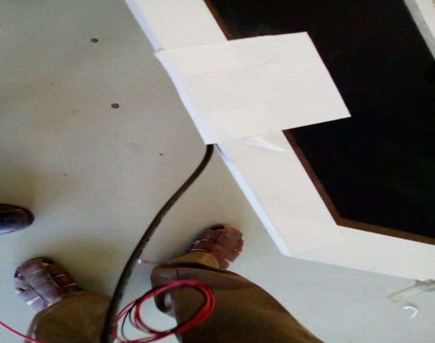 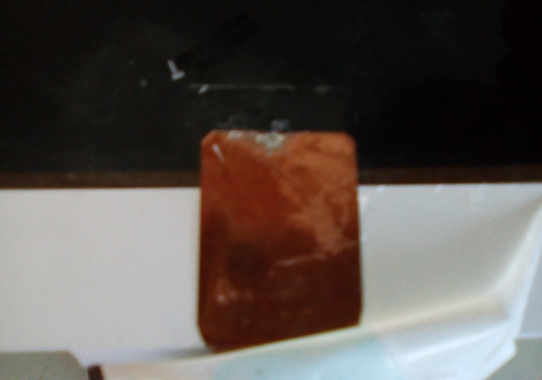

**Ground Connection**

3 mm

2.5 mm

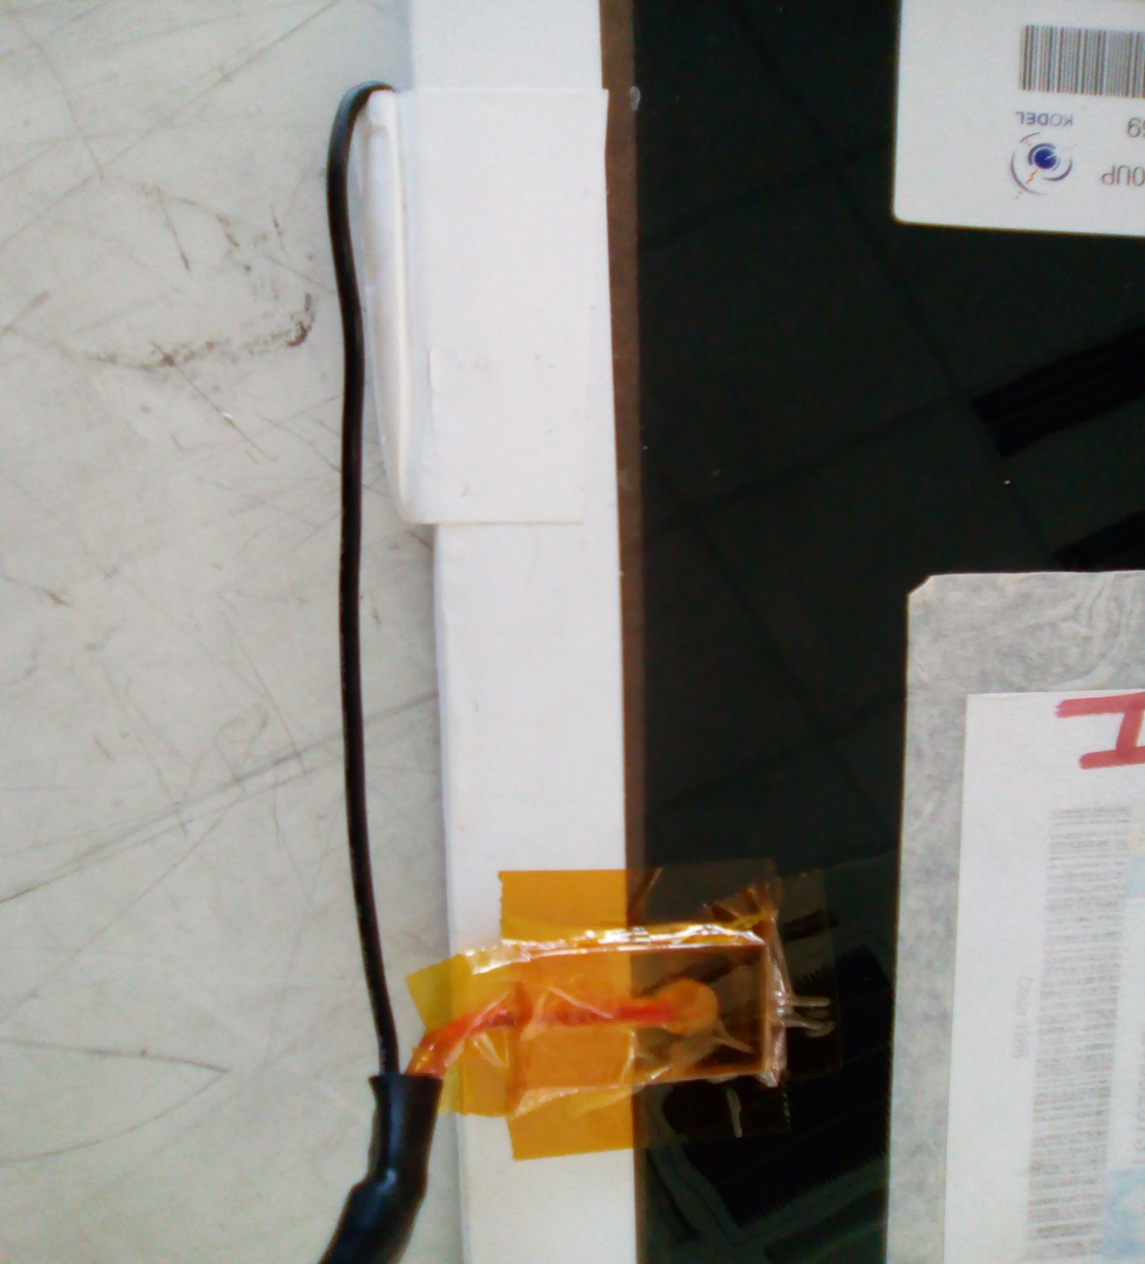

**Both wires wrapped together for braid before the Gap is going into the chamber.**

**These are passing along the side of the Gap and not over the Gap.**

9 cm

3.5 cm

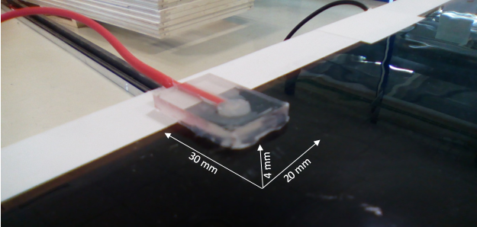

# Summary of HV Connection

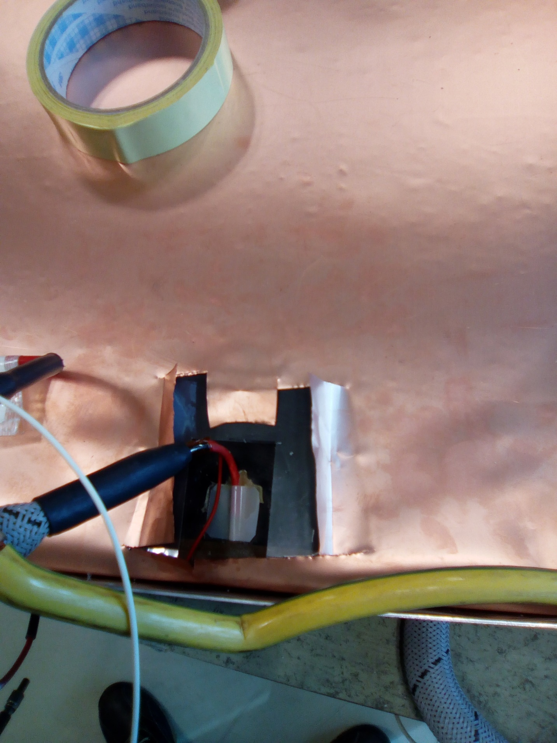

* **Not fully covered the black surface of the Gap with mylar around the HV connection.**
* **Insulation Pad is very thin about 190µm.**
* **The HV cable direction on the gap is going to the center of the gap. So the ground wire come close to it when wrapping both wires for braid. Whether the mechanics allows this to rotate the direction of HV cable at 180 degrees.**
* **The ground cable looks not so strong, very close to the HV cable and in this case even passes over the Gap which is not covered by the Mylar.**

# Level of Stress

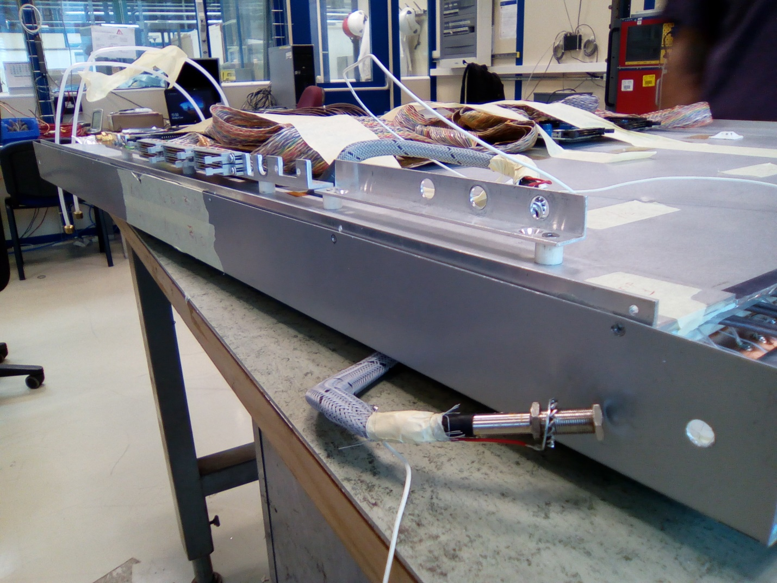

* **Level of Stress can be seen from the offset of the holes for screws**
* **This offset is different for each hole as the holes on the side bar are not aligned.**
* **The first hole in this picture has offset around 6mm.**

# Outer most Strip

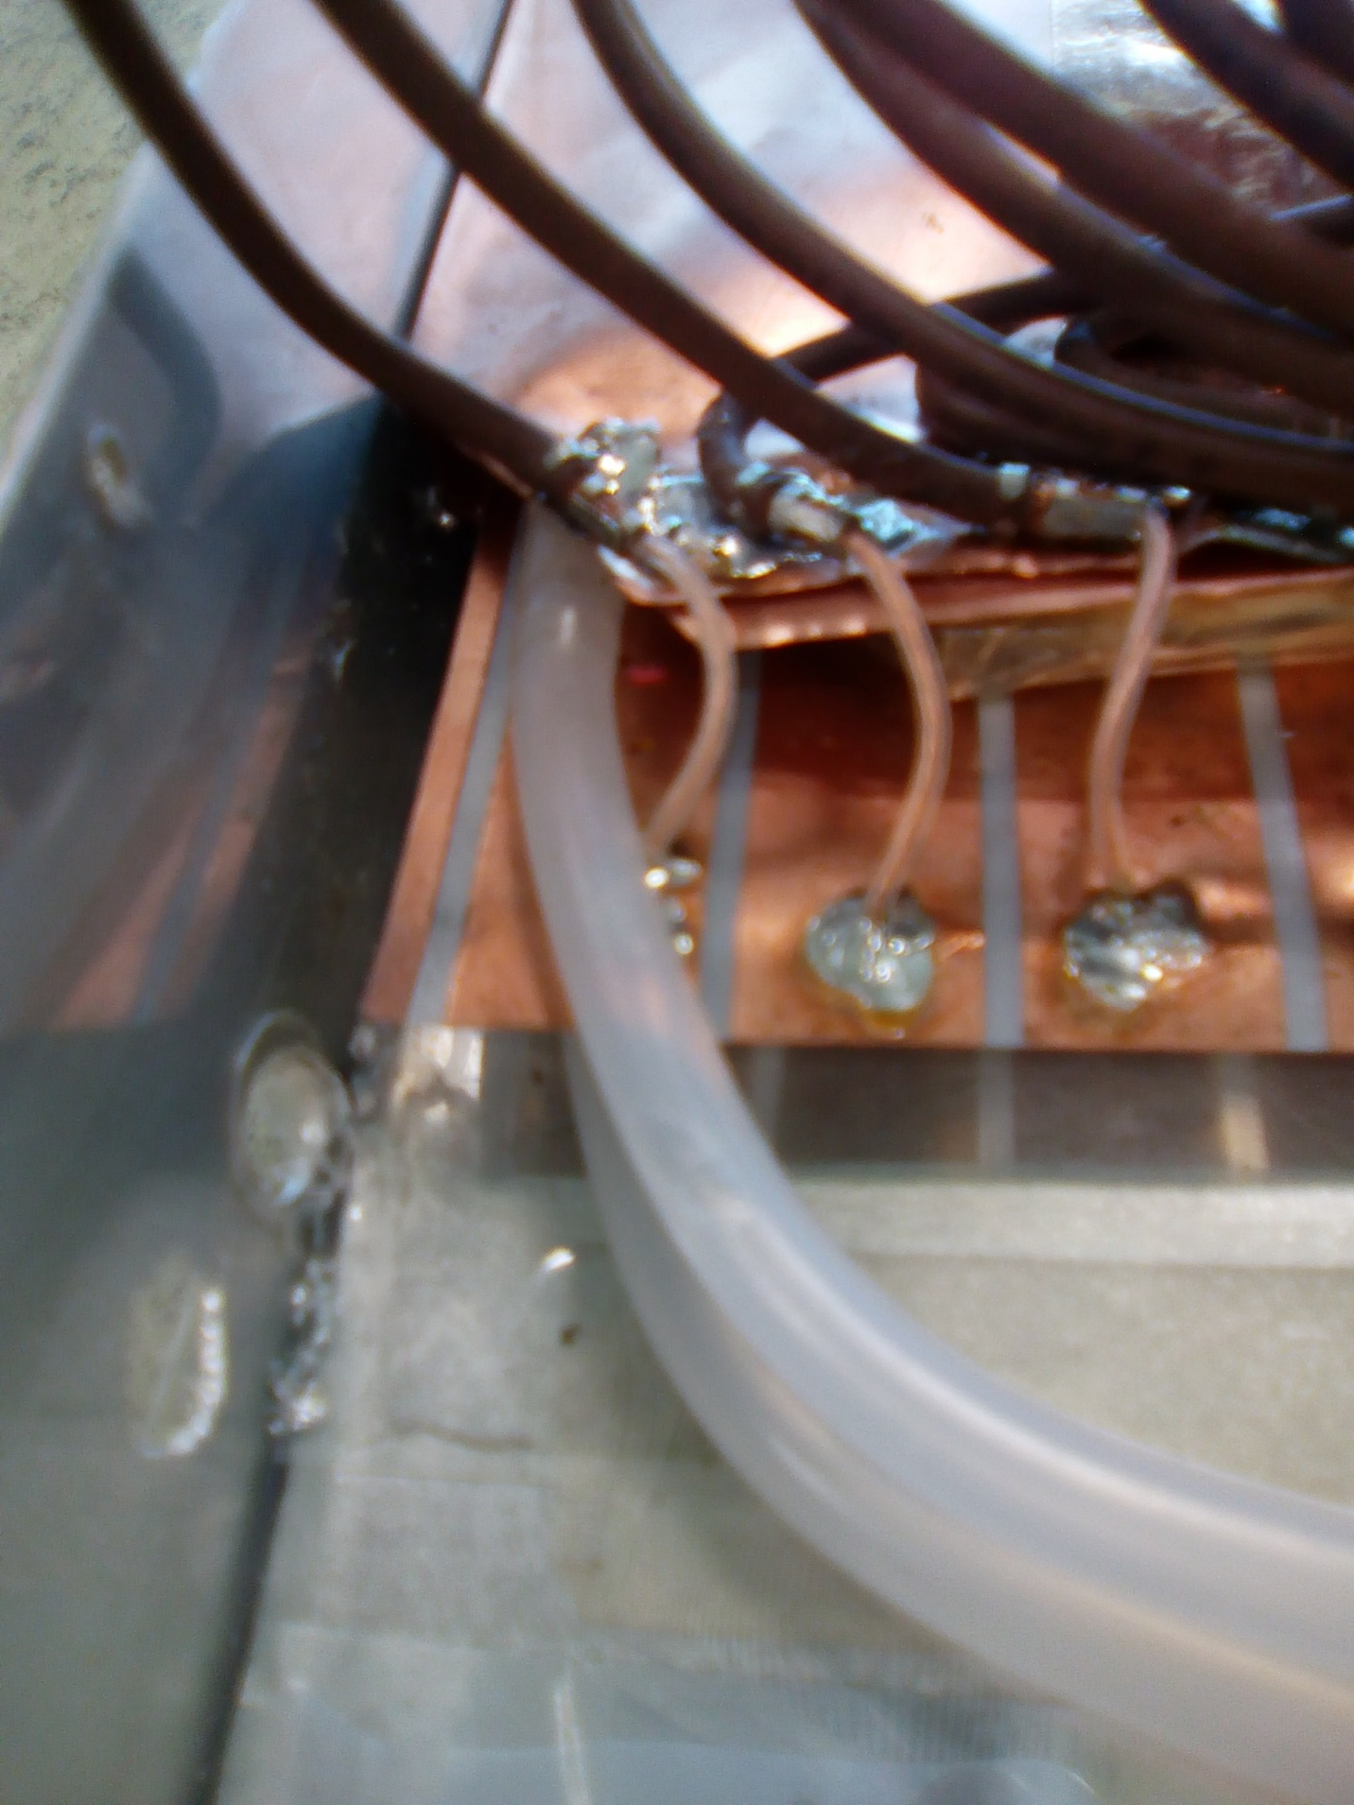

* **This outermost strip which is on both sides of the strip plane with smaller width is charged and produces the spark with the screw very close to it. The screw is not present at the moment as the chamber is opened. But one can see the hole for screw**
* **This strip can cross talk with nearby strip if not discharged**
* **Either this can be cut or to be grounded, if it is not for any special purpose**
* **However, we didn’t see any effect on the current of the Gap**

30 mm

20 mm

4 mm