Honeycomb panels

Ian Crotty

28 march 2017

Construction

Materials

Encapsulated fixings

Method

<https://www.youtube.com/watch?v=M9qkvBZwMwE>

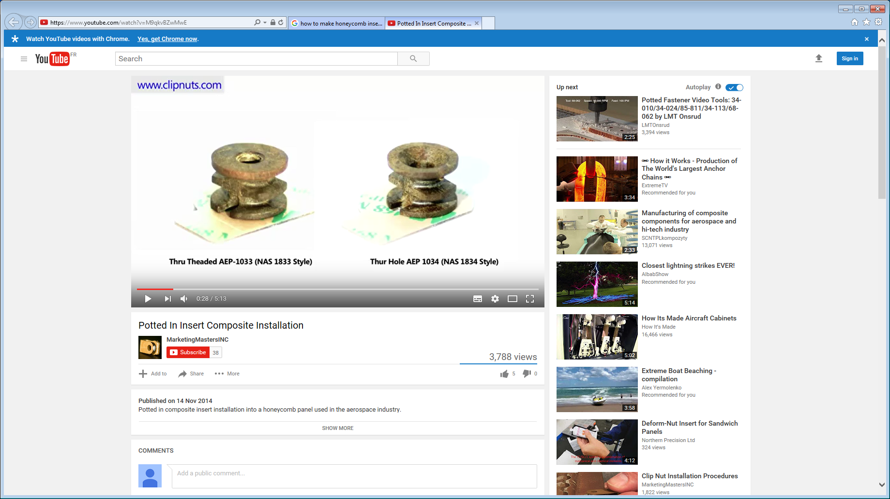

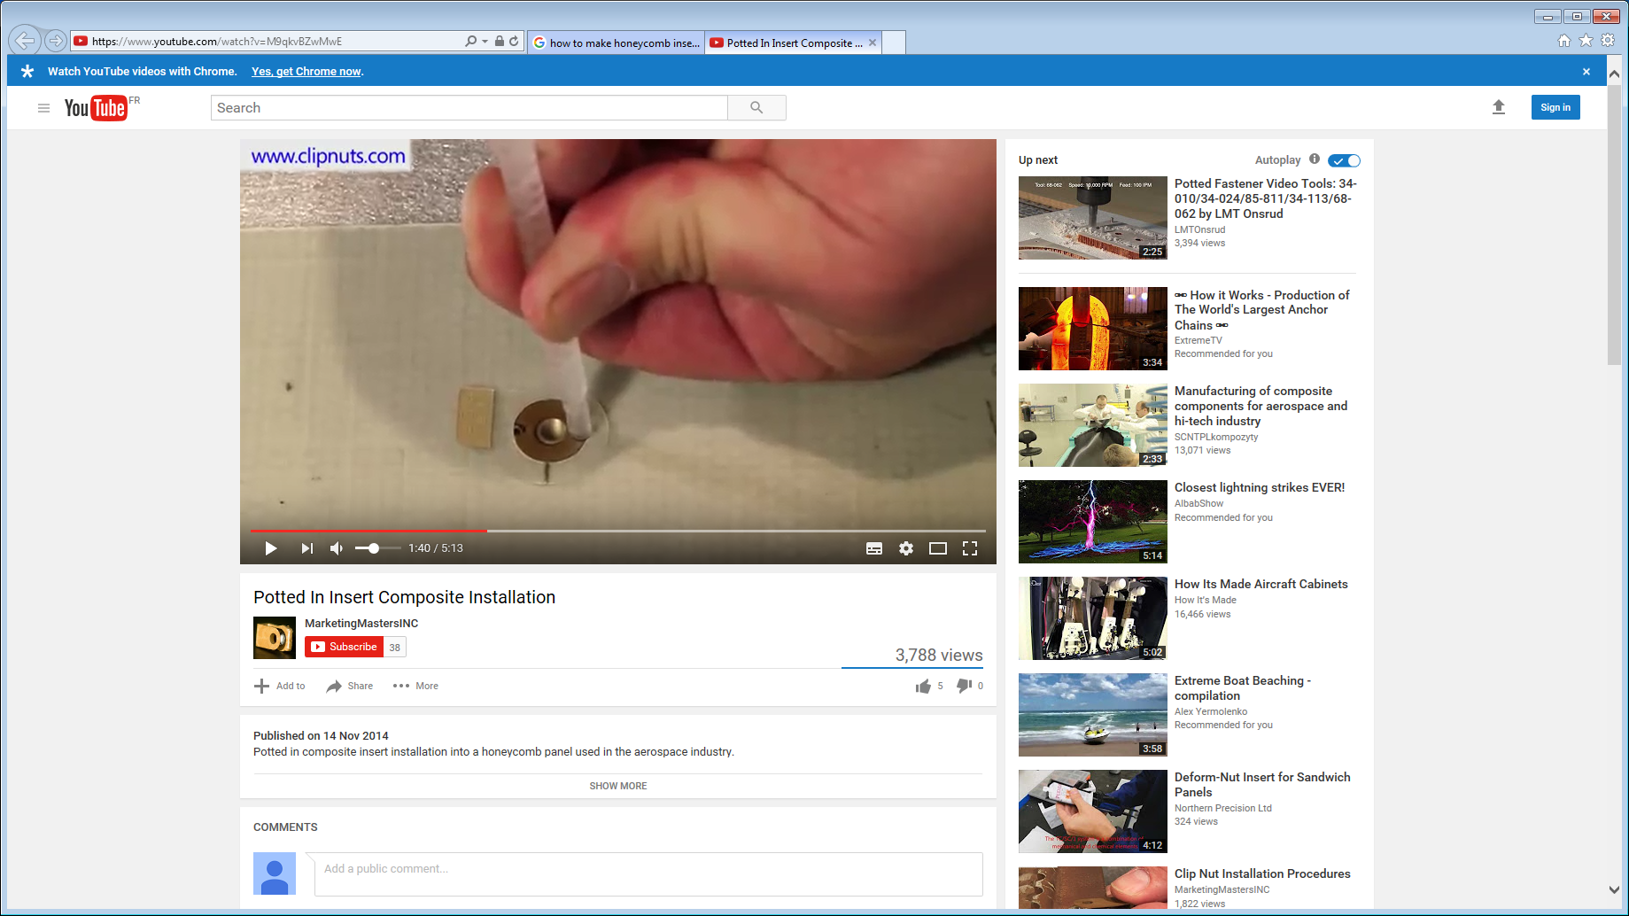

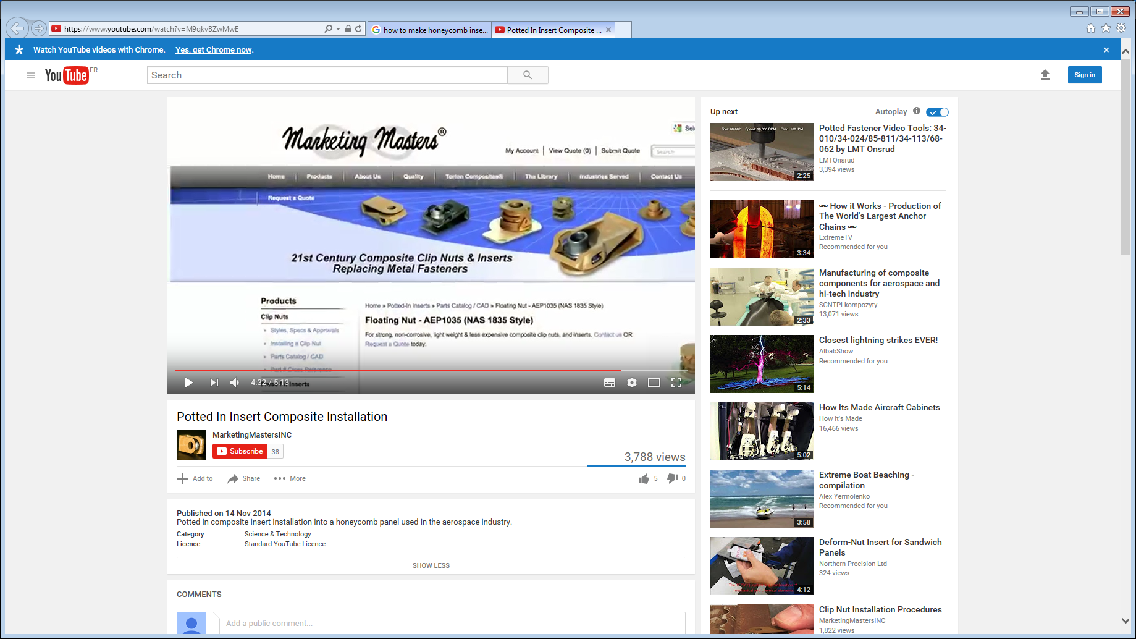

Also

<https://www.youtube.com/watch?v=NCC2TcSR4bY>

<https://www.youtube.com/watch?v=-MkuarxkesE>

https://www.youtube.com/watch?v=27S7tThj5yc&list=PLjztg1Gd4WZTwsiik-_3J9ERh7ajpzHxC