Arduino Ethernet Read out ian Crotty

6 March 2017

<http://www.instructables.com/id/Arduino-Ethernet-Shield-Tutorial/>

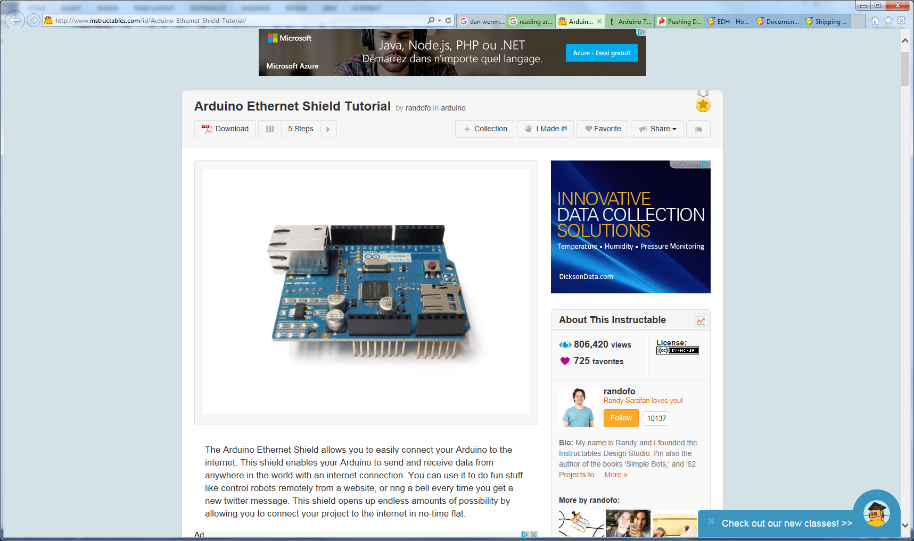

<http://tronixstuff.com/2013/12/06/arduino-tutorials-chapter-16-ethernet/>

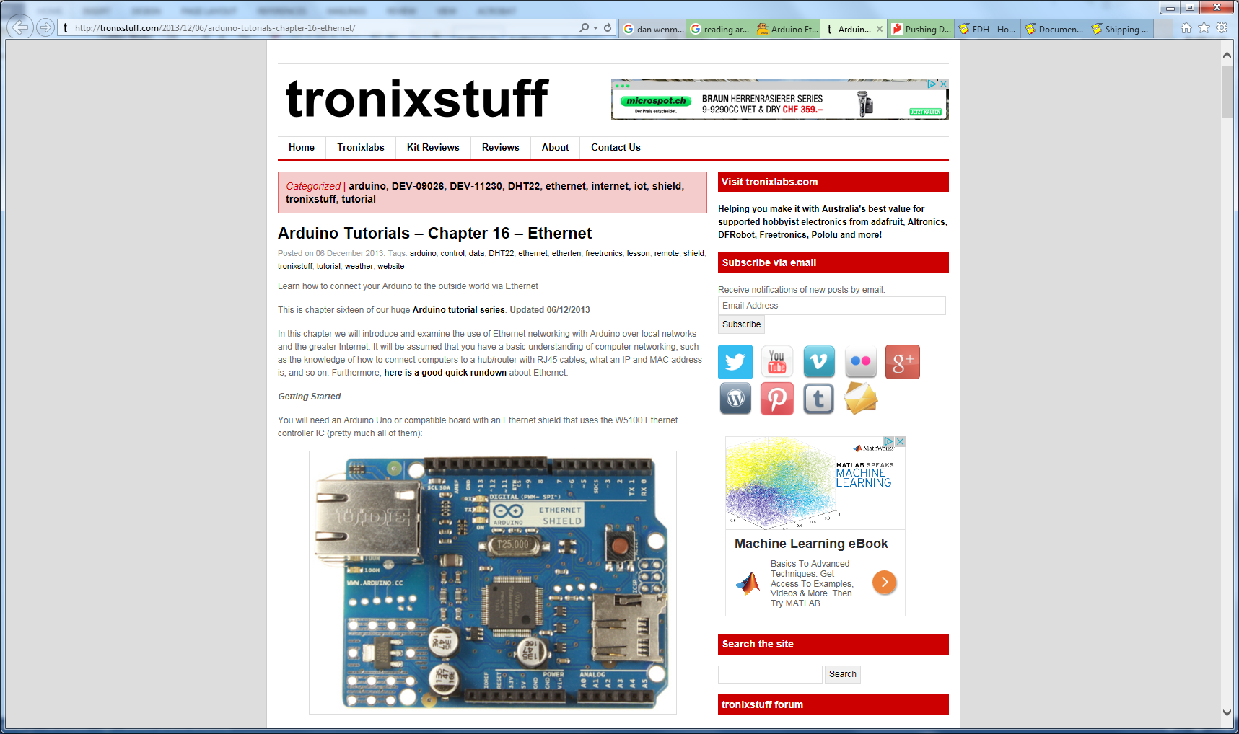

<https://learn.sparkfun.com/tutorials/pushing-data-to-datasparkfuncom/arduino--ethernet-shield>

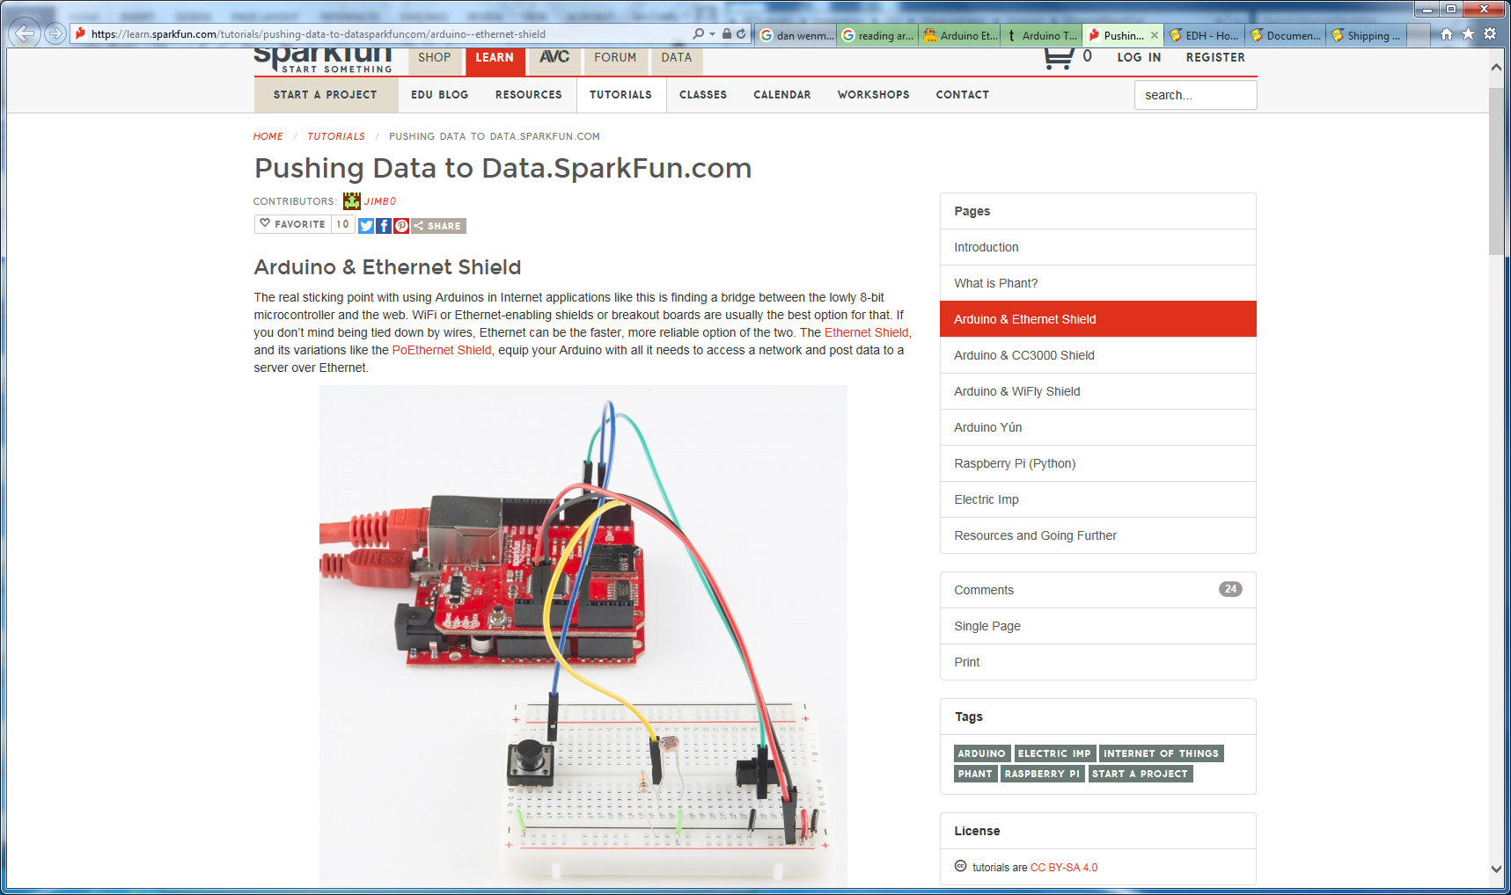

<https://tutoarduino.com/lethernet-shield/>

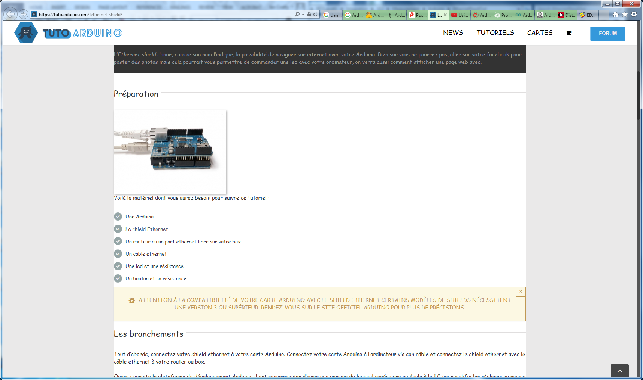

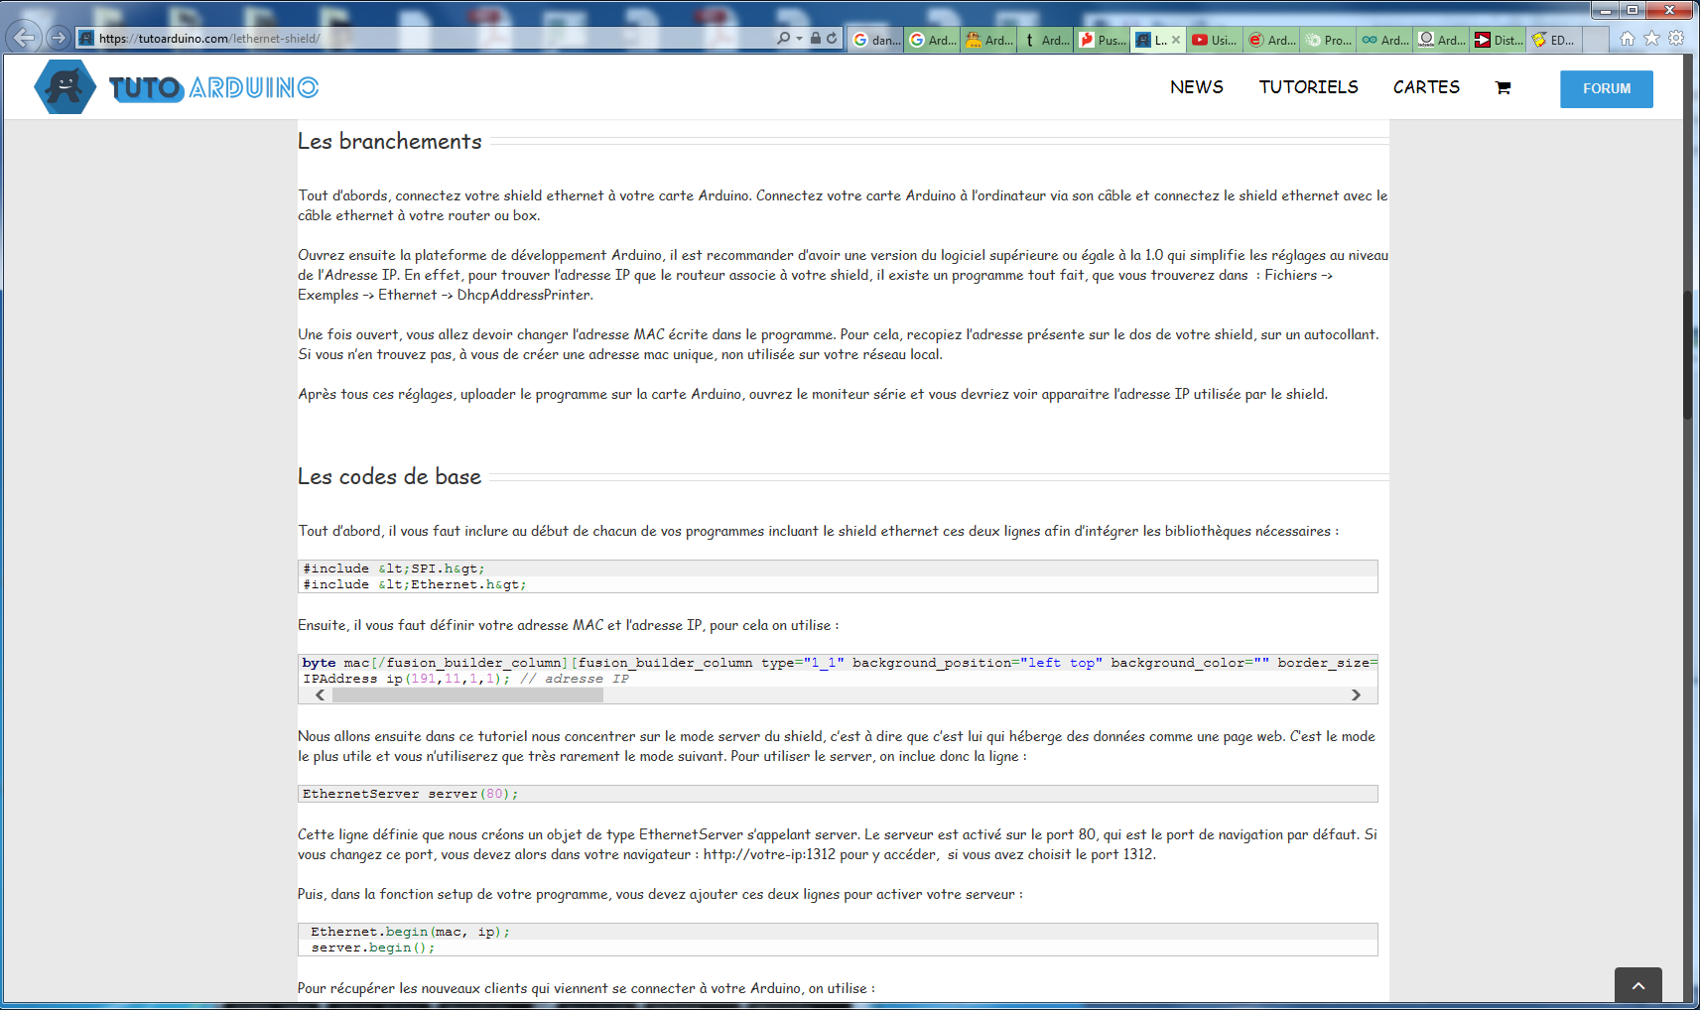

You Tube

<https://www.youtube.com/watch?v=vcOE2XAQHzY>

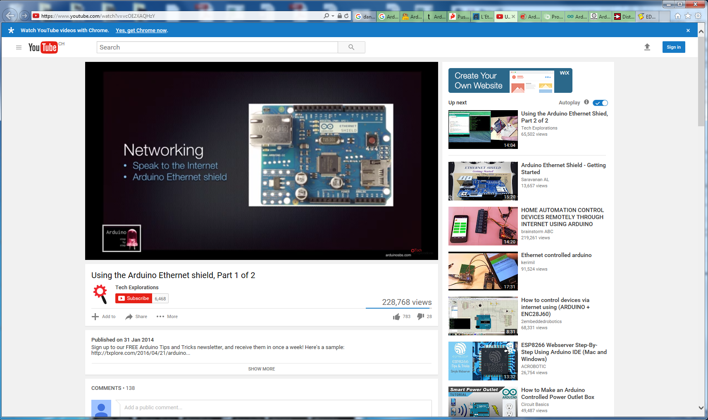

<https://startingelectronics.org/tutorials/arduino/ethernet-shield-web-server-tutorial/>

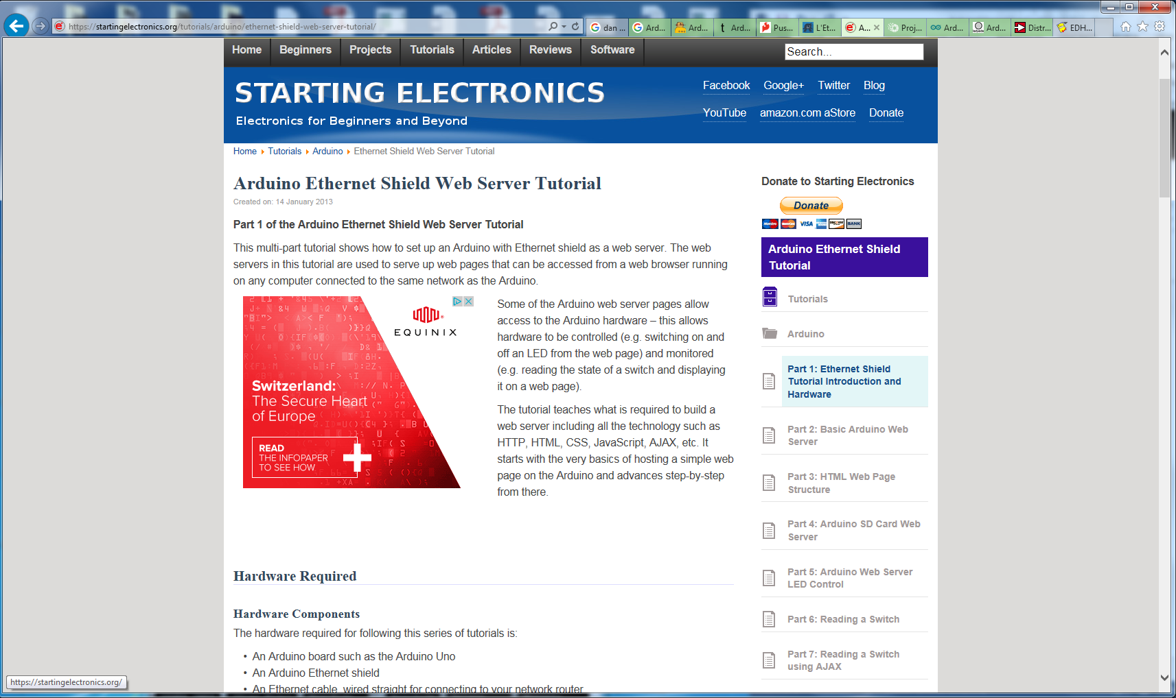

<https://openclassrooms.com/forum/sujet/projet-arduino-ethernet-shield-plaque-relais>

ARDUINO.ORG

<http://www.arduino.org/learning/tutorials/boards-tutorials/content/arduino-ethernet-shield-2-tutorial>

Logging web monitor

<http://www.ladyada.net/learn/arduino/ethfiles.html>

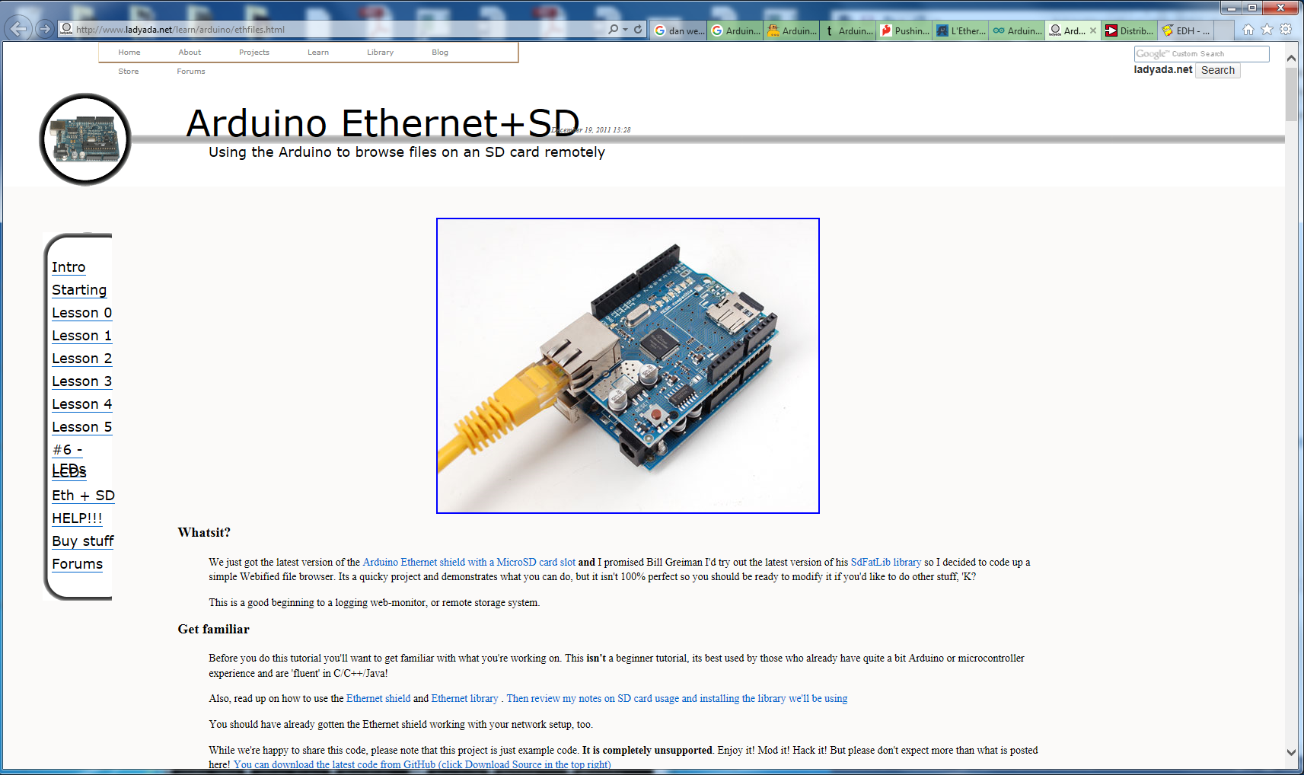

Suppliers

http://www.digikey.fr/product-detail/fr/arduino/A000024/1050-1039-ND/3476356

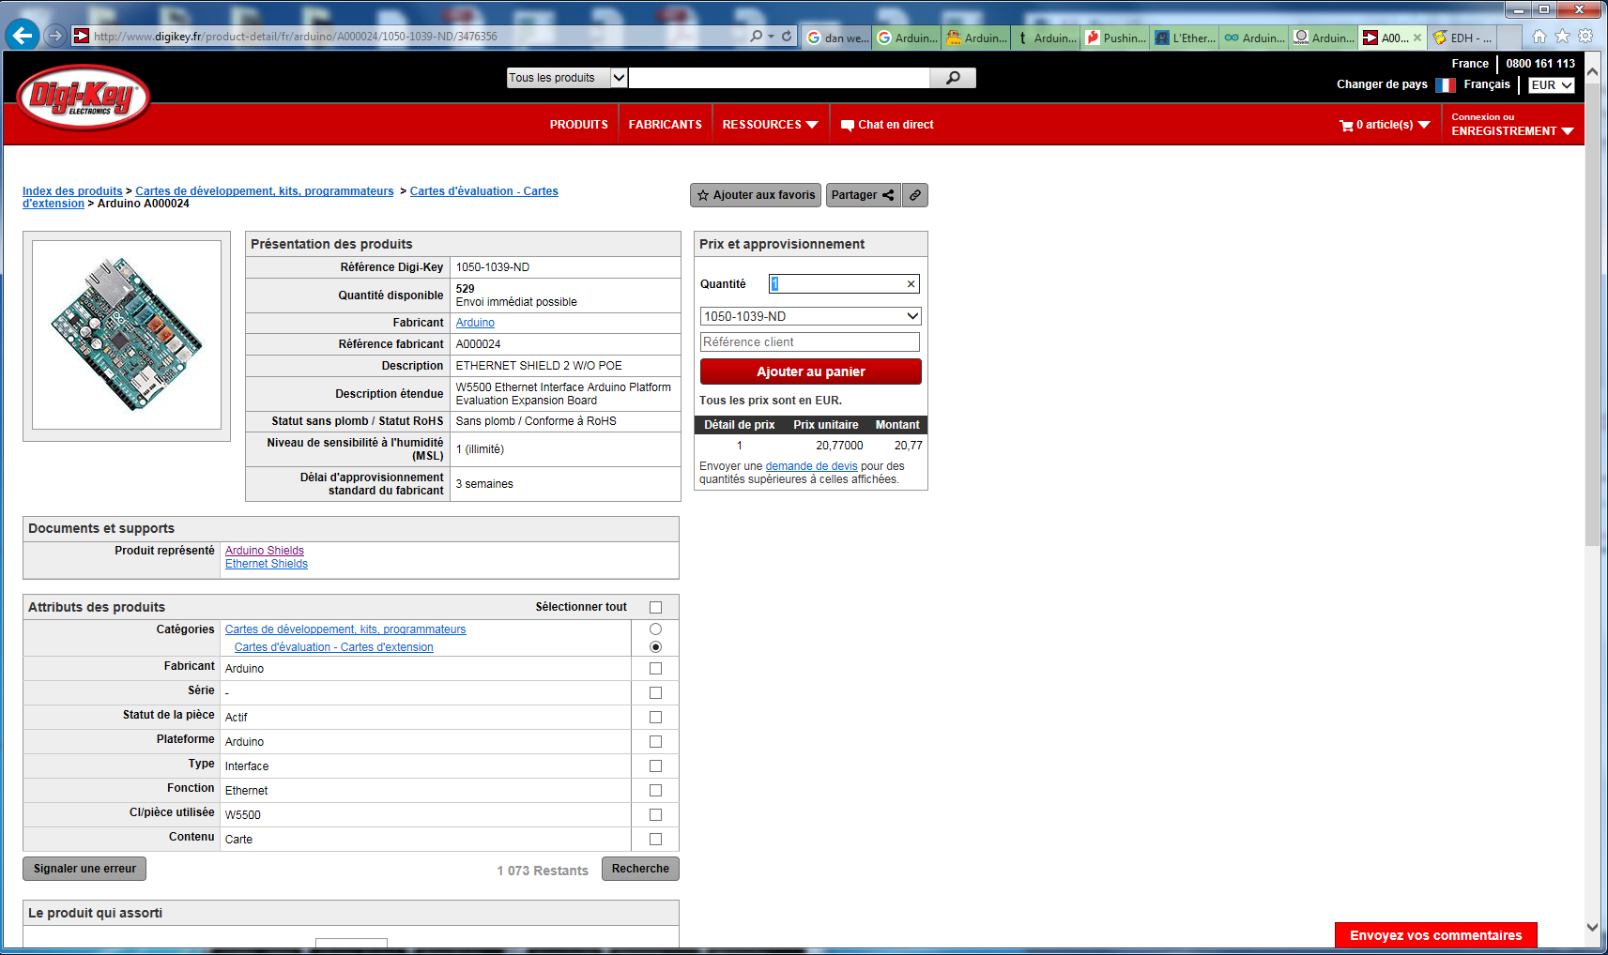

RS Online

http://fr.rs-online.com/web/p/kits-de-developpement-pour-processeurs-et-microcontroleurs/8732294/

