***Integration of high eta RPCs RE3/1 & RE4/1 in CMS***

**5.5.6 Installation and integration**

**5.5.6.1 Mechanical aspects**

The RE3/1 chambers will be mounted on the YE3 steel as shown in the figure 5.32. They will overlap the circular neutron shielding (18 trapezoids) attached to the YE3 and reach the cylindrical neutron shielding surrounding the collar that separates the yokes YE2 & YE3.

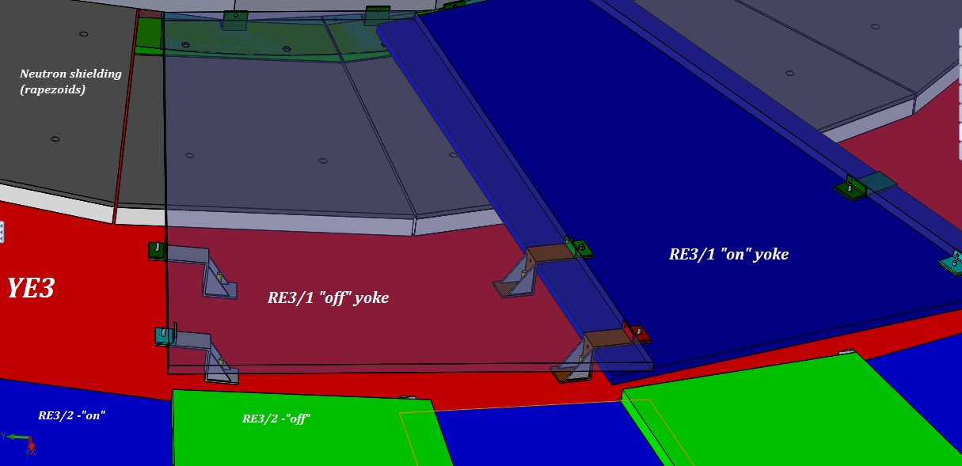

Figure 5.32: Schematic view of the mounting of RE3/1 chambers on the YE3 steel plate.

The chambers will be mounted directly to the yoke. Using the foreseen mounting points threaded into the yoke steel. Allowance for sagitta in the yoke with applied “B” field will be made using simplified kinematic mounts. The screws and washers securing the neutron shielding will be modified to make them flush with the outer lead part of the shield so increasing the available space in “Z”. Equally the CSC alignment system will be decommissioned to give space for the chambers over the neutron shielding.

For RE4/1 the mounting is quite different as they mount to the same side of YE3 as the ME4s taking advantage of the CSC mounting posts which will be extended with large M24 studding. To these supports will be built a thin light weight frame made from aluminium alloy 8mm thick. The chambers are then screwed to this frame. This configuration is similar to that used for the RE4/2 & RE4/3 but the smaller frames and chambers are mounted separately.

Access for both chamber installation and commissioning of RE4/1 will necessitate the “push back” of the YE4 from the YE3. The negative end has been already operated but the positive end has yet to be commissioned. As the services will be behind the already installed chambers, their installation must be completed during the LS2 prior to the installation during YETS 21-22 and 22-23.

**5.5.6.2 Power System**

The High Voltage power system for the new chambers will make use of the same components as the actual system. However unlike the present RPC Endcap HV system, one upgrade RE3/1 or RE4/1 chamber will be connected to one HV channel, therefore 72 channels or 12 HV boards, distributed equally in 4 new Easy3000 crates, will be needed. Eight HV Distribution boards, with 9 active and 1 spare channel each, will be used to split the power of each HV channel into 2 lines supplying power to the Top and Bottom chamber HV layers independently. Eight umbilical cables with 10 two-core cables inside will be necessary to link the USC Power Supplies to the UXC via the Main Cable Chains situated in the UXC. There will be a HV Patch panel (YE1 PP) located in the Experimental cavern (UXC). The USC-UXC connection for the upgrade chambers at the YE1 PP was already foreseen in the initial PP design. From there, single channel HV cables will go through the mini Cable Chains to reach the YE3 where they will be distributed around the peripheral cable trays to both stations. Numerous CPE Jupiter and tri-polar connectors will be demanded to realise the multiple connections from the HV boards up to the RPC chambers (see Table 5.3).

The RE3/1 and RE4/1 LV power system will be an extension of the present RPC LV system, located mainly in UXC, powered, and controlled through CAEN A1676A branches from the USC rack S4F03. However, for cost and rack space optimization, the powering schema of the upgrade chambers will differ from the one of the actual detector. To supply the LV power to the front-end electronics (FEB) we will replace the 12-channel, 8V/45W per channel, CAEN A3009 boards with 6-channel, 8V/90W per channel, CAEN A3016 LV boards. In addition, 2 A3016 channels will power three 20deg chambers, instead of two 10deg chambers as at present 2 CAEN A3009 channels do, in an optimal regime of operation of about _70% of max power. This will provide excellent segmentation as one A3016 LV board will power 180deg in phi coverage, therefore 2 boards per end and station or 8 boards in total will be needed. Those boards would require 4 new Easy3000S crates to be installed at the four corner towers of the endcap detector (positive near, positive far, negative near, negative far) and additional 2 branches in the Endcap LV mainframe in rack S4F03, to control the newly installed equipment for the upgrade equipment in the entire RPC LV system.

Lack of rack space and optimisation of costs may dictate that the very same racks and easy crates of the present RPC LV system (already in UXC: X3A51, X3S51, X3J51 and X3V51) will be used to power the new chambers. This implies a redesign of the entire LV system by regrouping the existing LV power cables into a smaller quantity of A3009 LV channels in order to liberate slots for 2 A3016 boards per crate so accommodating the entire upgrade equipment into the present RPC LV system.

Tables 5.3 and 5.4 summarize the number of components for each system respectively.

Equipment Quantity

CAEN easy3000 crates 4

48V service cables 8

Anderson connectors for service power 32

CAEN A3512N HV boards per crate 3

Total number of CAEN A3512N HV boards 12

HV coaxial cables 80

Jupiter connectors female for coaxial cables 160

HV distribution boards 8

HV Jupiter connectors 400

Umbilical cables (8 needed, 1 inherited from GEM during LS2) 7

HV CPE tri-polar connectors 232

HV cables 72

Table 5.3: HV system equipment for the RE3/1 and RE4/1 project.

Equipment Quantity

CAEN EASY3000S crate 4

CAEN A1676A branch controller 2

CAEN A3016 board per create 2

Total number of CAEN A3016 board 8

Table 5.4: LV system equipment for the RE3/1 and RE4/1 project.

**5.5.6.3 UXC and USC Rack space**

Although the racks on YE3 are largely occupied there is space for re-cabling the LV system, DCS and associated FO patch panels. The two RPC gas racks are on X2 far. The RE3 gas racks have 12 spare channels for both the RE3/1 and RE4/1 chambers with 1 channel per 60 degrees.

The trigger system including fibre optic cable patch panels will be required in the trigger

racks in the USC. Additional racks will be required adjacent to the S1F01 to 05 racks. Space is

available in S1F06 adjacent to the present trigger system. If necessary space is also available in

a rack (S1F00) closer to UXC. The HV power modules CAEN A3512N will be installed in an additional rack at the end of the present USC RPC HV rack row.

**5.5.6.4 Readout system**

The data and control from the chambers is achieved by fibre optics rather than by copper cable as used in the present system.

Given the few channels required for these fibre optic cables, they can be installed by hand as per the

Trigger LB system in two of the six transfer channels between USC and UXC.

**5.5.6.5 Cable routing**

Services will transit through the gap formed by the RE3 rear face and the YE3. Trials have been performed that confirm that this is possible between these two smooth uninterrupted surfaces. This solution is preferable to installing services over the top of the presently installed RE3/2 & RE3/3 chambers as this would hinder access and removal of same. Running these services behind the chambers will require their installation prior to the chambers, meaning that installation should be done during LS2 prior to chamber installation in the following YETS.

The services are planned to be placed in ducts between the RE4 SMs and ME4s. They will be fed through the ample gap from the inner radius of RE4/2 towards the peripheral cable trays. This scenario will be facilitated and quickened if it remains scheduled to coincide with the change of the FE electronics on the CSCs. Concerns of induced noise in the CSCs from the RPC services will be dealt with by joint CSC/RPC discussions and appropriate remedial action taken such as specific cable specification.

Figure 5.33: Picture showing the available space for RPC services between CSCs and RE4s chambers.

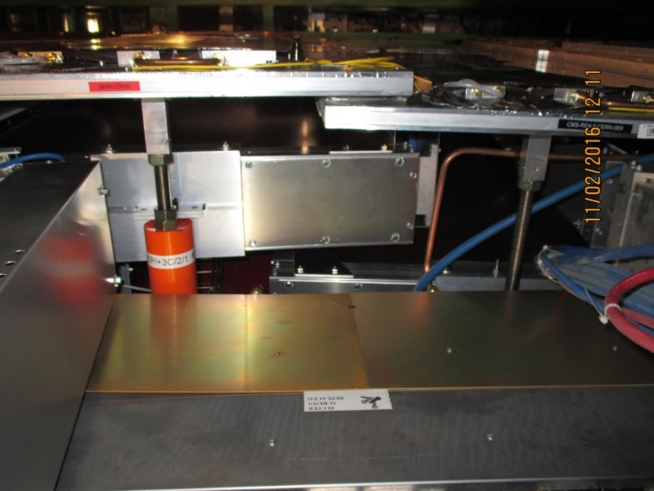

Although the Main Cable Chains are quite full the near side (+X) chain has sufficient space for the HV and fibre optic services. The 8 umbilical HV cables and Fibre optics will fit in the 4 Main Cable Chains. Optical fibres will go through the two FO transfer channels, between the USC and UXC, leading to the base of the main cable chains in the UXC.

**5.5.6.6 Gas System**

The gas mixture is identical to the present system. The only modification will be downstream of the UXC distribution racks. New piping and bulkheads will have to be installed around the yoke on the non IP side of the yoke for RE4/1. The presently installed piping foreseen for the original RE3/1 will have to be modified as it occupied all 12 channels on the rack. The bulkheads are in position on the yoke periphery. Their mapping will need modifying. All piping from bulkheads to the chambers will be required. Impedances, as used in RE4 SM system, will be installed on the peripheral structure to ensure a parallel flow to each chamber.



**5.5.6.7 Cooling System**

The cooling system specification is a function of the electrical power distributed into the UXC cavern. Technical Coordination have requested that all electrical load be cooled, meaning that the minimum heat load should go into the cavern ventilation system. The chamber loads are significantly less than in the previous RPC chambers. Nonetheless the chambers and rack elements will be cooled by circulating water from the Endcap cooling circuit. The relatively small load can be accommodated by branching off from the present system.

|  |  |  |  |  |  |  |
| --- | --- | --- | --- | --- | --- | --- |
|  |  |  |  |  |  |  |
| **Power dissipation for PetiRoc with integrated TDC** | | | | | |  |
|  |  |  |  |  |  |  |
| Channel | Chamber | FPGA+GBT | 1 station | 1 YE3 | Rack Power | PetiRoc Dissipation |
|  | 384 | 20 + 1W | 18 |  | Eff 66% |
| [mW] | [watt] | [W] | [W] | [W] | [W] | [W] |
| 6 | 2.304 | 21 | 419 | 839 | 432 | 1271 |
|  |  |  |  |  |  |  |
| One Endcap Power | |  |  |  |  | 1271 |
|  |  |  |  |  |  |  |
|  |  |  |  |  |  |  |
|  |  |  |  |  |  |  |
|  |  |  |  |  |  |  |
|  |  |  |  |  |  |  |

Table 5.6: Expected power dissipation for PetiRoc with integrated TDC for RE3/1 and RE4/1 chambers

This value of dissipated power is approximately 10% of the total power dissipated on YE3s. This power should increase the coolant temperature by approx. 0.1deg C. The RE3/1 chambers will be cooled as planned in 2005 by extending the circuit of 2 of the RE3/2s to one RE3/1 chamber. Given the fragility of the cooling circuits on the RE4 SMs separate cooling circuits will be taken off the present mini manifold using tee connections and flow restrictors to equalise the flow in these parallel circuits.

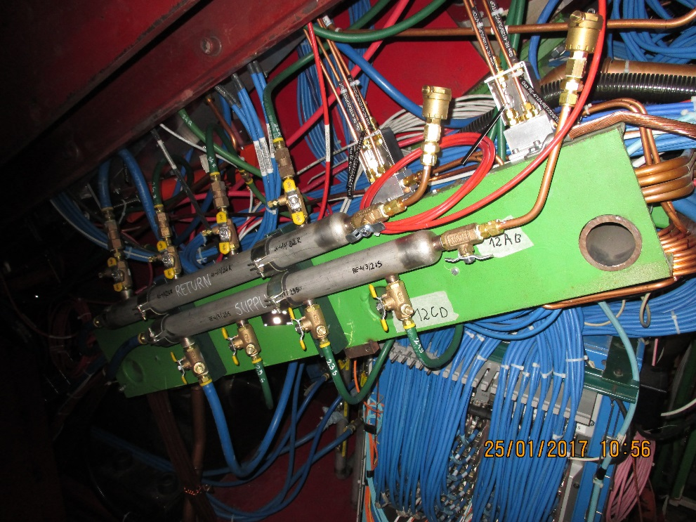

Figure 5.33: Picture showing the mini manifolds from where the RE4/1 chambers will be cooled by adding parallel circuits.