***Integration of high eta RPCs RE3/1 & RE4/1 in CMS***

**5.1 Mechanical aspects**

**5.1.1 Description of the RE3/1 location and mounting**

The RE3/1 chambers will be mounted on the YE3 steel as shown in the figure 5.1. They will overlap the circular (18 Trapezoids) neutron shielding attached to the YE3 and reaching the cylindrical neutron shielding surrounding the collar that separates the yokes YE2 & YE3.

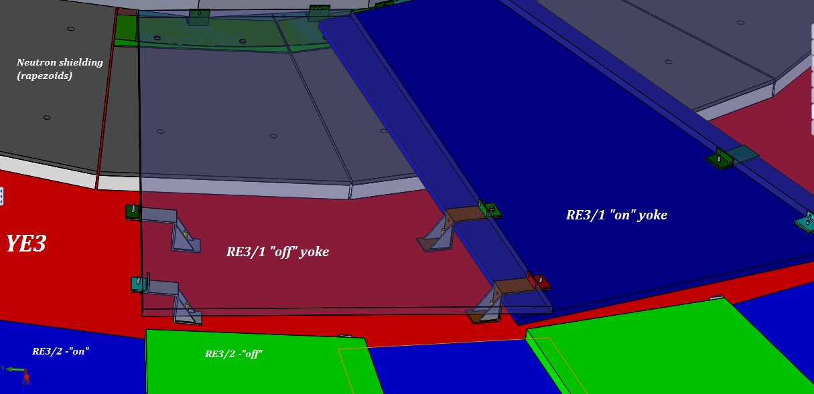

The chambers will be mounted directly to the yoke. Using the foreseen M12s threaded into the yoke steel. Allowance for sagitta in the yoke will be made using a simplified kinematic mounts.

The screws and washers securing the neutron shielding will be modified to make them flush with the outer lead part of the shield so increasing the available space in “Z”.

**5.1.2 Description of the RE4/1 location and mounting**

Here the mounting is quite different as they mount to the same yoke as the ME4s taking advantage of the CSC mounting posts which will be extended with large M24 studding. To these supports will be built a thin light weight frame, in 30 segments, made from aluminium alloy 8mm thick. The chambers are then screwed to this frame.



Access for both chamber installation and commissioning will necessitate the “push back” of the YE4 from the YE3. The schedule dictates that services will be installed prior to the LS2 during the YETS.

**5.2 Power System**

An identical extension of the actual HV system will be built. The HV power modules CAEN A3512N will be installed in an additional rack at the end of the present USC RPC HV racks. This will necessitate the installation of 4 more umbilical cables from the USC to the UXC connecting via the YE1 Patch Panel (PP). From the main YE1 HV PP, where there is space in the present panel, the single channel cables will go through the Mini Cable Chains (MCC) to the YE3 where they will be distributed around the peripheral cable trays.

Optimisation of costs dictates that the same Easy crates and LV modules already in UXC will be used to power the new chambers. Re-cabling in front of the LV modules will be done in order to liberate the two modules required. Service Power and Communication bus for these crates, through the A1676A Branch controllers, is done from the USC X4F03 rack.

Space in the USC S1F06 rack will be used for the trigger system.

Table of HV modules ??

**5.3 Cable, Fibre and Pipe Routing**

**5.3.1 RE3/1**

Trials have been performed to show that both cable and piping services can be routed between the Yoke and rear face of the chambers both of which are smooth uninterrupted surfaces. This solution is preferable to installing services over the top of the presently installed RE3/2 & RE3/3 chambers as this would hinder the access and removal of same. Running these services behind the chambers will require their installation prior to the chambers, meaning that installation should be done during the preceding YETSs.

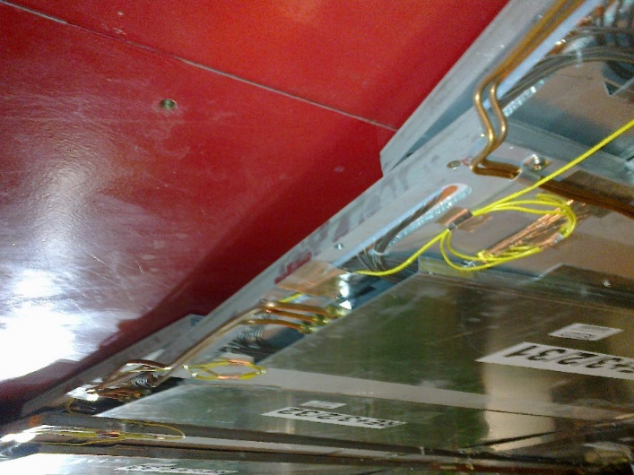

**5.3.2 RE4/1**

The services are planned to be placed in ducts between the RE4 SMs and ME4s. They will be fed through the ample gap from the inner radius of RE4/2 towards the peripheral cable trays. This scenario will be facilitated and quickened if it is scheduled to coincide with the change of the FE electronics on the CSCs.

Concerns of induced noise in the CSCs from the RPC services will be dealt with by joint CSC/RPC discussions and appropriate remedial action taken such as specific cable specification.

Diagram illustrating cross-sections available for services between the CSCs and RE4s.

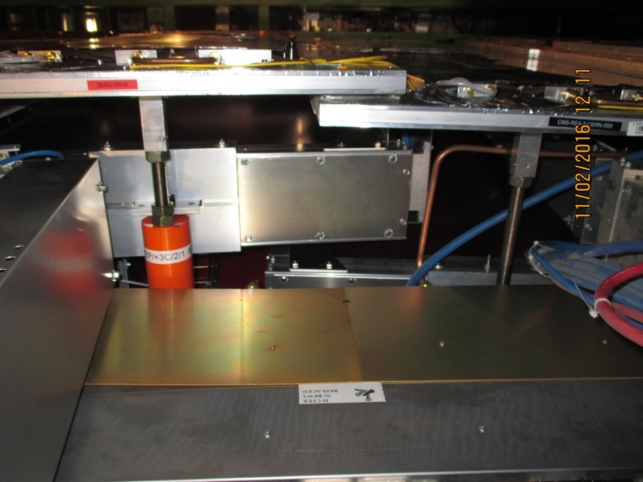

**5.3.3 Main and Mini Cable Chains**

Although the mini cable chains a quite full the near side chain has sufficient space for the HV and Fibre optic services to transit here.

The 2 umbilical HV cables and Fibre optics will fit in two of the four the main cable chains.

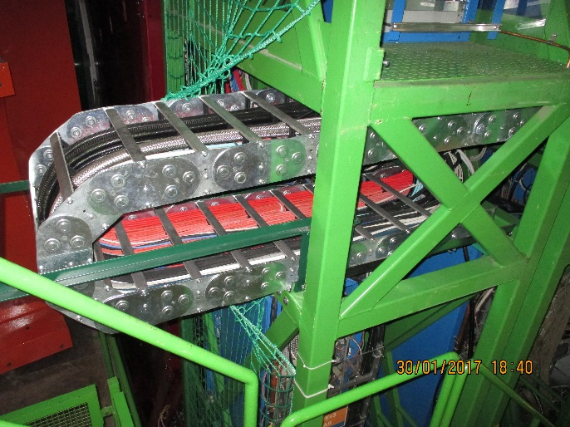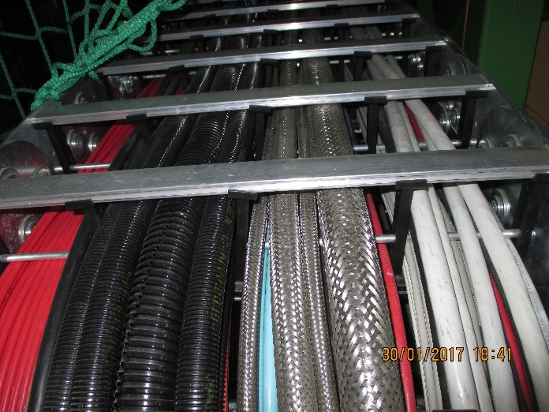

Table with cross sections ?.

Optical fibres will be used for the trigger system …….. There is sufficient space to go through the two Fibre Optic passages leading to the base of the Main cable chains in the UXC.

**5.6 Gas System**

The gas mixture is identical to the present system. The only modification will be after the UXC distribution racks.

New piping and patch panels will have to be installed around the yoke on non IP side of the yoke for RE4/1. The presently installed piping foreseen for RE3/1 will have to be modified as it used all 12 channels on the rack. The PP are in position on the yoke periphery. Their mapping will need modifying.



**5.7 Cooling System**

The cooling system specification is a function of the electrical power distributed into the UXC cavern. Technical Coordination have requested that all electrical load be cooled, meaning that the minimum heat load should go into the cavern ventilation system. The chamber loads are significantly less than in the previous RPC chambers. Nonetheless the chambers and rack elements will be cooled by circulating water from the Endcap cooling circuit. The relatively small load can be accommodated by an extension of the present system.



This value of dissipated power is approx. 10% of the total power dissipated on both YE3s. This power should increase the coolant temperature by approx. 0.1deg C.

Given the fragility of the cooling circuits on the RE4 SMs separate cooling circuits will be taken off the present “mini manifold” using tee connections and flow restrictors to equalise the flow in these parallel circuits.

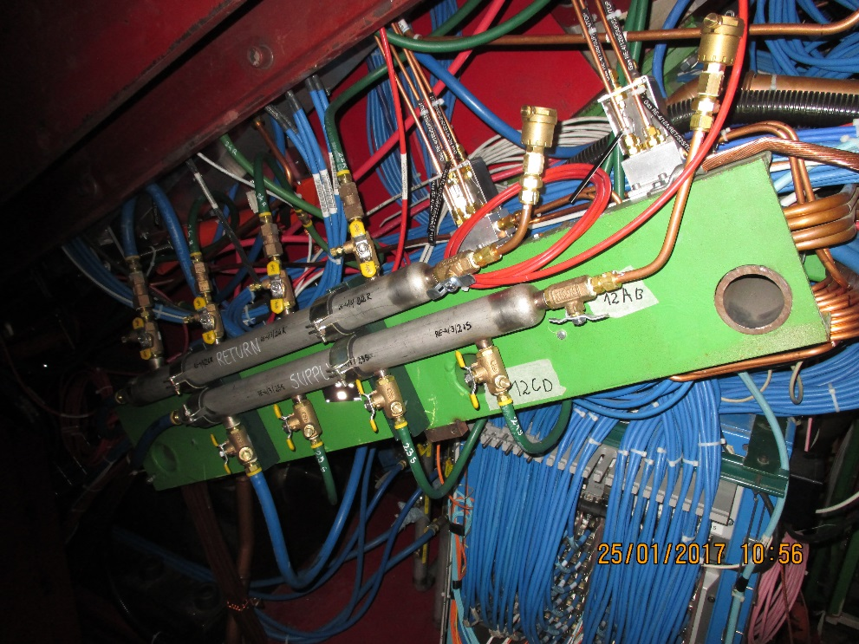

The RE3/1 chambers will be cooled by extending the RE3/2 chamber cooling piping.