***Integration of high eta RPCs RE3/1 & RE4/1 in CMS***

**5.1 Mechanical aspects**

**5.1.1 Description of the RE3/1 location and mounting**

The RE3/1 chambers will be mounted on the YE3 steel as shown in the figure 5.1. They will overlap the circular (18 Trapezoids) neutron shielding attached to the YE3 and reaching the cylindrical neutron shielding surrounding the collar that separates the yokes YE2 & YE3.

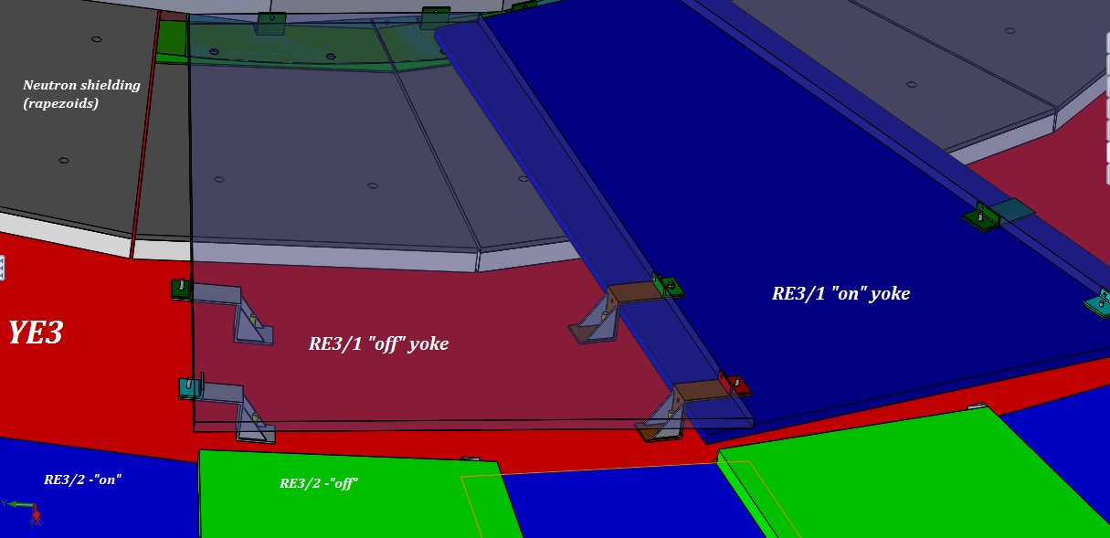

The chambers will be mounted directly to the yoke. Using the foreseen M12s threaded into the yoke steel. Allowance for small sagitta in the yoke will be made using a simplified kinematic mounts.

The screws and washers securing the neutron shielding will be modified to make them flush with the outer lead part of the shield so increasing the available space in “Z”.

**5.2.2 Description of the RE4/1 location and mounting**

Here the mounting is quite different as they mount to the same yoke as the ME4s taking advantage of the CSC mounting posts which will be extended with large M24 studding. To these supports will be built a thin light weight frame, in 30degree segments, made from aluminium alloy 8mm thick. The chambers are then screwed to this frame.

Drawing/ schematic of the mounting plate to which the RE4/1 chambers will be screwed.



**5.2.3 ”B” field constraints**

The “Z” space occupied by both RE3/1 and RE4/1 is both modified and displaced, in ”Z”, when the CMS magnet is energised. Calculations and measurements already done indicate that the displacement will be in the order of 12mm and the change in the space between the yokes will be deformed by 2mm. To be verified.

**5.2.4 Alignment**

The special resolution of the chambers is significantly improved over the other RPCs and so will require alignment to CMS. As there is only limited provision for the alignment of the chambers during installation tracks will be used from the CSCs in order to ensure …… To be verified.

**5.3 Power System**

**5.3.1 High Voltage**

The HV power modules CAEN A3512N will be installed in the present USC RPC HV racks. There is sufficient space for this installation. To be verified. This will necessitate the installation of 4 more umbilical cables from the USC to the UXC connecting via the YE1 Patch Panel (PP). From the main YE1 PP, where there is space in the present panel, the single channel cables will go through the Mini Cable Chains (MCC) to the YE3 where they will be distributed around the peripheral cable trays.

(This is not a viable option, IO is working on an alternative for the Main Cable Chain, see routing chapter, but the Mini Cable Chains may be able to absorb the extra load/section.

**5.3.2 Low Voltage**

LV CAEN A3016 modules will be located in the UXC on the X3 level, two in each tower. Optimisation of costs dictates that the same Easy crates and LV modules already present will be used to power the new chambers. Re-cabling in front of the LV modules will be done in order to liberate the two modules required. Service Power and Communication bus for these crates, through the A1676A Branch controllers, is done from the USC X4F03 rack.

Add table of required modules

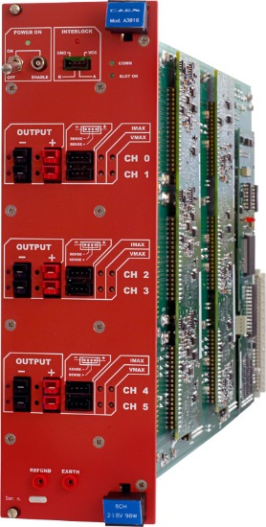

**5.3.3 Rack location**

**5.3.3.1 UXC55 racks**

The racks on YE3 are largely occupied. Space is required for the LV system, DCC and associated FO patch panels. The two RPC gas racks are on X2 Far. The RE3 rack has sufficient 12 spare channels for the RE3/1 and RE4/1 chambers with 1 channel per 60degrees.

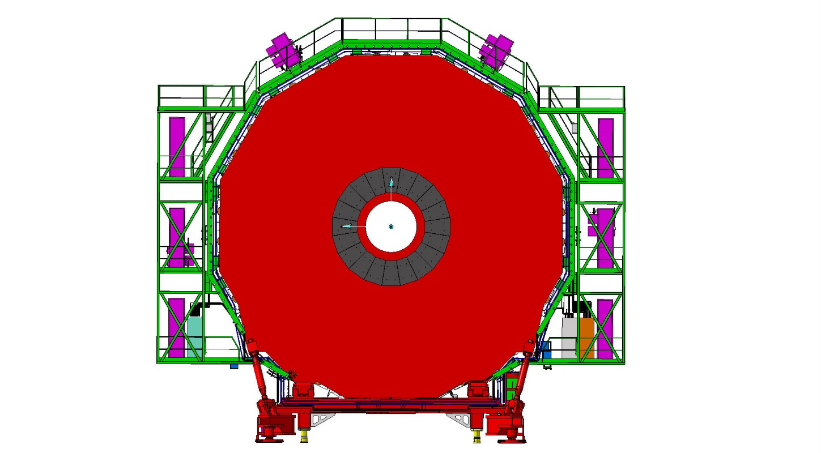

Gas Rack X2 Far spare channels

LV rack X3

LV rack X3

**5.3.3.2 USC55 racks**

Additional racks space is required for the HV and Data/control functions in the USC. The LV system is controlled through the A1676A modules presently located in the X4F03 rack in the USC.

The Trigger system including Fibre optic cable patch panels will be required in the Trigger racks in the USC. Additional racks will be required adjacent to the S1F01 to 05 racks. Space is available in S1F06 adjacent to the present Trigger system. If necessary space is also available in a rack (S1F00) closer to USC.

**5.4 Readout and Control**

The data and control from the chambers is achieved by fibre optics rather than by copper cable. Given the few channels required for this FO cables can be installed by hand as per the Trigger LB system in two of the six channels between USC and UXC.

**5.5 Cable, Fibre and Pipe Routing**

**5.5.1 RE3/1**

Trials have been performed to show that both cable and piping services can be routed between the Yoke and rear face of the chambers both of which are smooth uninterrupted surfaces. This solution is preferable to installing services over the top of the presently installed RE3/2 & RE3/3 chambers as this would hinder the access and removal of same. Running these services behind the chambers will require prior installation to the chambers, meaning that installation should be done during the preceding EYETSs.

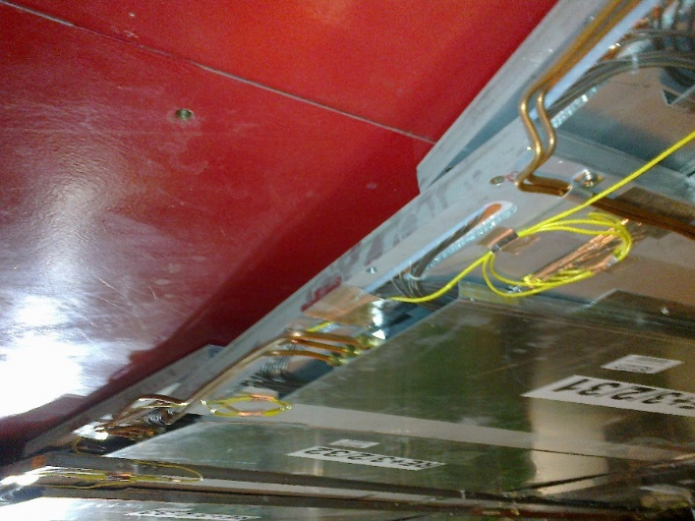

**5.5.2 RE4/1**

Although the job is more fastidious the RE4 SMs will remain in place which is far better bet than disconnecting all the services and removing all the chambers.

Services will be routed between the CSC and RPC chambers where there is plenty of space. Specific cabling specification is required to ensure the RPCs do not create noise problems for the CSCs. More care will be taken to mount cable and pipes to ensure that we are within the RPC volume given by the RE4 SMs.

Diagram illustrating cross-sections available for services between the CSCs and RE4s.

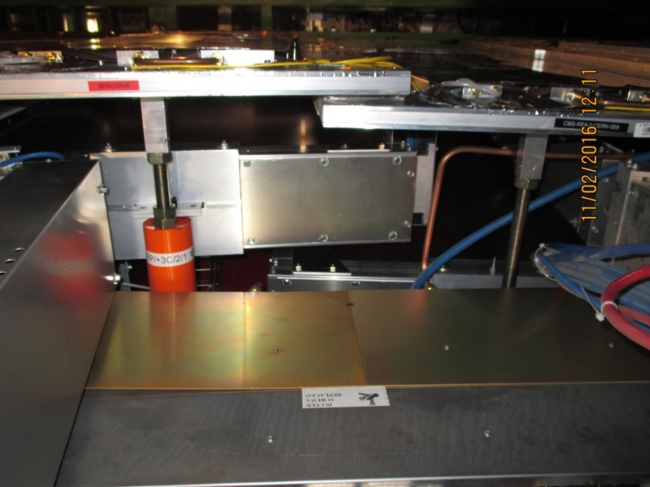

**5.5.3 Main Cable Chains**

The main cable chains are extremely full. The need for 2 umblical HV cables in each is XXXXXX

To be verified

**5.5.4 Mini Cable Chains**

Although the mini cable chains a quite full the near side chain has sufficient space for the services to transit here.

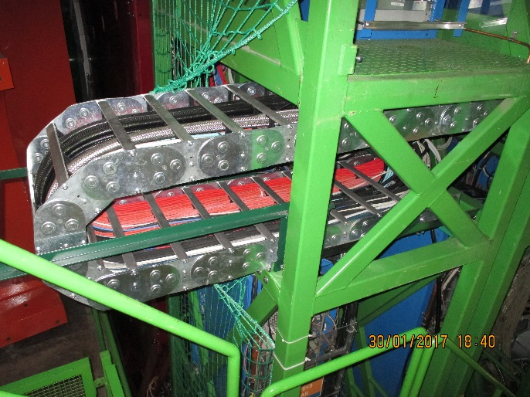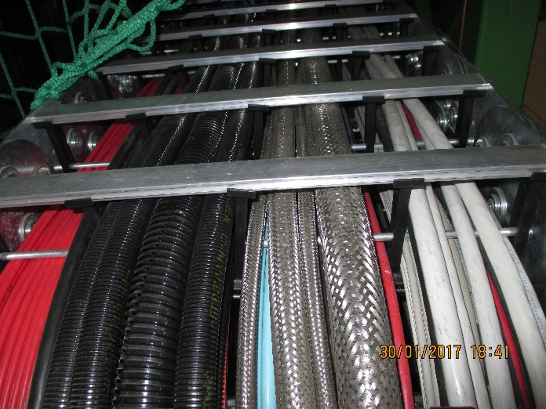

Table with cross sections.

To be verified

**5.5.5 Fibre ducts between USC and UXC**

Table with

There are 6 ducts that are dedicated for FO routing between the USC and UXC. The route taken is shorter than that of other services. This is necessary for the trigger system …….. There is sufficient space to go through the two leading to the base of the Main cable chains in the UXC

**5.6 Gas System**

**5.6.1**

The gas mixture is identical to the present system but will not go through the SGX humidifier.

Gas Mixture C2H2F4/isoButane/SF6 (95 : 4.7 : 0.3)

A single 22mm pipe will be taken from the SGX to the UGX and on through the Main Cable Chains to the UXC. This pipe will go through the Mini Cable Chains to YE3. The gas distribution system will be located on the X2 Far RE3 rack where sufficient channels are available. An additional manifold will be added to the rack rather than modifying the supply piping. Return is through the present return manifold to join the humid gas system.

New piping and patch panels will have to be installed around the yoke on non IP side of the yoke for RE4/1. The presently installed piping foreseen for RE3/1 will have to be modified as it used all 12 channels on the rack. The PP are in position on the yoke periphery. Their mapping will need modifying.



**5.7 Cooling System**

**5.7.1**

The cooling system specification is a function of the electrical power distributed into the UXC cavern. Technical Coordination have requested that all electrical load be cooled, meaning that the minimum heat load should go into the cavern ventilation system. The chamber loads are significantly less than in the previous RPC chambers. Nonetheless the chambers and rack elements will be cooled by circulating water from the Endcap cooling circuit. The relatively small load can be accommodated by an extension of the present system. TO BE VERIFIED.



This value of dissipated power is approx. 5% of the total power dissipated on both YE3s

To be verified 11kW/YE3 or 22kW for both YE3s

Proposed schematic of extended cooling for RE3/1.

**5.7.2 The RE4/1 cooling system**

Given the fragility of the cooling circuits on thw RE4 SMs separate cooling circuits will be taken off the present “xmas trees” using “Ts” and flow restrictors to equalise the flow inb the parallel circuits.

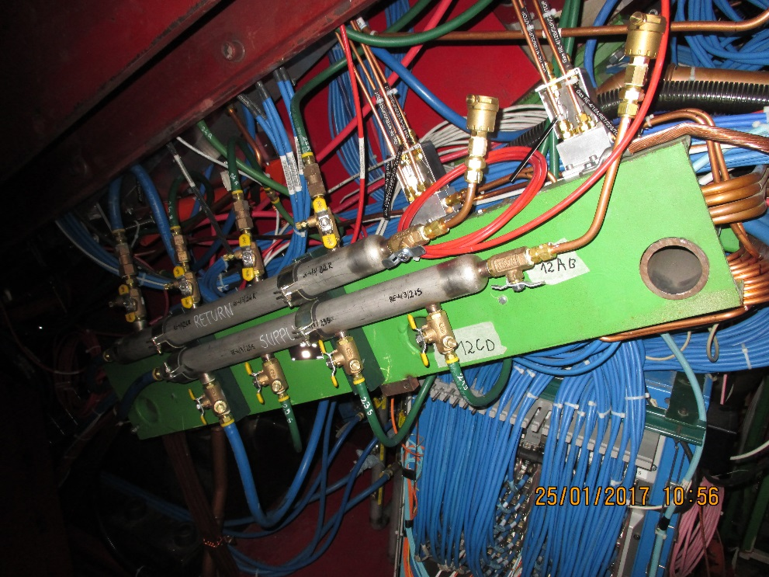3.5 pages for GEM !

**5.8 Installation and Commissioning**

**5.8.1**

The installation of the chambers will be accomplished by slinging the chambers off the crane as was done for RE4. Those chambers under the beam pipe will be done with forklift truck. To be verified.

Specific transport trollies will be necessary to vehicle the chambers form the final QC in 904 to CMS by road. Sufficient vibrational protection will be afforded by the use of trucks equipped with pneumatic suspension limited to 60km/hr.

Access for both chamber installation and commissioning will necessitate the “push back” of the YE4 from the YE3. The negative end has been already used but the positive end has yet to be commissioned.

The schedule dictates that services will be installed prior to the LS2 during the EYETS. During the LS2 all other works……….

To be verfiied