**Q45.**  iRPCs:

Detailed information     and about the QA/QC procedures is needed.

**This point should also be improved in the TDR.**

**RPC: (1)** add a brief answer here and

          (2) update TDR to include a section on iRPC QA/QC (state here it is done, once done)

**Answer:**

The QA/QC in iRPC will follow a similar protocol to the one applied in RE4 production in 2010.

4 level of QC will be applied: chamber components, HPL gaps, Chamber validation in construction site, long term chamber validation at CERN before installation. For each of them a precise acceptance protocol will be defined and applied in the involved sites during mass production. All collected data will be recorded in a Construction DB, always accessible online by all RPC collaboration members.

QC1 level will be applied to basic chamber components: HPL resistivity level, selection of gas pipes, unions, HV/LV/signal connectors/cables, cooling pipes/elements. For HPL it will be done avisual inspection, it will be controlled the level and uniformity of resistivity in the production site. For all the other components there will be a visual inspection and the production batch will be recorded in construction DB.

QC2 will be applied to chamber elements: HPL gaps, cooling circuit. For HPL gaps several parameters will be recorded during and after the mass production: visual inspection, gas leaks and spacer gluing, resistivity and dark current. For cooling circuits a pressure test will be performed with defined max leak rete as pre-agreed with CMS Cooling team.

QC3 will be applied to full chamber soon after production in 2 steps. QC3.1(Chamber assembly tests) will be performed: visual inspection, cooling circuit test, connectivity tests, electrical test (LV, threshold). QC3.2(Chamber cosmic tests) will be performed: dark current (in first 24h, at different HV, ohmic current), cosmic ray test measurements (efficiency, mean clustes size, noise rate, dark current in operation).

Once the chamber is received at CERN, the QC4 final validation test will be performed to secure that no effect was due to transport and to validate the chamber long term performance. Again 2 levels of QC will be applied. QC4.1 (Final Chamber tests), meaning: Connectivity, electrical, leak (gas/cooling) and dark current tests. QC4.2 (Stability long term tests), meaning: dark current monitored for 2 weeks.

**TDR sentence (only the first sentence in the answer):**

The QA/QC in iRPC will follow a similar protocol to the one applied in RE4 production in 2010.

4 level of QC will be applied: chamber components, HPL gaps, Chamber validation in construction site, long term chamber validation at CERN before installation. For each of them a precise acceptance protocol will be defined and applied in the involved sites during mass production. All collected data will be recorded in a Construction DB, always accessible online by all RPC collaboration members.

**Q46.**iRPC Quality Control

The roadmap towards the final prototype and production of the detectors should be detailed a bit further. More precise information on the expected Quality Controls would be beneficial as the new chamber are different in many ways from the legacy RPCs.  The committee notes that aspects like gas leaks etc. rely on the good experience in the production of the earlier Endcap chambers with no extra detail.

**RPC:** answer the question (note a partial overlap with Q45)

**Answer:**

Roadmap towards the final prototype and production of the detectors….

As stated in previous answer the QA/QC in iRPC will follow a similar protocol to the one applied in RE4 production in 2010.

4 level of QC will be applied: chamber components, HPL gaps, Chamber validation in construction site, long term chamber validation at CERN before installation. For each of them a precise acceptance protocol will be defined and applied in the involved sites during mass production. All collected data will be recorded in a Construction DB, always accessible online by all RPC collaboration members.

Concerning possible differences with previous RPC production for Endcap and Barrel, the iRPC are very similar to the CMS previous RPC endcap chamber, a part of the new HPL panel thickness (1.4mm instead of previous 2.0 mm) and the type of strips and electronics.

HPL different panel thickness will demand additional care in HPL gap manufacturing QC1, and gap manufacturing QC2. The strips and electronics will follow specific QC1 as done for previous chamber prouctions.

No change will be applied in term of gas piping inside the chamber wrt previous CMS endcap RPC chambers, so similar performance in term of negligeable gas leaks are expected, following a similar gas leak QC protocol.

The RPC suffering severe leaks in CMS are those in the barrel. These chambers have significant larger dimension wrt endcap ones. This was forcing to split gap for the same layer in 2 elements and consequently additional link gas pipe elements were needed (T and I shape). Unfortunately, it turn out that these components were quite fragile in long term stability and today they cause the major element of leak in the CMS RPC barrel chambers. Being inside the chamber these elements are accessible only with chamber extracted from CMS yoke structure. This reduced accessibility is significantly slowing down their curing possibilities.

These components are NOT needed/present in the CMS RPC endcap chambers and will NOT be used in iRPC chambers.

**Q47.**iRPC gas-tightness.  It would be desirable to see an explicit list of components (e.g. in the gas supply manifold) which are the main source of leaks in the existing RPCs, and an explanation for how these components are being avoided/substituted in the iRPCs. In addition, will there be a more extensive leak-checking campaign before & during installation?

**RPC:** answer the question (illustrate the list with pictures)

**Answer:**

As already stated in previous 2 questions, for what concerning the gas leak tests, as done for CMS endcap RE4 chamber production, we will start the QC at level of QC1 securing the selection of the right material for gas pipes, inlets and unions for patch panel. In QC2 we will check the tightness at level of gap production applying validation criteria defined in term of max leak rate acceptance 5x10-7 mbar l/s. The QC will follow after the chamber construction in the assembly sites, applying the same acceptance test during the QC3 and during long term validation test at CERN during QC4. All these controls will secure that no leak has been created during the HPL gap/chamber transport and manipulation in different labs.

With this QC protocol during the RE4 production we have secured ALL the constructed chambers to suffer NO leak during QC4 and in CMS, successfully running now for 4 years.

Similar stable performance were obtained in the older CMS RPC endcap chambers, running since 10 years now.

As explained in the answer to Q46, the gas leak in CMS RPC is happening in the RPC Barrel chambers. They were demanding additional components (not used in the endcap chambers) in order to join 2 adjacent gaps in the same chamber layer (see Upper Gap Back and Front in fig1). This action was demanded because of the significantly larger dimension of barrel chambers wrt endcap ones.

Here in the following some technical drawings of the CMS RPC barrel and endcap chambers, showing the major differences in the gas distribution inside the barrel chamber mechanical structure. The weak element is the so called T-Connector, visible in the Barrel chambers and completely absent in the endcap chambers.

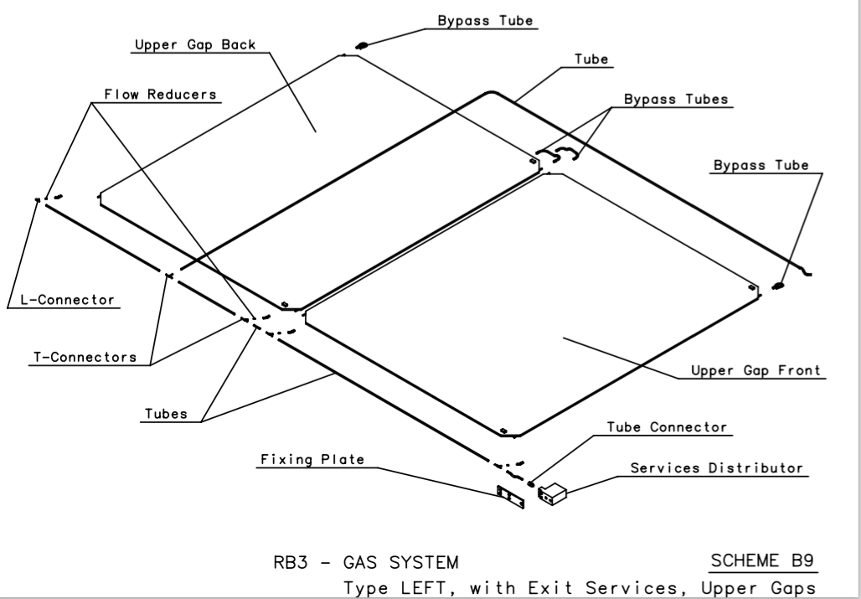

Fig1. CMS RPC Barrel chamber internal gas distribution schematic.

Fig2. CMS RPC Endcap chamber internal gas distribution schematic.