ME-3 Layout Phi and on off locations original file “alldisks-allchambers-may07_03”

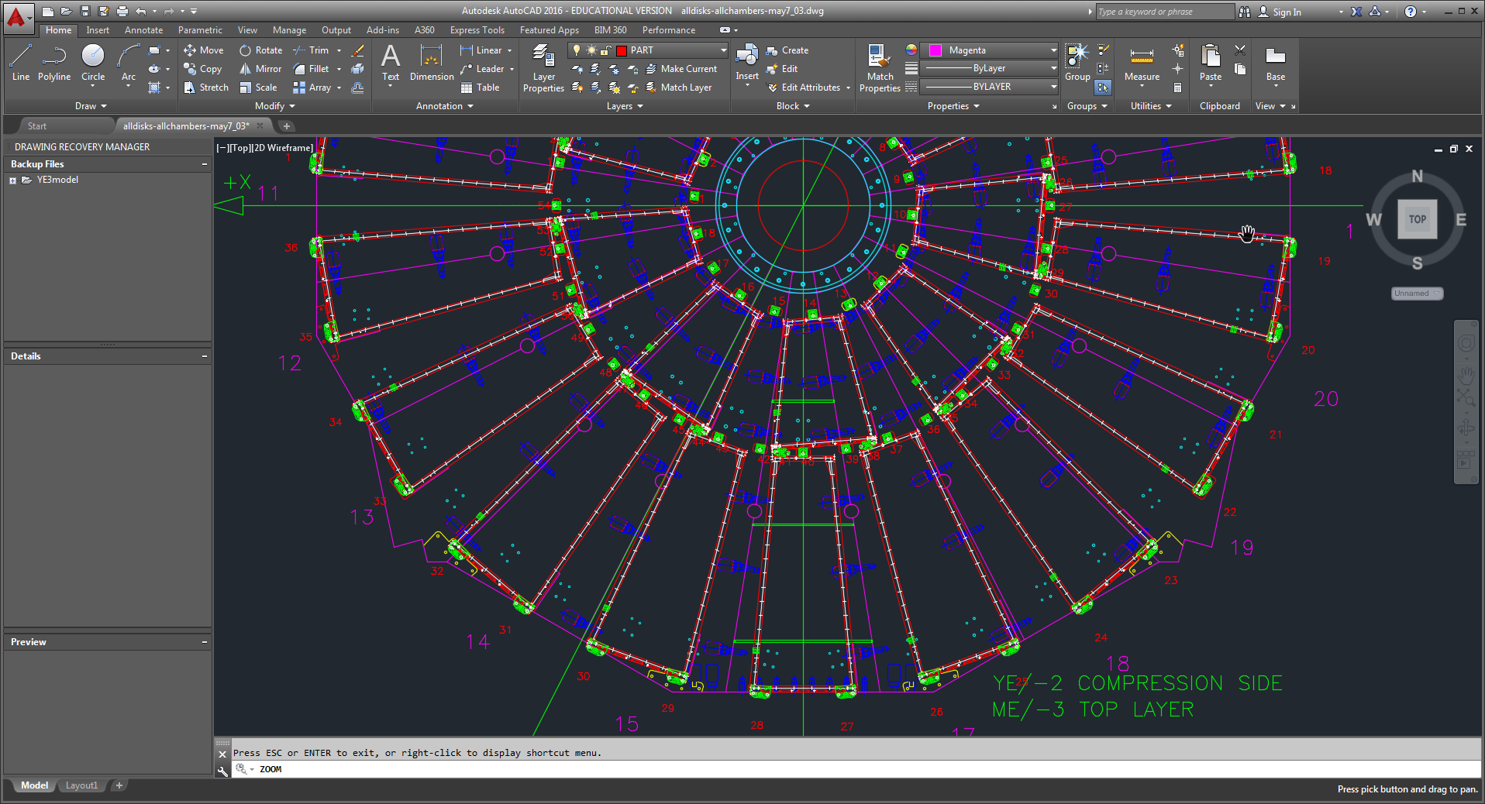

ME-3/1/12