Taken from ;

The Future of High Energy Physics Ã Â¢Ã â ¬Ã â Some Aspects, by L R Flores Castillo, K Prokofiev

Talk given at CERN 10 – 12 May 2017

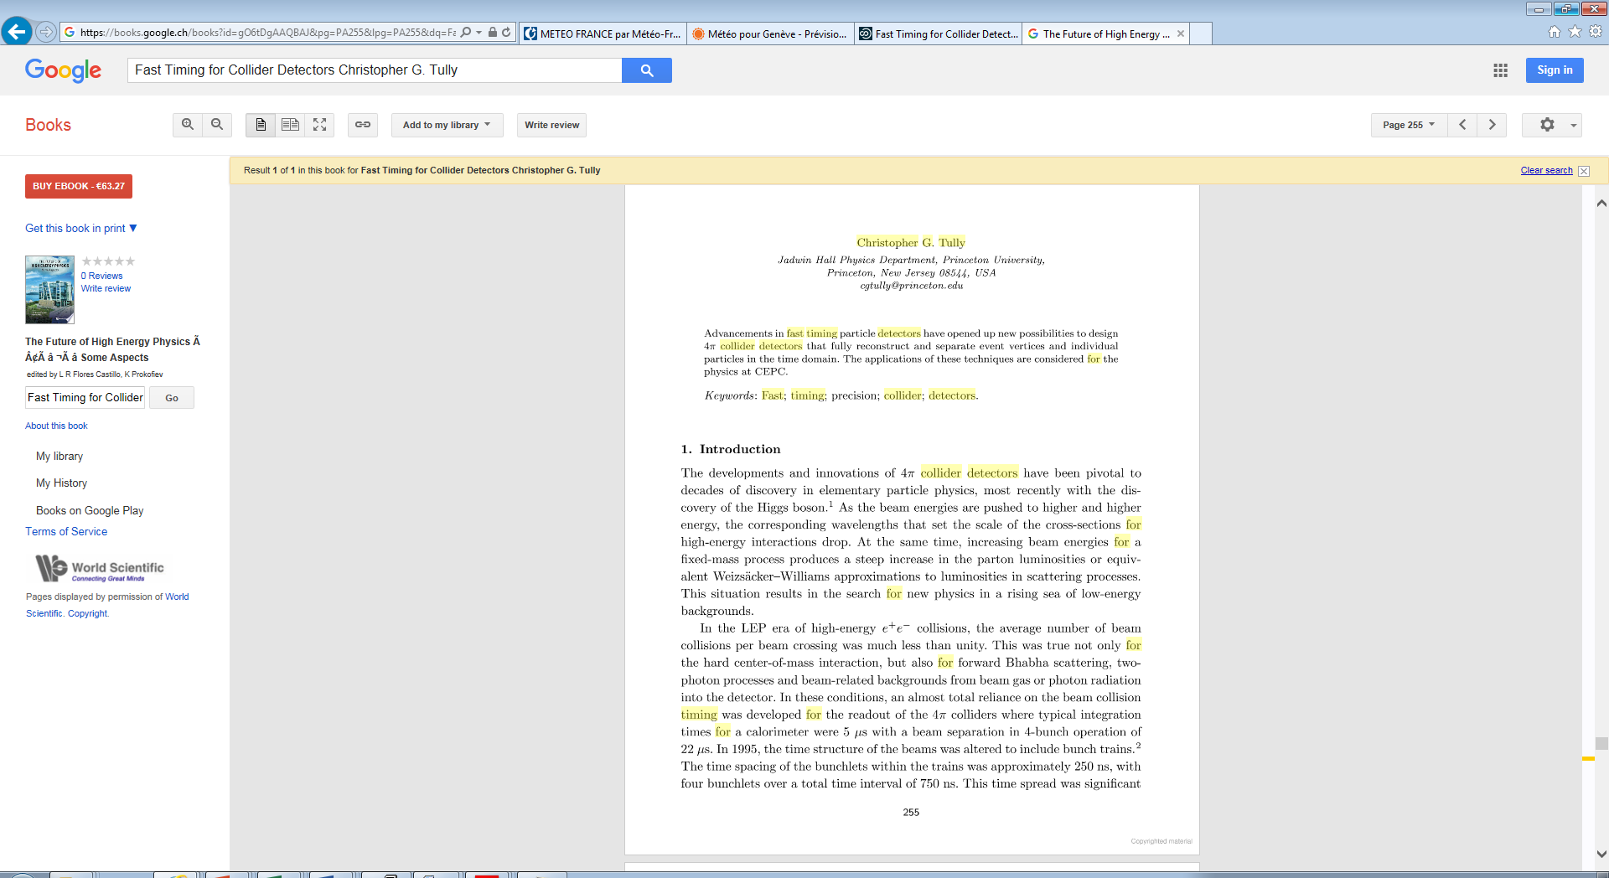

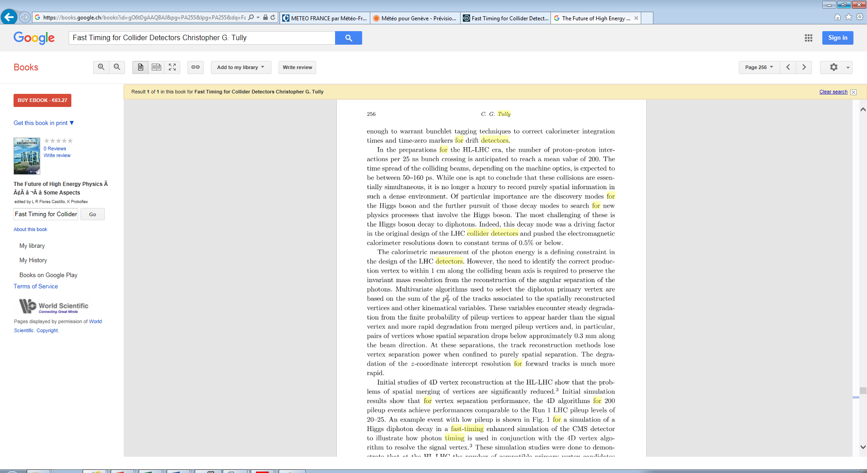

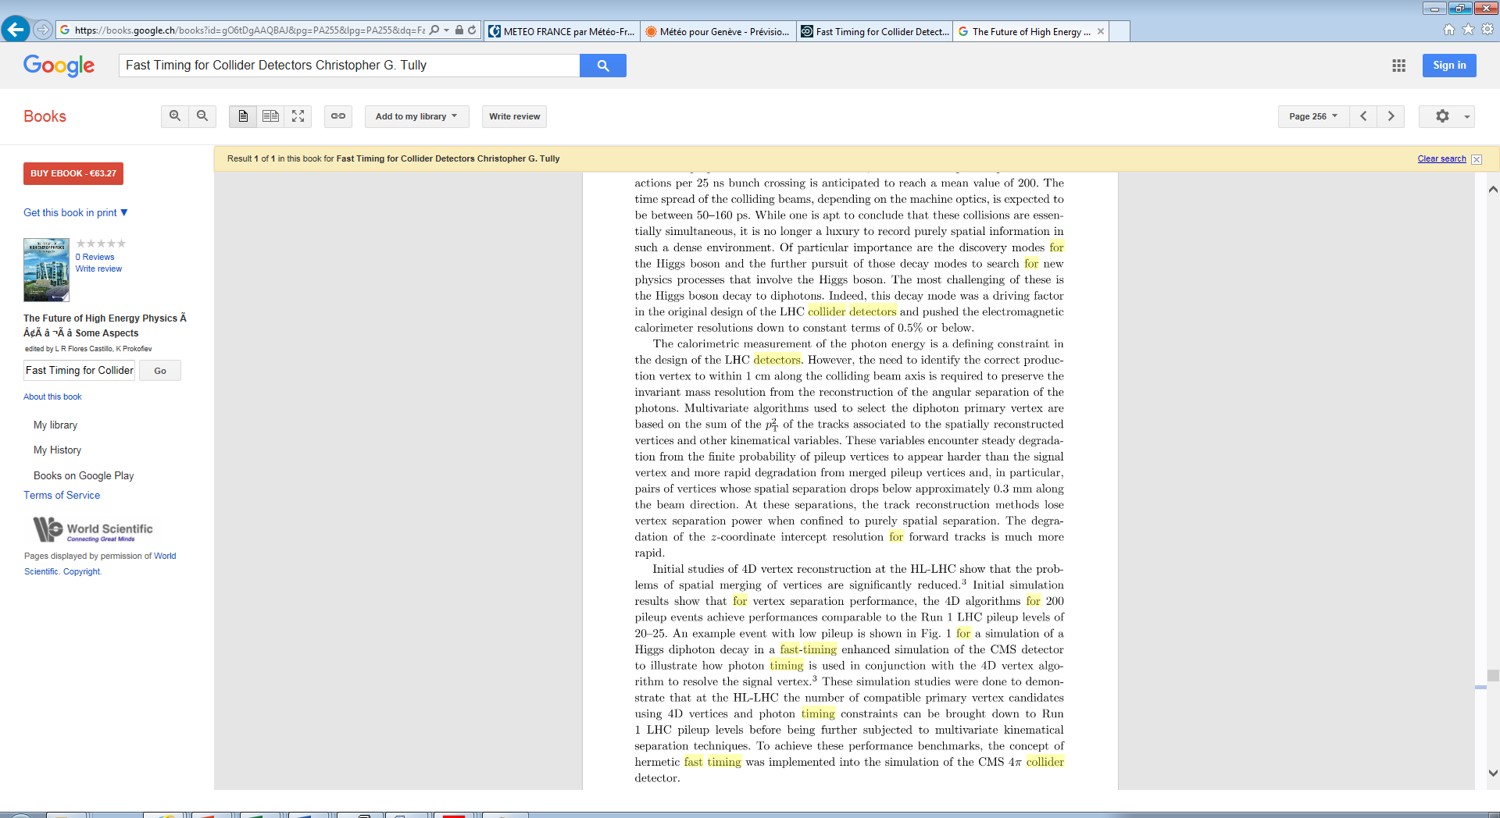

2 pages are missing !!

