X Sections RPCs

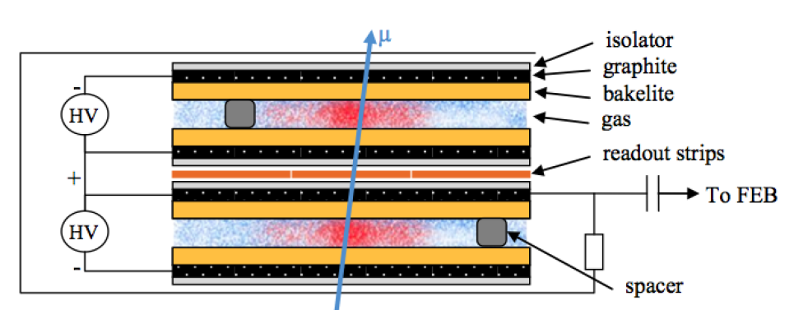

Standard double-gap RPC

Phenolic and glass dual bi-gap RPC

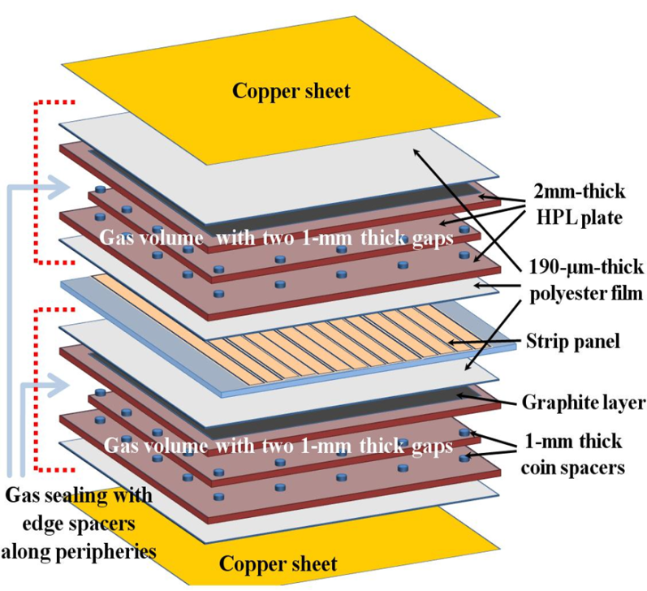

Low-resistive glass multi-gap RPC

