The table about the cable length

Cable length : from ferrule to another ferrule
Total length : from the end of the cable to the other end of cable
Brief instruction:
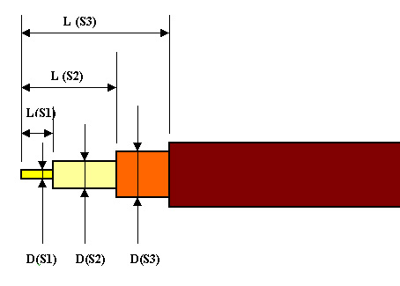
- The standard about the striping
Index | S1 |  | S2 |  | S3
Index | L | D | L | D | L | D
Adaptor | 03.0 | 00.30 | 15.0 | 00.88 | 20.0 | 01.25
Strip | 03.0 | 00.30 | 19.0 | 00.88 | 24.0 | 01.25
  - The table about the cable length
 | A | B | C | D
Cable length | 199mm | 159mm | 159mm | 159mm
total length | 199+15+19=233mm | 159+15+19=193mm | 193mm | 193mm

