***Proposed Cooling Tests of the GEM Prototype*** Ian Crotty

03 Oct 2014

1. **Worst case scenario,** all heat is transferred into the cooling circuit. This is done with an electrical load applied directly to the cooling pipe. Either flat resistors on soldered tabs to the pipe or resistive wire wound around the pipe. This will give the greatest ΔTemp across the chambers in a 20deg Sector (2 SMs) and so an idea of the difference in operating temperatures.
2. **Detailed study** of the Real GEM with VFATs and OH. Will be used to optimize the thermal circuit to obtain the best cooling of the electrical loads, namely VFATs & OH board.

Require isothermal conditions, real cooling circuit conditions.

1. **Full Test** in the CMS HE nose mockup to be built in 904. This will include convective currents engendered by the GEM (and its neigbours ). Full services to ensure the details of unions & connectors and cable bending radius. Study the assembly techniques for piping with all cables etc present.

***Worst case scenario***

A simple test to get the cooling study up and running. Obtain the cooling station, perhaps on loan, to ascertain the required performance. Set up the temperature measurement & data logger.

The cooling circuit does not need to be the version for the GEM but simply the length and diameter are required. The pipe is isolated to ensure full heat transfer to the cooling medium (water). This test should confirm the expected temperature rise of < 4degC per sector for the 2 GE1/1 SCs and the RBX already installed. The calculation of the expected delta T across the 20deg sector for just the GE1/1s gives 1.5degC.

***Schematic of the test***

T1

T2

Flow Rate [kg/s]

Cooling station

GEM type 8mm Cu pipe L=2m

With resistive loads &Insulation

Pipe with Soldered tab & resistor ( See Appendix)

Resistive wire coiled onto pipe and insulated thermally and electrically

In addition the delta P across a real circuit will be measured with the proposed Swagelok rapid connectors.

***Detailed study of GEM, VFATs & OH board***

The detailed study through experimentation should enable optimisation of the thermal resistances/paths from the junctions to cooling medium (water).

Tpad

Tchip

Junction Temp TJ

Twater

θJC

θPad

θCu

θJWATER= (TJ - TWATER) / PD [degC/Watt]

θJWATER Thermal Resistance junction to water

TJ Temp @ junction [degC]

TWATER Temp @ water (18degC)

PD Dissipated Power [Watt]

The aim is to keep the junction temperatures as low as possible for reasons of reliability and electrical noise. In addition losses to the environmental air including the surrounding detectors and structure should be as small as possible.

The full VFAT/OH electronics on a GE1/1 should be built and studied with local and remote temperature sensing. A full data logging system for high resolution sensors (0.05degC) both IR image and local will be required. A FLIR T620 or better Lumasense MC320L or similar. Archana can help with local sensors and their data taking.

From a study done by Da Riva we have a good idea of what is needed for the VFATs. See Ref below



Initial conditions with only air cooling will be made as a base line to see how well the water cooling works in comparison! The latter will only be done if considered safe for the components under test. Different solutions for the thermal path between chip/electrical loads and the water will be tried.

An isothermal housing for the setup is necessary that should be as small as possible to limit gravity induced gradients (convection) with a large mass for stability in time. This should be done in the 904 QC3 area as over large time intervals the volume is stable in temperature and there is some isolation from solar radiation induced diurnal temperature variation.

Ambient temperature variations are difficult to remove. Below is a plot of the 40min AC cycle

Below is a plot of solar induced diurnal temperature variations in 904 over 3.5 days during May 2013 with a dispersion of 5degC. A period of 24hrs is visible, time axis is in secs.

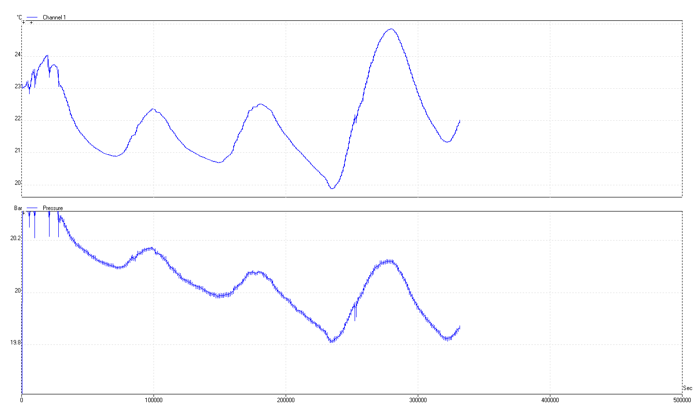

***Full test installed in CMS HE nose Mockup***

This should simulate the real conditions in P5 with emphasis on service details. This will combine with the study of the services, installation procedure.

Wooden mockup of the HE nose area with the 4 GE1/1s.

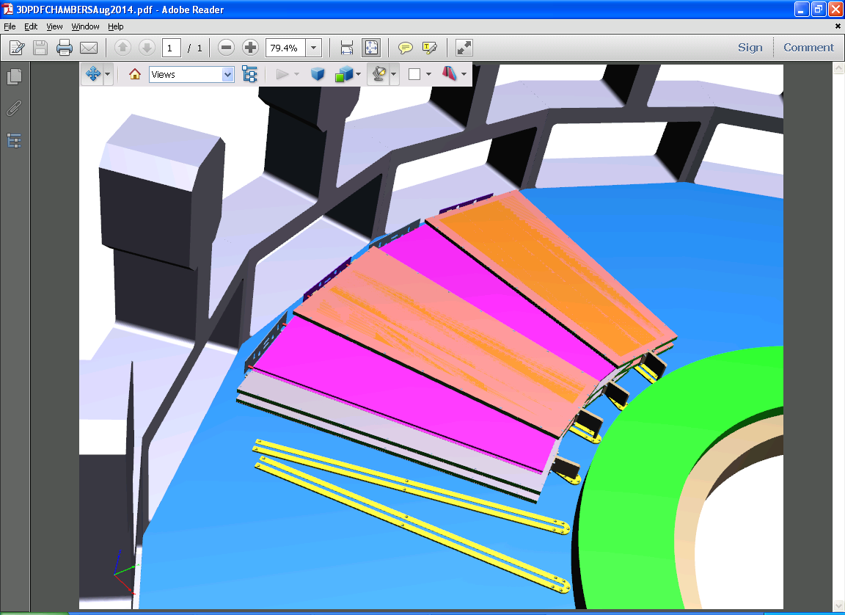

***List of equipment and facilities required.***

* Cooling station, flow meters and pressure gauges.
* Cooling circuits, thermal pads and formed copper sheets.
* Resistances for thermal load simulation.
* Data taking of temperature sensing instrumentation (local and IR).
* VFATs and OH on a GEB board.
* Isothemal housings for each of the 3 steps.
* HE flange with Brackets and CSC on a wall.
* All services to the above mock-up.

This is not a full list !

***Cooling station spec;***

0 – 40degC

Cooling capacity <1kW @ 20degC

Precision <0.05 degC

Pump pressure <3Bar @ 10l/min flow rate

As an example;

<http://www.lauda.de/shop/en/temperiergerate/umlaufkuhler-variocool/?t3m_lang=en>

***Appendix***

***Calculated temp rise for 20deg Sector.***

Q [watts] = Mass Flow rate[kg/s] x Cp[J/kg] x delta T [K]

Specfic heat of Water (Cp) = 4186[J/kg]

Nominal CMS YE1 Flow rate = 3.3 x 10^-2[kg/s]

Flow velocity with dia 4-6mm pipe = 2.5m/s high, giving erosion

Flow velocity with dia 6-8mm pipe = 1.1m/s a good value( 6-8mm is installed)

Delta T = 200[W]/ 3.3 x 10^-2 x 4186

= 1.5 degC

***Power resistor***

SFERNICE, type RH 50

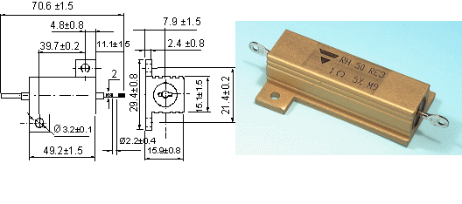

See calculation for applied voltage and the resultant power;

ResistorPowerCalc.xlsx

***References***

Power & Services

<https://indico.cern.ch/event/267789/session/10/contribution/5>

Calculations

<https://espace.cern.ch/cms-project-GEMElectronics/Powering/Cooling%20of%20GEM%20EDR.pdf>

http://project-cms-rpc-endcap.web.cern.ch/project-cms-rpc-endcap/rpc/UpscopeHighEta/GEM/VFAT/Cooling%20of%20GEM%20EDR.pdf

Junction temp calculators (JTC)

*http://www.daycounter.com/Calculators/Heat-Sink-Temperature-Calculator.phtml*

Coolers

<http://www.scimed.co.uk/chillers/>

<http://www.lauda-brinkmann.com/variocool.html>

<http://www.lauda.de/shop/en/temperiergerate/umlaufkuhler-microcool/microcool-umlaufkuhler-wassergekuhlt/?t3m_lang=en>

<http://www.coleparmer.com/TechLibraryArticle/1450>

<http://www.huber-online.com/en/product_listing.aspx?group=3.07>

<http://www.julabo.de/en/products/recirculating-coolers/fl601-recirculating-cooler>

<http://www.julabo.de/sites/default/files/downloads/catalogue-flyer/english/JULABO-Catalog-2014.pdf>

Heat exchangers/Water Blocks

<http://event.msicomputer.com/x99/>

<http://en.wikipedia.org/wiki/Thermal_management_of_electronic_devices_and_systems>

http://www.electronics-cooling.com/

Tested devices for cooling CPUs in PCs

<http://www.hardocp.com/article/2014/07/28/enermax_liqtech_240_aio_cpu_liquid_cooler_review/3>

Heat Sink calculations (HSC)

<https://www.aavid.com/sites/default/files/technical/papers/how-to-select-heatsink.pdf>

Suppliers of cooling for electronics

<http://www.thermacore.com/applications/electronics-cooling.aspx>

Conductive greases

<http://www.intertronics.co.uk/products/circuit-works-conductive-grease.htm>

Thermal Image camera

<http://en.wikipedia.org/wiki/Minimum_resolvable_temperature_difference>

<http://en.wikipedia.org/wiki/Modulation_transfer_function_(infrared_imaging)>

<http://www.extech.com/cameras/product.asp?catid=76&prodid=545>

<http://www.omega.com/manuals/manualpdf/Flir12_Booklet.pdf>

<http://www.telops.com/en/products/infrared-cameras>

<http://www.micro-epsilon.com/temperature-sensors/thermoIMAGER/thermoIMAGER_160/index.html>

[http://www.lumasenseinc.com/EN/products/thermal-imagers/?utm_source=Google-AdWords&utm_medium=cpc&utm_term={keyword}](http://www.lumasenseinc.com/EN/products/thermal-imagers/?utm_source=Google-AdWords&utm_medium=cpc&utm_term=%7bkeyword%7d)

<http://www.lumasenseinc.com/uploads/Solutions/pdf/Application_Notes/Advanced_Technology/English/AppNote_Electronics-Testing.pdf>

<http://thermal-imaging-camera.irpod.net/?gclid=CLrSxPqnicECFa7KtAodnT0AKA>

<http://www.conrad.ch/ce/de/product/100959/VOLTCRAFT-IR1000-50CAM-Infrarot-Video-Thermometer-Optik-501-50-bis-1000-C-mit-Transportkoffer;jsessionid=386CAF3F9BB9D9561A41BA1062DEB613.ASTPCEN21?ref=list>

Ideas to improve OH cooling

What are the conditions of the if the electronics is air cooled ( say corona cooling !) ? This is a first calculation to see how much better we can do !

It's also possible to use surface mount heat sinks. Ref JTC1

Micro channel cold plates or heat pipe