First IR images of GEB and OH V1 21 Oct 2014

Ian Crotty

Thanks to Aysen

View of the set up in 904

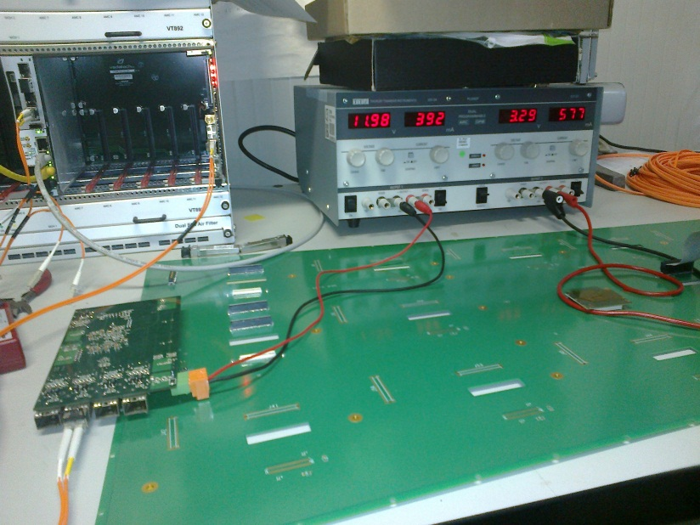

Top side Voltage regulators ??

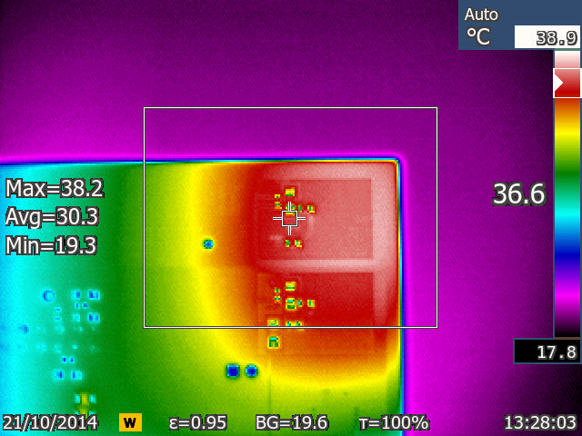

The rear of the OH approx. where the FPGA is ( Vertex 6)

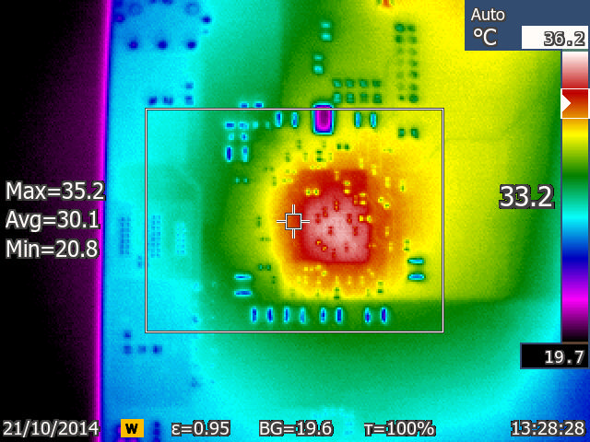

Another rview

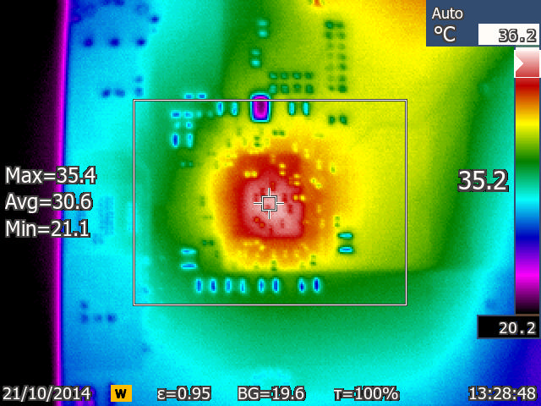

??

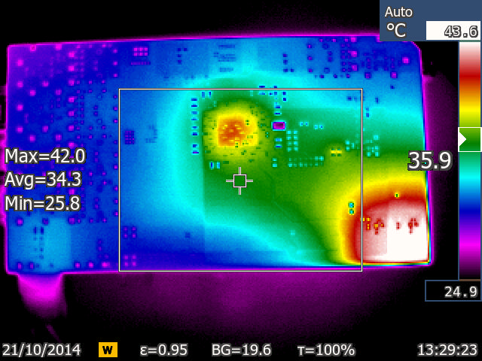

Underside of OH. Portion of the OH beyond the GEB board with SFP and FPGA

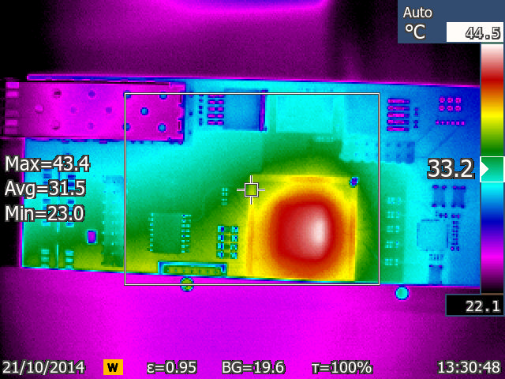

Same view. It is not possible to see the temperature of the SFP as it is not adjusted for emissivity

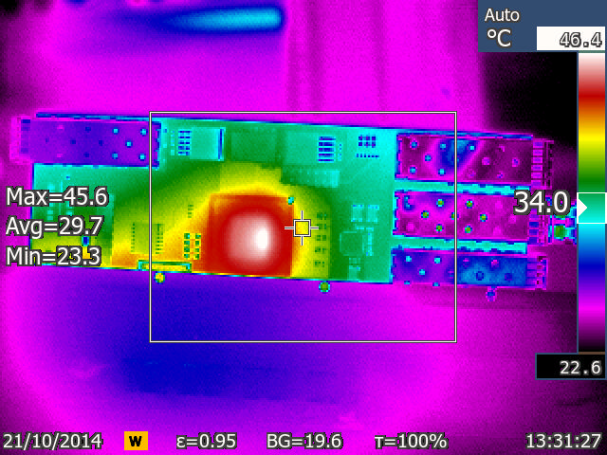

Not focussed

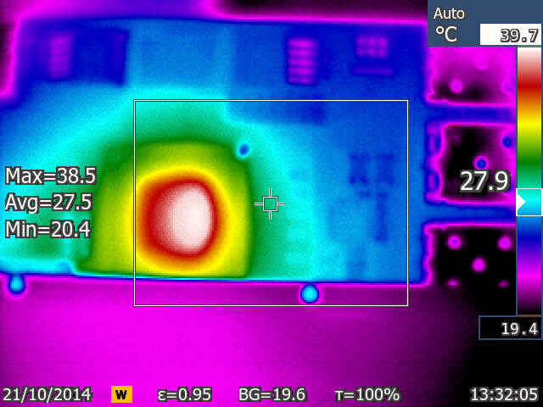

VFAT high radius

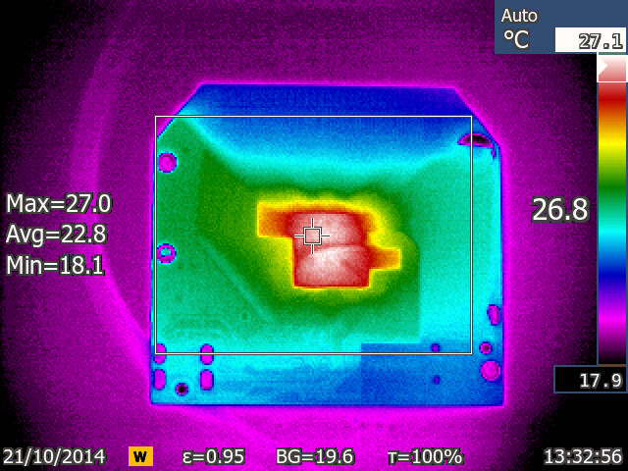

VFAT medium radius

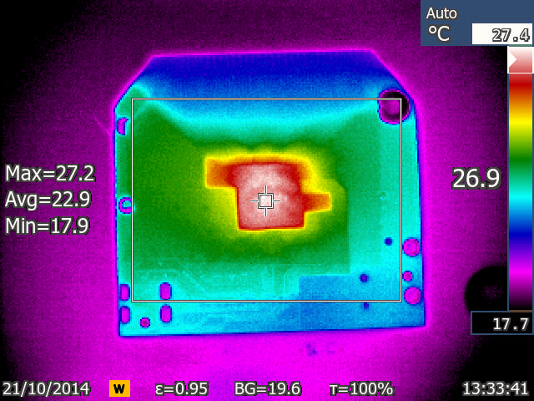

VFAT low radius

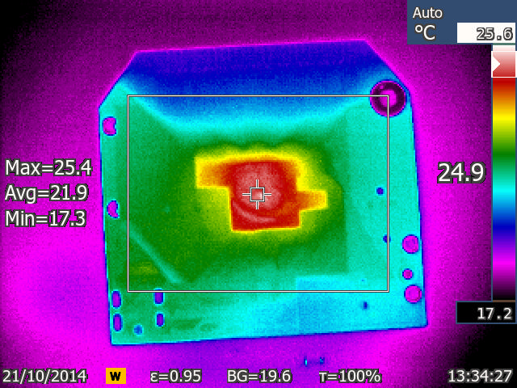

??

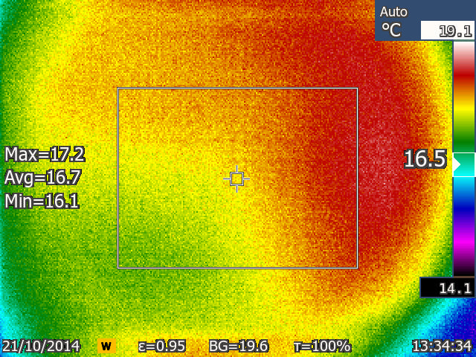

Layout nin 904 Electronics lab with PS on. The OH is at extreme LHS. Notice the reflection of PS

