***Betta Tech CU500***

Chiller recuperated from 186 outside the Tracker TIF lab. The pump is seized

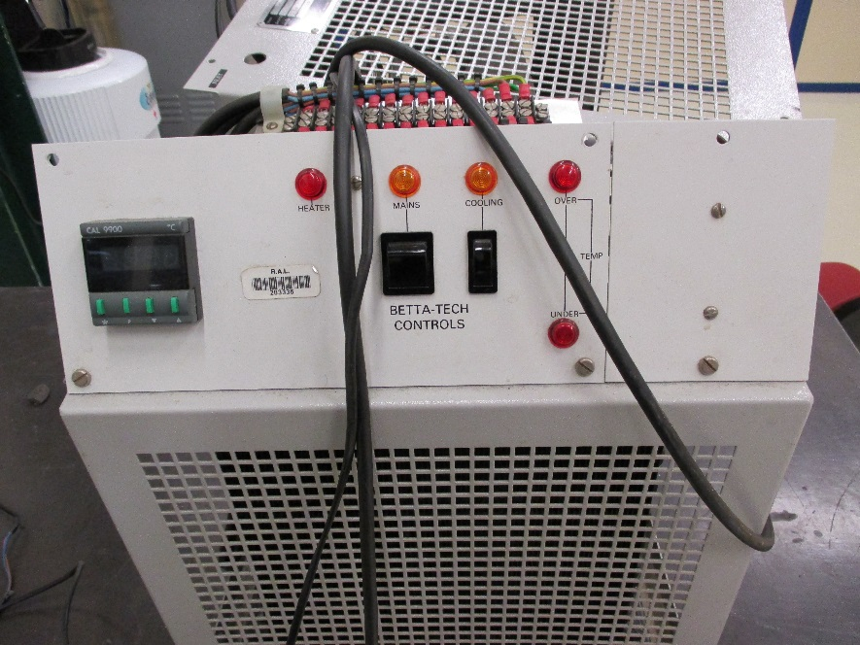

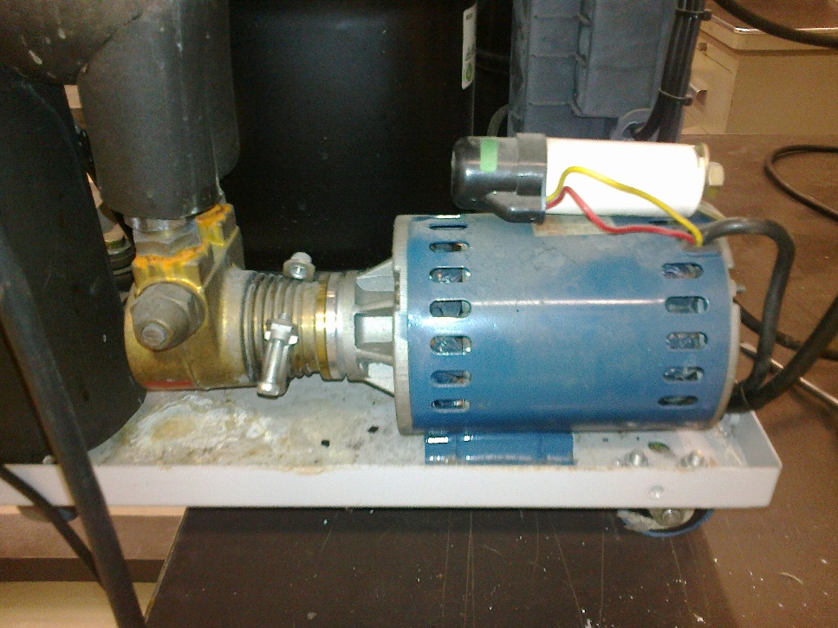

***Chiller Specs CU500***

Serial number; 26240896

***Motor specs;***

Brook Crompton Motors Fractional Motors

Motor Ref ; BRE264BN-D47338

Tel no 00441302812712 in Doncaster.

<http://www.brookcrompton.com/index.html>

Email sent 25 Nov 2014.

***Pump specs;***

NU. E. R.T. Italy, PR/3ASV date 07/95

Catalogue Nuert

<http://www.nuert.com/>

<http://www.nuert.com/rotary-vane-pumps/standard-pumps.php>

Spares;

http://www.nuert.com/rotary-vane-pumps/standard-pumps-spare-parts.pdf

Emails

Date: Fri, 21 Nov 2014 10:34:08 +0100

From: Kutay Saxer <kutay.saxer@satoag.ch>

To: 'Matteo Quattrin' <matteo.quattrin@nuert.it>, ian.crotty@cern.ch

Cc: 'Nuert_info' <info@nuert.it>, 01 Sato Office <info@satoag.ch>

Subject: AW: pumps in Switzerland

Dear Mr Crotty

Thank you for your inquiry to Nuert Italy.

As Matteo already quoated we should know first the correct pump code and all

necessary motor specifications. The best is to send us some pictures of the

pump and motor label.

Awaiting your reply we send our best wishes.

Kind regards

Kutay Saxer

Managing Director

Sato AG / Sato International AG

Stetterstrasse 21 / P.O.Box 246

CH-5507Â Mellingen/Switzerland

T +41-56-483 44 44

F +41-56-483 44 45

M +41-79-237 55 15

kutay.saxer@satoag.ch

www.satoag.ch [www.satoag.ch]

In addition a email was sent to Betta Tech on XX Nov 2014. With an offer on XX Nov 2014 of 175GBP for ……………

Refs;

http://project-cms-rpc-endcap.web.cern.ch/project-cms-rpc-endcap/rpc/UpscopeHighEta/GEM/Services/Cooling/Lab904Tests/Chiller/Chillers904/BettaTechCU500/Photos/