dimension draft V0.1

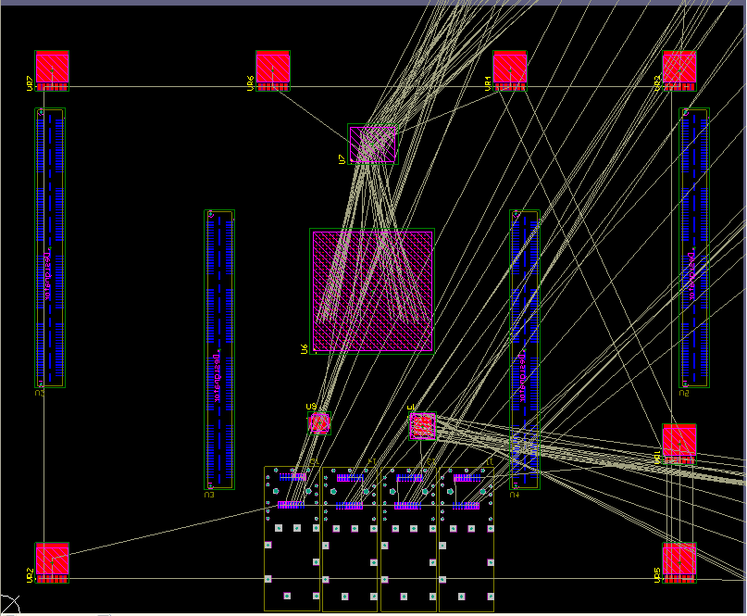

red parts are on the top layer, blue parts are on bottom layer.

Components need to be cooled included:

MIC69502(7 LDOs with red rectangle ), height around 1.9mm

FPGA(U6,BGA in the middle),height around 3mm

XCF128(U7,BGA between FPGA and LDOs),height around 1.1mm

cdce62005(U1,VQFN between FPGA and SFPs),height around 1mm

SFPs, height around 9.7mm on the bottom layer, it's possible to put them on the top but quite difficult.

