*An initial look at the patch panel configuration.*

As discussed in our TC meeting last month we agreed to define the max width of the OH board by establishing what space could be available between the two cooling pipes. The distance between the two cooling pipes is constrained by the space available on the patch panel (PP) that is itself defined by the overlap of one Super Chamber (SC) with respect to the adjacent one.

Patch panel dimensions used to define the OH extents in at least one dimension. The panel at present, based on an old drawing from Antonio, is 310mm x 60mm for both chambers (SC).

View of old design

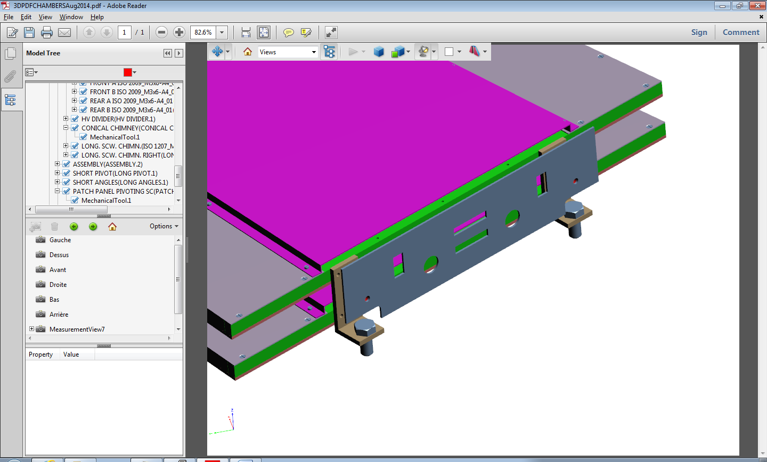

-Z

R

Phi

Cross sectional sketch of the cooling pipes and OH board

Board must sit within the pipes given the limited “head height” in Z.

Distance of bulkhead from the Gem structure ( still an old version)

Side view showing just one chamber with the common bulkhead. The bulkhead stands off the GEM by 30mm (spacers 25mm and mounting bracket thickness 5mm)

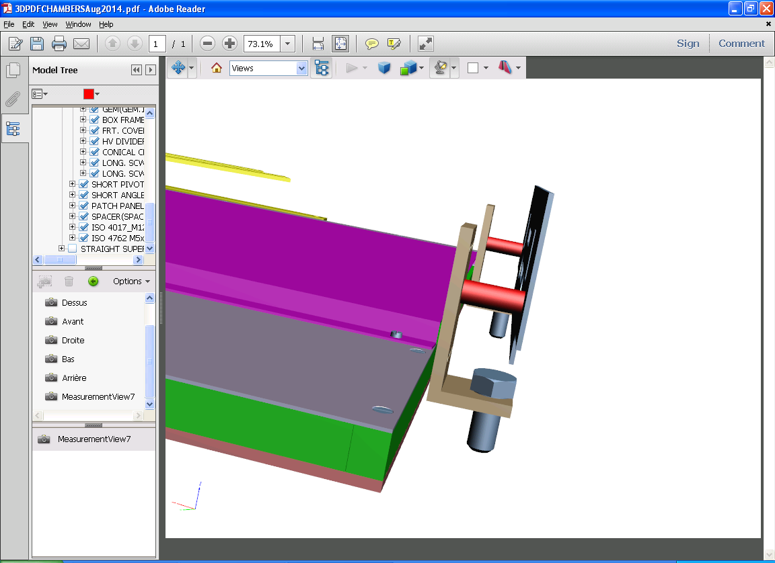

The standoff dimension will be defined by the space available under the HE brackets and the dimensions in R of the connectors and their cables et cetera on the PP. To facilitate production, assembly and reduce connecting errors one design of PP for both the on and off mounting face would be preferred.

The cooling union will look something like this (Swagelok) and with this orientation wrt the PP shown above. There are basically 2 options for the cooling pipe diameter, 8 or 6mm. Smaller may be possible. Dimensions given for Sagana.

8mm dia gives AF 17mm

6mm dia gives AF 17mm

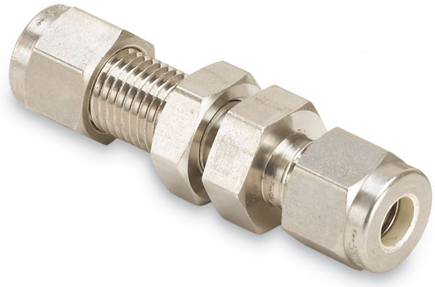

Union extends 36mm behind PP

Length = 62mm

This means with the present standoff distance of 30mm the union will protrude 6mm into the GEM volume.

Sketch of the PP 310 x 60mm with only cooling unions shown. The unions are 17mm across the hexagonal flange butting up to the PP. The pipes already installed in CMS are 8mm dia. Unions are available to reduce to 6mm. There are many variants possible, flexible hoses will make the assembly easier and will be of similar sizes.

285mm

The OH should not therefore exceed 280mm in Phi. The mounting brackets for the GEM will need modifying.

***Conclusion***

Here one of the dimensions (Phi) of the OH is defined. It will be up to the OH designers to say if this is sufficient and also define the dimension in R.

Antonio should study this proposition and see if it fits into the GEM design and CMS.

If necessary the pipes can sit on the board, rather than its edge, but either side of the components, thereby gaining some few more millimetres. This will obviously impede installation of the OH pcb if they are on top.

Additional information on the exact components and their dimensions to fit on the PP are also neccessary for the PP design and are forthcoming.

Ian Crotty 9 Sept 2014