Cooling unions

Proposal from 2013 Barthel Philips (Aarchen)

Used in ECAL ?

<http://www.swagelok.com/search/find_products_home.aspx?part=SS-QC4-B-6M0-SC11>

<http://www.swagelok.com/downloads/webcatalogs/en/MS-01-138.pdf>

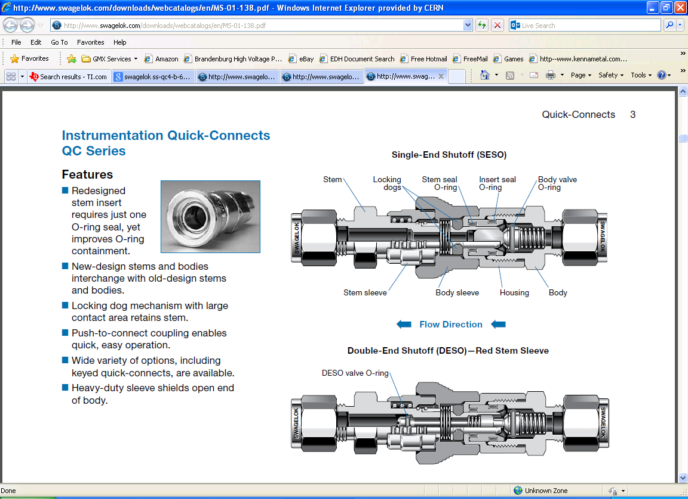

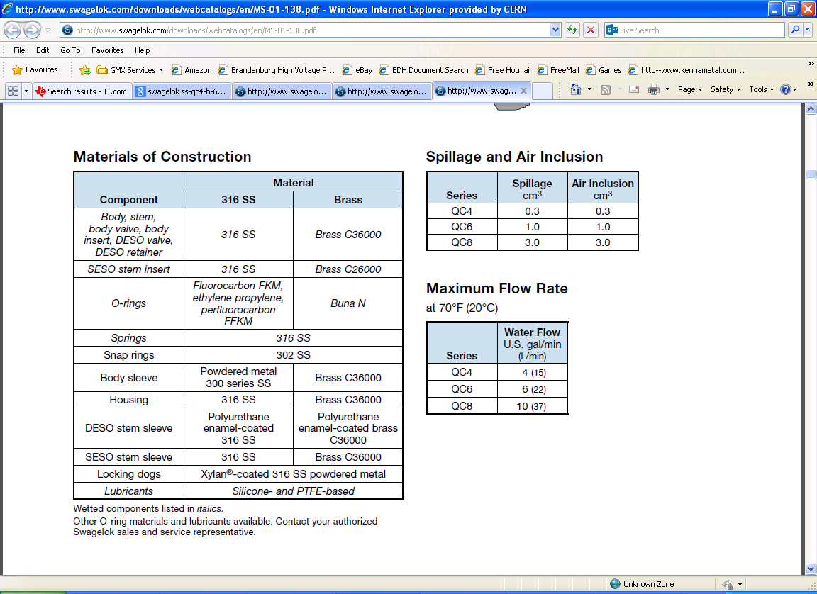

Notice the spillage 1cm3

What is the pressure drop ?

What of lubricant and elastometic degradation in the radiation field …

Cost is some thing in the region of 200 chf/complete union ?

Use barb fitting to go to the hose.

Notice the elastomeric blue hoses already installed on the HE are hard !! after 2 years at low intensity beam.

***The flexible connection***

Swagelok

<http://www.swagelok.com/search/find_products_home.aspx?part=SS-PB4-TM8>

<http://www.swagelok.com/downloads/webcatalogs/En/MS-01-180.PDF>

Steel flexible hose from above catalogue

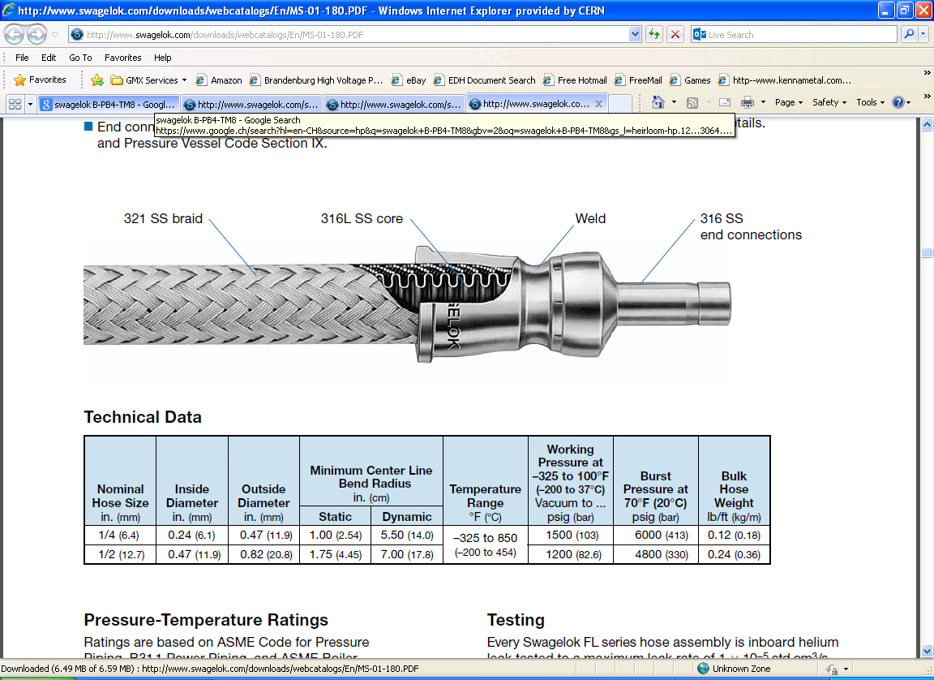

PTFE flex

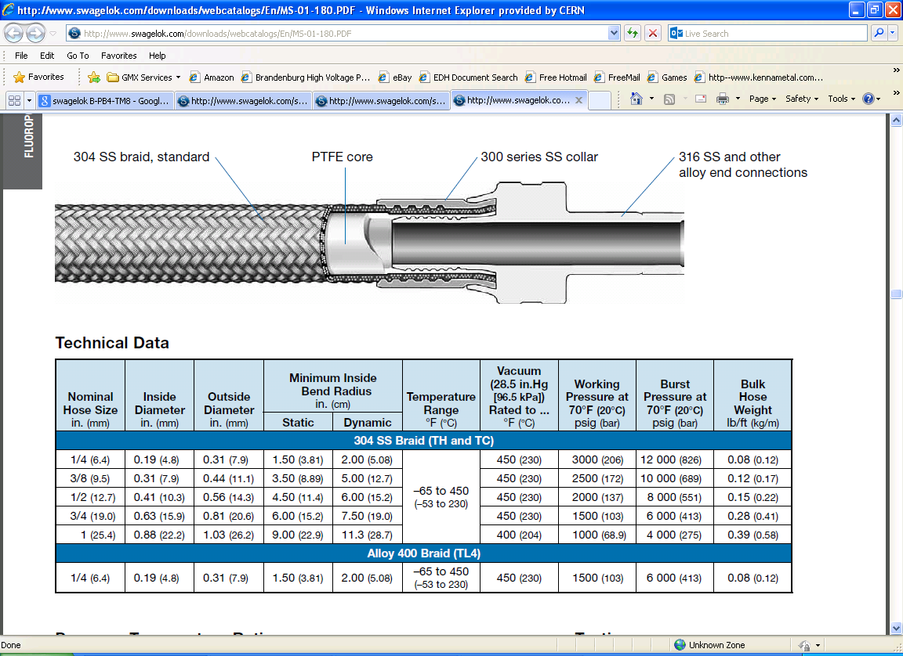

Nylon and PU & PE hoses

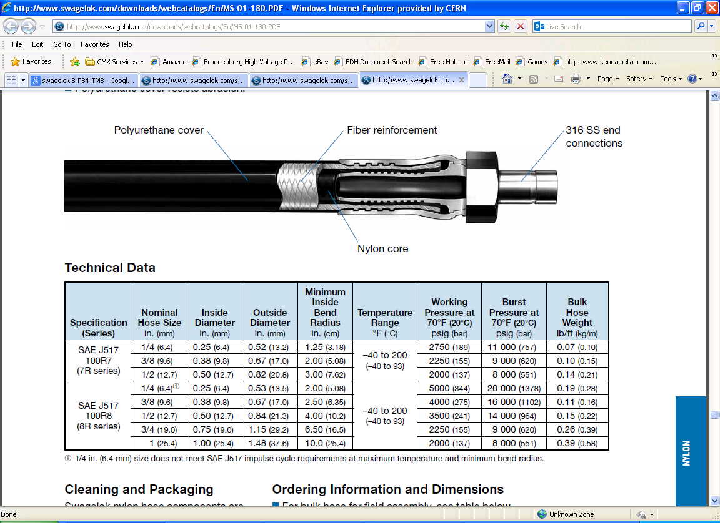

<http://www.swagelok.com/search/find_products_home.aspx?part=SS-PB4-TM8>

http://oem.cadregister.com/asp/PPOW_Entry.asp?company=SwagelokCo&elementID=63396501/FOLDER11/FOLDER2/Y70381/FS&orderedResponses=2|1|0|&language=GB&oem=true

