Specification for RE1/1 ferrules to connect the Read-out strips to the Front End Board Adaptor cards.

Previously we have used cable C-50-2-1 and the ferrules that are shown below. They were originally made by the company Fondex and refered to as “Ferco 26”. See Appendix 1 for a scan of the old CERN Catalogue (1994 ?)

The ferrule is pictured below

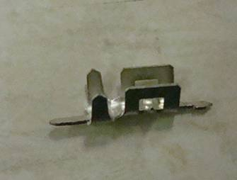

With some indication of dimensions ;

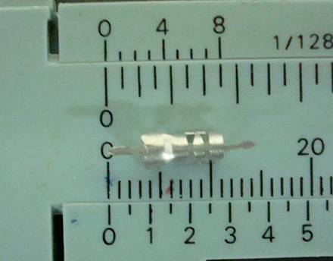

It will be noticed that the protrusions from each end are to be bent down , as shown in the appendix 1, for insertion into the PCB holes.

The crimping tool shown below was used. It was made by AMP ref: 220141-1
It was in CERN Catalogue 34.95.14.140.6

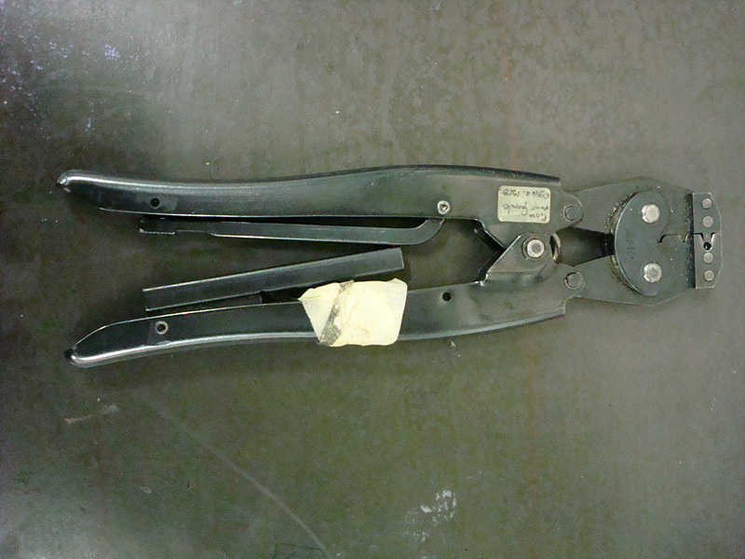

The result after mounting to the Adaptor card is shown below. This card was from the CERN Circuit design office some 10 or so years ago.

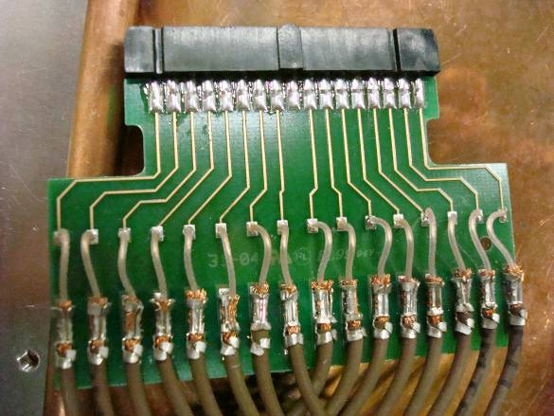

In fact this is an example using C-50-1-1 cable that has a diameter of 2.1mm rather than the original 2.85mm. We need to use this smaller cable for RE1/1.

It is clear form the photo below that this ferrule is now too big. The spacing for the legs to engage into the PCB is fine must however remain the same. Despite attemps to use different crimping tools such as AMP 90.067 (Scem 34.95.14.120.0) and thin nosed pliers the result is poor, perhaps resulting in damage to the inter conductor insulator and requires significant set up time with a dextrous operator.

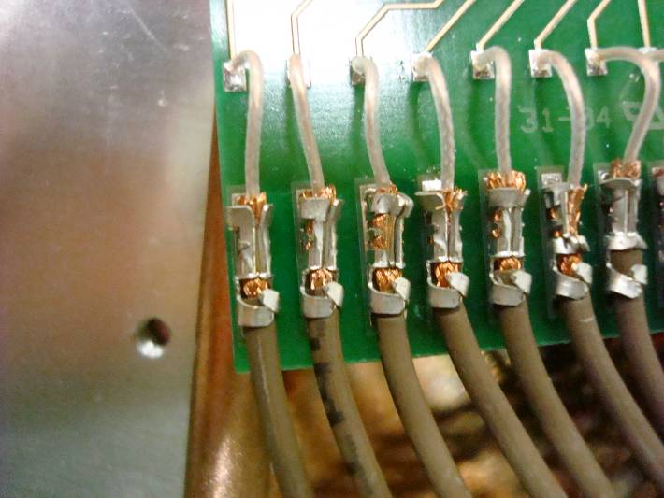

We are therefore in need of a smaller version, although the leg spacing must remain the same as we will use the same Adaptor board. The quantity required for immediate use is 1600 pieces and for the final production this year will be 21500 pieces.

Appendix 1

