RE1/2(- z endcap) Installation
(2-7 Feb. 2006)
Numbering of RE1/2 Position on yoke:
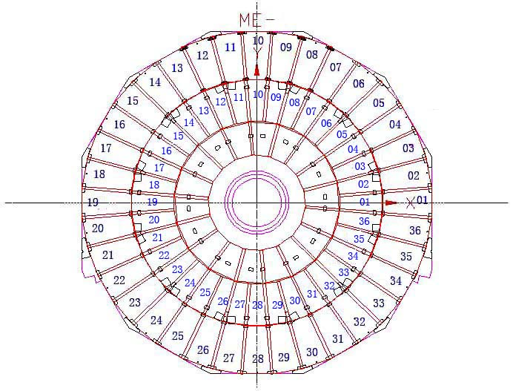

Chambers transferred to point 5 on 1,2 Feb. 2006:

Rack 1:

RPC Num /  (Box Num) | RPC Num /  (Box Num)
66(034) | 44(019)
77(035) | 67(055)
76(033) | 65(049)
57(057) | 54(040)
69(029) | 79(065)

Rack 2:

RPC Num /  (Box Num) | RPC Num /  (Box Num)
75(050) | 71(028)
56(017) | 73(051)
21(030) | 37(001)(at P5)
53(041)
50(038)

RPC - RE1/2 - z Installation Layout
(blue: on yoke; red: off yoke)
RE1/2 position | CSC No. | RPC No. (Box No.)
01 | 014 | 64(048)
02 | 059 | 54(040)*
03 | 039 | 70(031)
04 | 002 | 71(028)
05 | 025 | 46(043)
06 | 027 | 65(049)*
07 | 019 | 33(016)
08 | 037 | 21(030)
09 | 046 | 24(006)
10 | 051 | 50(038)
11 | 061 | 36(012)
12 | 007 | 56(012)*
13 | 048 | 29(018)
14 | 031 | 75(050)
15 | 032 | 62(080)
16 | 006 | 73(051)
17 | 030 | 51(039)
18 | 011 | 44(019)*
19 | 016 | 58(013)
20 | 045 | 53(041)
21 | 042 | 63(053)
22 | 001 | 66(034)
23 | 033 | 52(042)
24 | 058 | 76(033)
25 | 069 | 38(004)
26 | 009 | 69(029)*
27 | 057 | 61(015)
28 | 022 | 37(001)
29 | 070 | 59(056)
30 | 005 | 77(035)
31 | 064 | 31(061)
32 | 012 | 57(057)*
33 | 071 | 41(009)
34 | 075 | 67(055)
35 | 063 | 48(036)
36 | 047 | 79(065)
*: mounted with temperature sensor.

