CERN reference N° | SCEM 04.71.06.400.0
Identification | Twisted pair rouNd câble

REQUIREMENTS
Applicable documents | IEC60332-3-2 ; IEC60754-2 ; IEC61034 ; CERN IS23
Mechanical properties | Core : Stranded tinned copper,  Section : AWG28/7 or AWG26/7  Insulation : High density polyethylene, LSZH.  Individual conductor AND insulation must be suitable for IDC type connector of 1.27mm pitch. Diameter 0.7mm is common to some cables.  Pairs : Each group of 4 pairs white/blue; white/orange; white/green / white brown  Lay-up : Pairs twisted in 5 groups of 4 pairs, diameter over assembly 3,10mm  Screen : Al-PET-foil on the total and glass fibre as flame barrier + tinned copper braid, coverage > 75%  Outer sheath : Thermoplastic LSZH flame retardant compound – Blue RAL 5015  Max. outer diameter : 10mm  “Manufacturer logo – CERN 04.71.06.400.0 – Zero halogen – IEC60332-1 – Manufacturing date – Calibration in meter”
Electrical properties | Insulation resistance : >1000MOhm.km  Capacitance : <49pF/m  Velocity of propagation : ca 58%  Characteristic impedance : 110Ohm +- 10Ohm (f ≥1MHz - 100MHz)  Propagation delay : <460ns/100m  Skew time between pairs : <1ns/25m  Test voltage : 1kV, DC, 1min, core/core and core/screen
Operating voltage  Operating temperature | 150Vrms  -65 to 70°C

ACCORDING TO CERN SAFETY INSTRUCTION IS23

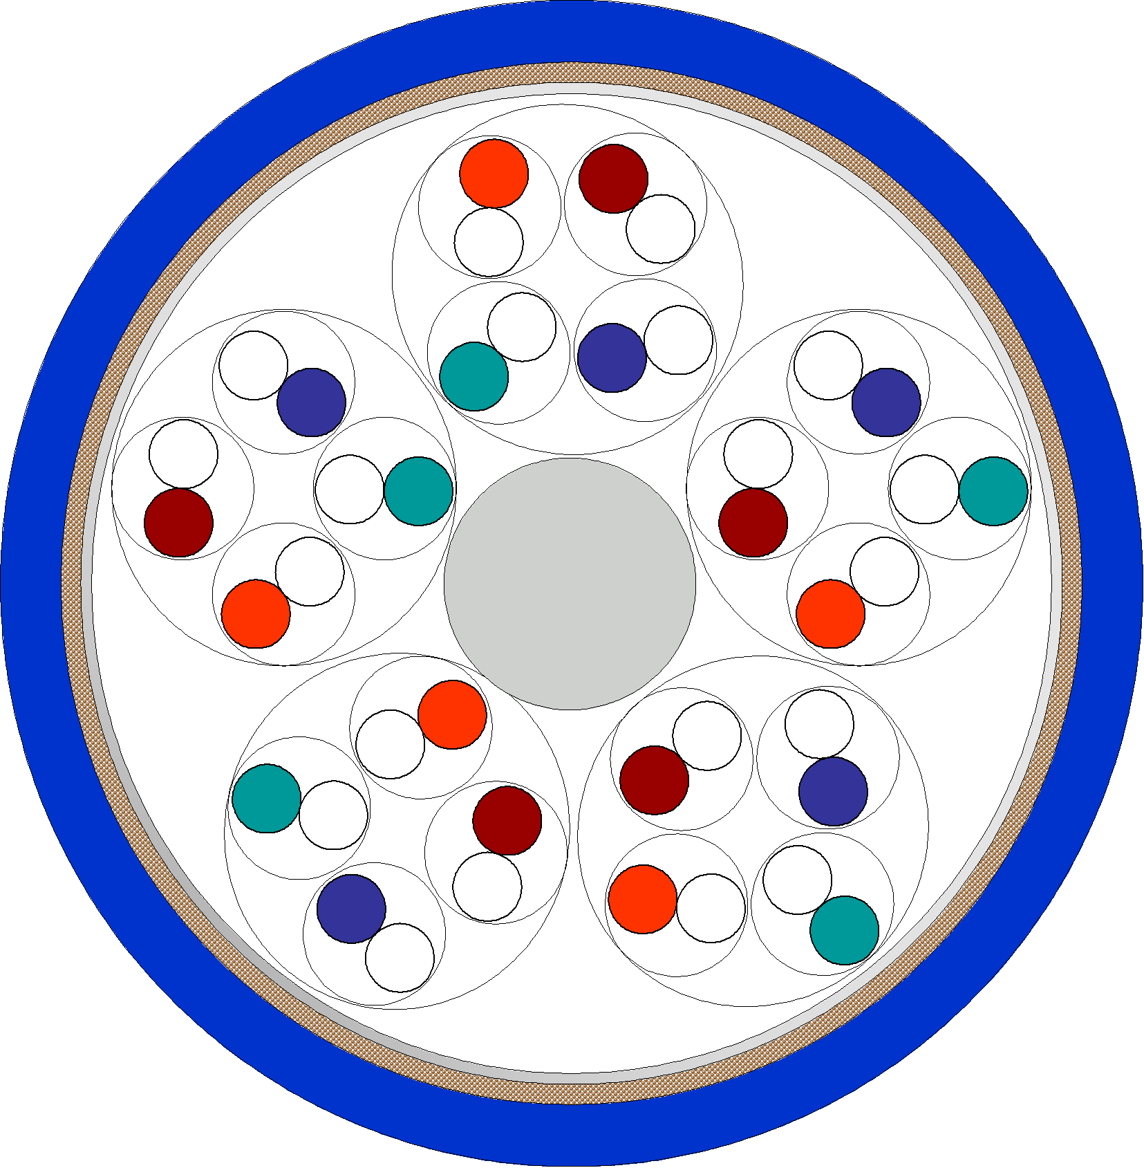

04.71.06.400.0 – not to scale !

