Permeability of water vapour through plastic piping

Fick's laws of diffusion,

https://en.wikipedia.org/wiki/Permeation

viscous flow contained within a sediment volume where the dominant fluid flow is by Knudsen Diffusion.

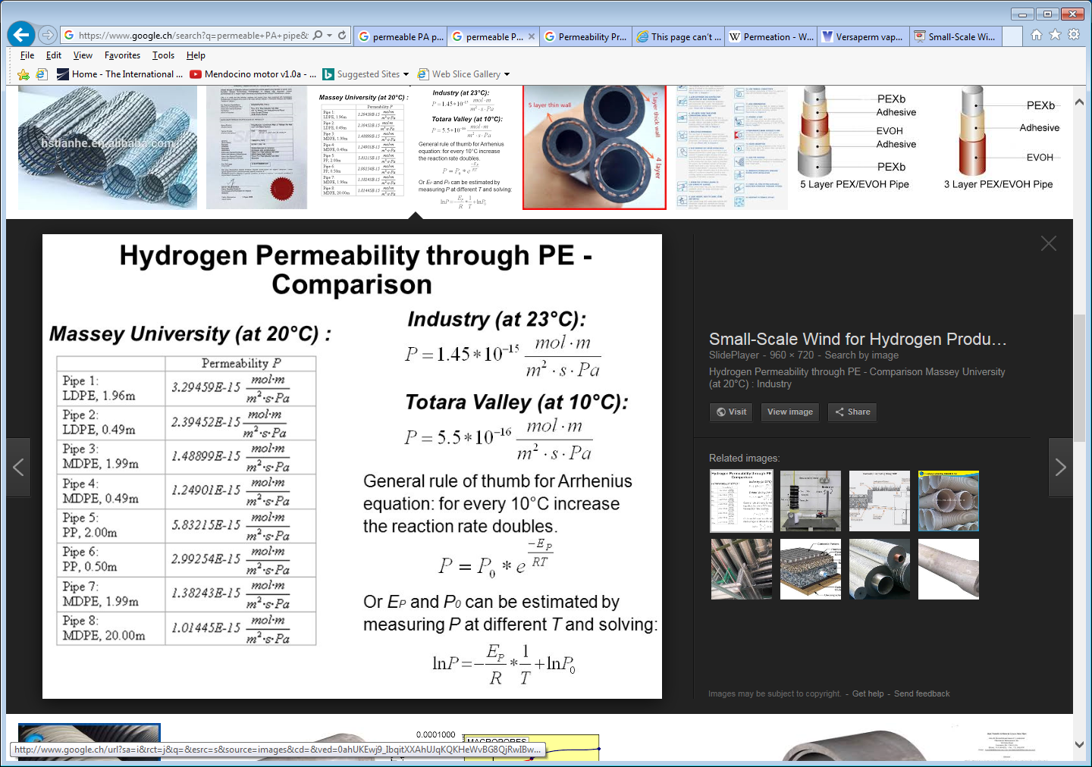

Contaminant Diffusion, Solubility, and Material Property Differences between HDPE and PEX Potable Water Pipes

<https://www.researchgate.net/publication/230887612_Contaminant_Diffusion_Solubility_and_Material_Property_Differences_between_HDPE_and_PEX_Potable_Water_Pipes>

Permeability Properties of Plastics and Elastomers

<https://books.google.fr/books?id=bUV5DAAAQBAJ&pg=PA68&lpg=PA68&dq=permeable+PA+pipe&source=bl&ots=U4hCPEVwoD&sig=yfQreebrty9Sp1gjBOHRy_LYUM8&hl=en&sa=X&ved=0ahUKEwjRiLuVitXXAhVCKuwKHSs7B-MQ6AEIPDAH#v=onepage&q=permeable%20PA%20pipe&f=false>

<http://www.versaperm.com/mkvi.php>

WVTR = Water Vapor Transmission Rate MVTR has units in europe of [gr/m2.day]

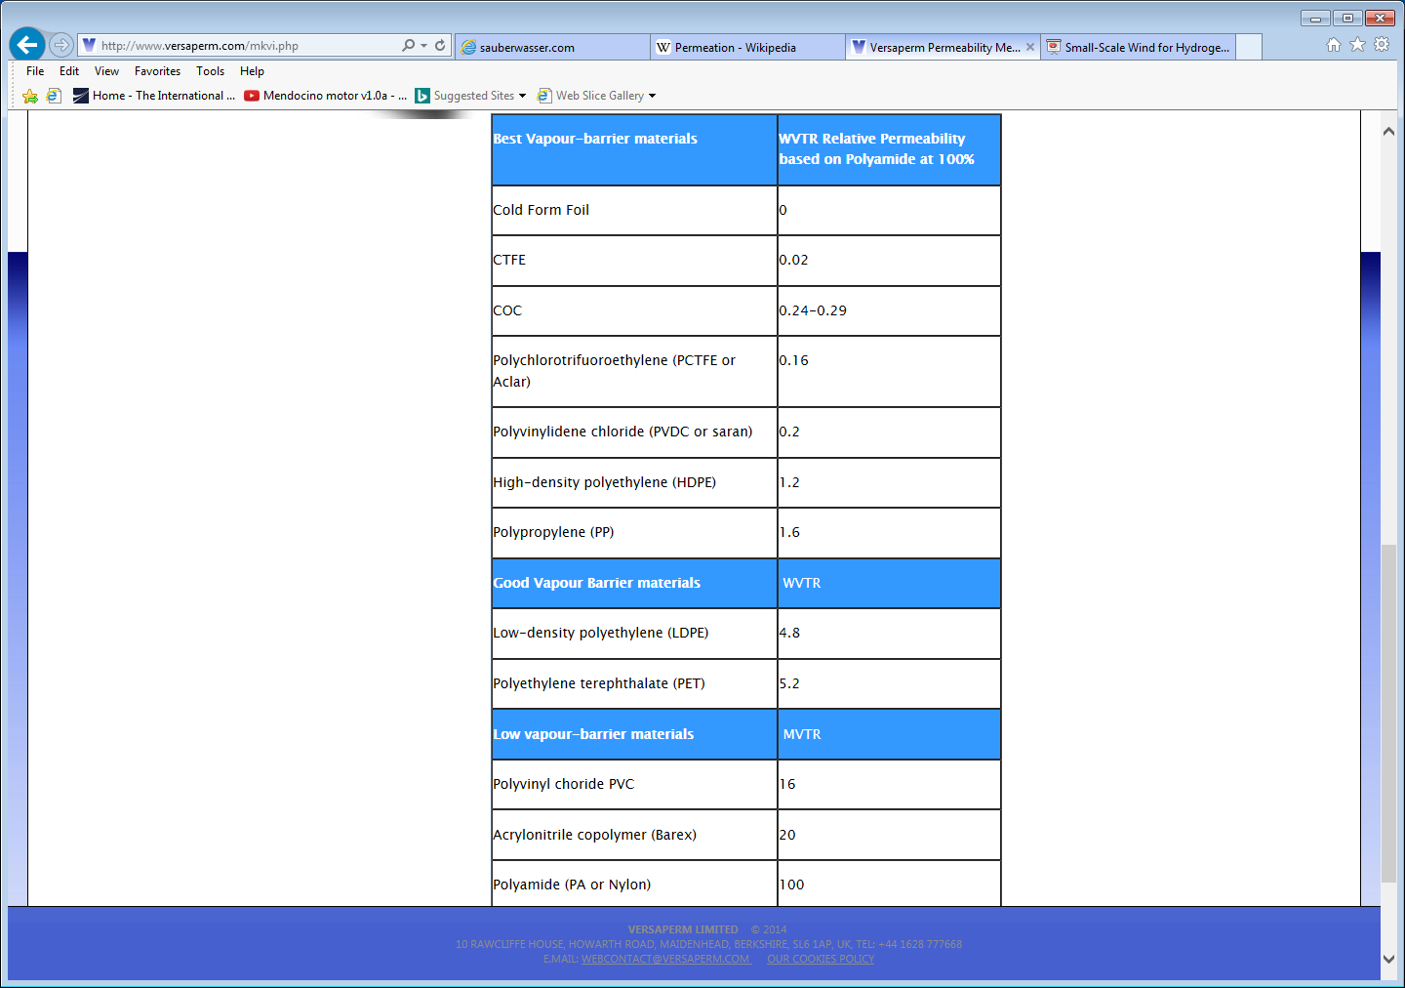

<http://www.medetec.co.uk/documents/MVTR-formulae.pdf>

Calculater

<https://www.norner.no/bcalc/model/otr/film>

Permeability

[(ml·mm)/(m2·atm·day)]

MVTR has units in europe of [gr/m2.day]