Gas RH instrument borrowed from Gas group Ian Crotty

20June 2017

DMT242 Vaisala finland

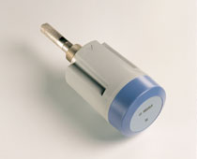

http://www.vaisala.com/Vaisala%20Documents/Brochures%20and%20Datasheets/CEN-G-EN-DMT143L-Datasheet-B211602EN.pdf

<http://www.vaisala.com/en/products/dewpoint/Pages/DMT242.aspx>

<http://www.dewpointsensors.com/?gclid=CPbck8bAzNQCFYiT7QodLvsFgw>

<https://megadepot.com/product/vaisala-dmt242-dewpoint-transmitter-for-oem-applications>

<https://www.dakotainstruments.com/thermohygrometer-with-nist-wd-20250-21?gclid=COOl3NPAzNQCFc-17QodCBADdw>

<http://www.nokeval.com/en/products/displays/>