Mas flow meters and controllers (MFM & MFC)

[](http://www.mathesongas.com/index.aspx)

<http://www.mathesongas.com/pdfs/products/Massflow-Equipment-Product-Line-Overview.pdf>

<http://www.mathesongas.com/pdfs/products/Model-8112-Self-Contained-Mass-Flowmeter.pdf>

http://www.ebay.com/itm/Matheson-Self-Contained-Model-8111-Mass-Flowmeter-/271571106322

**Aalborg**

<http://www.aalborg.com/index.php/main_page/product_info/products_id/493069/show_table_build/show/confback/23>

810USD

**Sierra**

http://www.sierrainstruments.com/library/tags/gas-flow-meters

Quote request 3 Feb 2015

**Bronkhorst**

<http://www.bronkhorst.com/?gclid=COjpvsunxsMCFUcUwwodAUcAJQ>

<http://en.wikipedia.org/wiki/Mass_flow_meter>

**Alicat** used by Pakistan, GEM Hassan Shazad.

We are using MC-series MFCs from ALICAT Scientific, USA.

<http://www.alicat.com/documents/specifications/Alicat_Mass_Controller_Specs.pdf>

Multiple MFCs contolled from a PC using “Multi Drop box” with USB connection rather than RS232.

<http://www.alicat.com/documents/manuals/Gas_Flow_Controller_Manual.pdf>

1000$ for standard MFC butane 20sccm.

<http://www.alicat.com/products/mass-flow-meters-and-controllers/mass-flow-meters/>

http://www.alicat.com/products/mass-flow-meters-and-controllers/mass-flow-controllers/

<http://www.alicat.com/whisper./>

Distributors for Switzerland

Natec Sensors GmbH

Niels-Bohr-Strasse 9-11

Garching, 85748

Phone: +49 89 307 591 0

sales@natec-sensors.com

**Brooks Instruments**

<http://www.brooksinstrument.com/flowmeter-flowcontroller-products/thermal-mass-flow-meters-a-flow-controllers.html>

**Omega**

<https://www.omega.com/pptst/FMA1700A_1800A.html>

500 USdollars !!

**CONCOA** made in USA

<http://www.concoa.com/massflowcontroller.html>

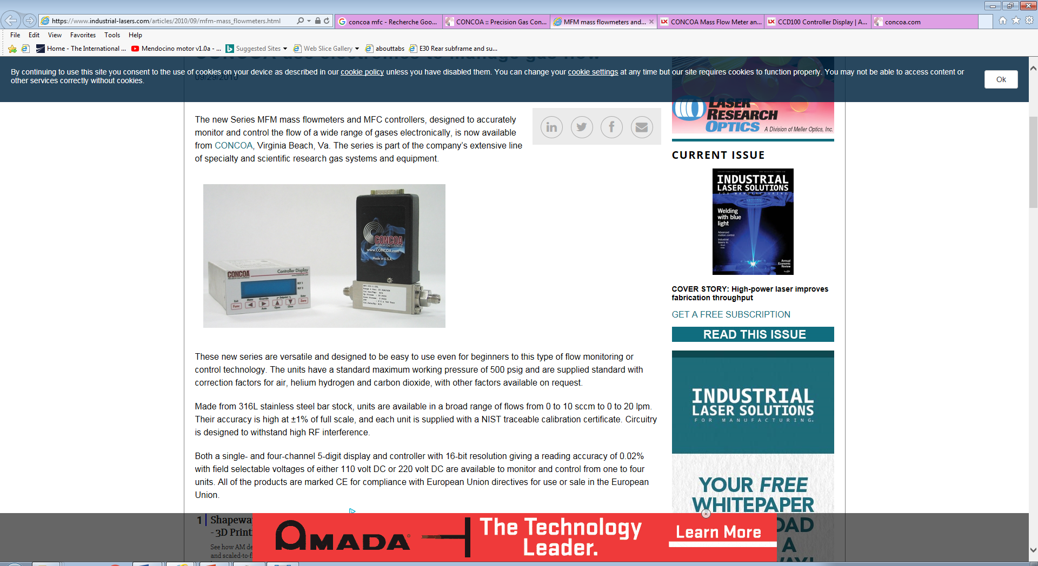

In ICN – UNAM the display/power seems to come from a Teledyne THPS unit;

<http://www.teledyne-hi.com/resourcecenter/Documents/PB-166_THPS-400.pdf>

TeleDyne Hastings also make their own MFCs

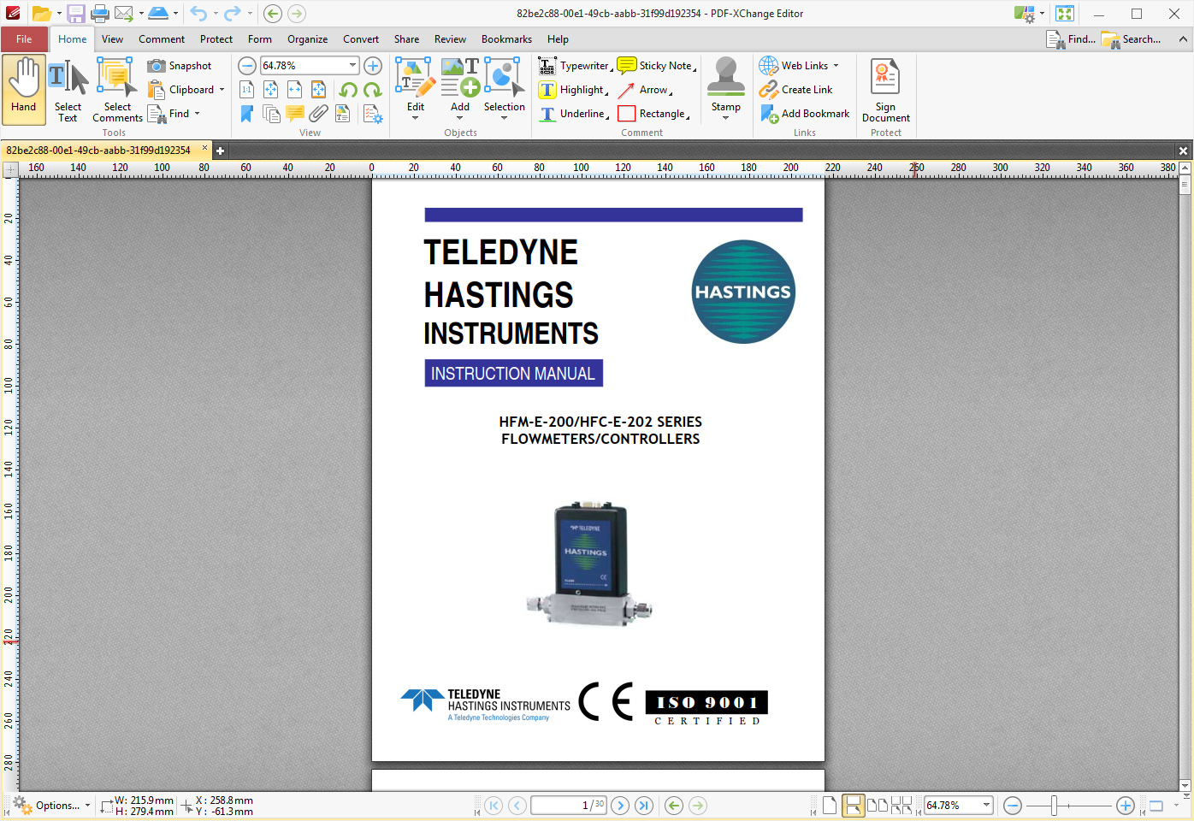

http://www.teledyne-hi.com/resourcecenter/Documents/PB-166_THPS-400.pdf

http://www.durhaminstruments.com/downloads/products/D-301-303-305-307%20Digital%20Flowmeters-Controllers_913.pdf

https://www.ebay.com/b/Teledyne-Flow-Meters/67070/bn_85185415

**MKS Instruments**

oieuch

Chinese suppliers

<https://www.google.ch/#q=chinese+mas+flow+controler>

<http://www.vici.com/cv/flowcon.php?gclid=CJLj-OGbo84CFUa6GwodVrMAww>

<https://www.alibaba.com/countrysearch/CN/mass-flow-controller.html>

<http://www.made-in-china.com/products-search/hot-china-products/Mass_Flow_Controller.html>

<http://mfchelp.com/mass-flow-controllers>

<http://www.mfcsevenstar.cn/en/>

<http://www.brooksinstrument.com/blog/tag/mass-flow-controller/>

<http://www.aliexpress.com/item/DHL-EMS-Celerity-TN2900-Series-FC-2900V-FC2900V-Mass-Flow-Controller-AR-300-SCCM-C-A1/32680725719.html?spm=2114.40010208.4.1.Yz3Pbs>

<http://www.aalborg.com/index.php/main_page/product_overview/id_product_overview/24>

<https://www.buerkert.ch/fr/content/download/7476/236630/version/19/file/EN-Product-Overview-06-MFC.pdf>

<http://www.made-in-china.com/productdirectory.do?subaction=hunt&style=b&mode=and&code=0&comProvince=nolimit&order=0&isOpenCorrection=1&word=gas+mass+Flow+controller>