Gas sources and spec

**R134a**

CMS Quality 99.9% = 30%

PanGas

http://www.pangas.ch/internet.lg.lg.che/fr/images/tega_ps_r134a-1-1-1-2-tetrafluorethan_d557_114878.pdf

**Isobutane**

CMS Quality 35 = 99.95%

**SF6**

CMS Quality 100% !!

<http://www.carbagas.ch/file/otherelementcontent/pj/sf6_f16664.pdf>

SF6 chez Linde

<http://hiq.linde-gas.com/en/specialty_gases/pure_gas_finder.html>

The worst classification, Sulfur hexafluoride 3.0

Purity ≥ 99.9% (Contact local team for exact specification)

Impurities [ppm]

Air ≤ 500ppmw CF4 ≤ 500ppmw H2O ≤ 5ppmw acidity (HF) ≤ 0.3ppmw

Hydrolysable fluoride ≤ 1ppmw

Suppliers

PanGas

<http://www.pangas.ch/fr/safety_and_quality/safety_glossary/index.html>

Linde

<http://www.linde-gas.com/en/index.html>

Carba Gas

Air Liquide

Web refs to be investigated.

<https://www.google.ch/#q=Industrial+gas+suppliers+in+europe>

<http://www.gasworld.com/>

<http://europa.eu/rapid/press-release_IP-89-426_en.htm?locale=en>

<http://ec.europa.eu/competition/consultations/2012_emissions_trading/eiga_en.pdf>

<https://www.gasworldconferences.com/conference/europe-2016/>

<http://info.dogpile.com/dogpl.305.02/search/web?q=industrial+gases+suppliers&ad.network=g&ad.keyword=industrial%20gases%20suppliers&ad.creative=87929141642&ad.position=1o3&ad.placement=&ad.matchtype=b&ad.aceid=&ad.ismobile=&ad.device=c&ad.devicemodel=&ad.adgroupid=25761287642&cid=363114482&ad.segment=dogpl.305.02>

<https://en.wikipedia.org/wiki/Industrial_gas>

list

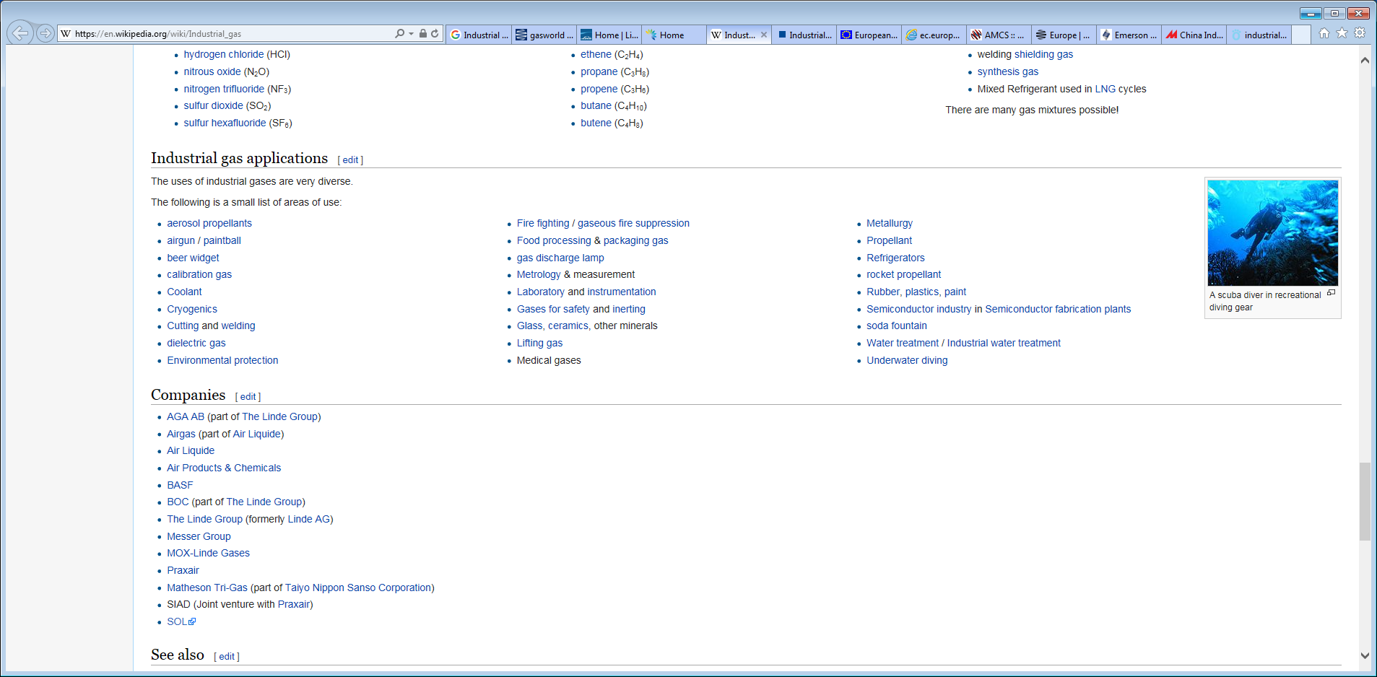

AMCS

http://www.amcscorp.com/

BASF

http://www.industrial-gases.basf.com/portal/4/en/dt.jsp

Euro Gas

http://www.eurogas.org/

Linde

<http://www.linde-gas.com/en/index.html>

Gas Bottles

<http://www.made-in-china.com/products-search/hot-china-products/Industrial_Gas_Cylinder.html>