Camping gas vapour pressure

Assume 80% Butane and 20% propane

https://www.engineeringtoolbox.com/propane-butane-mix-d_1043.html

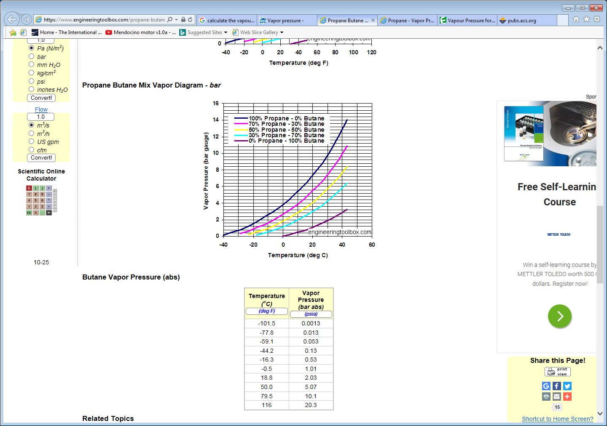

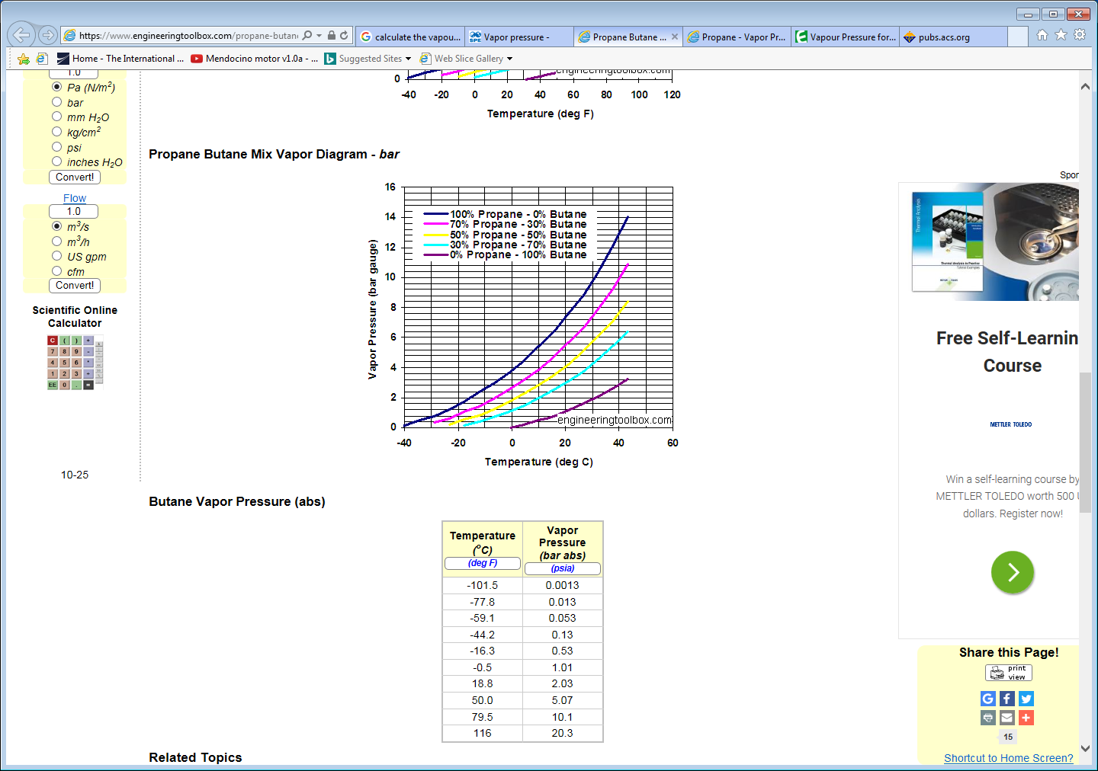

See also ;

<http://www.eng-tips.com/viewthread.cfm?qid=53610>

<http://pubs.acs.org/doi/pdf/10.1021/ie50341a021>

<http://ddbonline.ddbst.com/AntoineCalculation/AntoineCalculationCGI.exe>

<http://www.farnell.com/datasheets/1493663.pdf>