Intervention on 31 March and 1 April 2017 gas leaks

Ian Crotty 3 April 2017

RE+3/2,3/31,32,33 (TOP) done on Friday by-pass done on RE+3/3/31 with Rilsan

RE+3/3,2,/01,02 03 (TOP) checked in Sat am Saleh and IC no leak (using bottle H2O)

RE+3/3,2/10,11,12 (TOP) Were the same checks done with or without bubbler ?

The Sagana unions on the peripheral bulkheads were over tight !

The excel sheet made out in 2009 for the assembly was not made available, leading to delay in finding and confirming the Bulkhead and channel.

The Ar pressure was so small that it would not bubble in the Plastic Bottle Bubbler (PBB) over 12-15mm WC. So in the other tests was this a reason to believe that it was leaking ? Is it possible to operate the Gas leak Box in a manner that an apparent big leak is indicated ?

What did the leak test with a bubbler, if one was used, indicate for the RE+3/3,2/10,11,12 (TOP) as inspected by Anton and Aleksandar on late Sat morning.

***Conclusion***

The pipe used in the RE+3/31 between the type 2 &3 was NOT LDPE. It had gone hard and dirty yellow. See photos. Identification in progress.

Piping inside RE+3/3/31 appears to be in excellent condition, no discolouring, except perhaps for very slight crazing at the point of diameter increase where the pipe is forced onto the barbed gap fitting (gas gap inlet).

Can we depend on our instruments if one Gas group device says it leaks and our PBB shows it does not. Two of the three “leaks” were NOT leaks ! This is a very serious problem that can lead to all sorts of erroneous conclusions.

What is the action to take on RE minus if we have no confidence in the instrumentation/Gas leak box.

Are we wasting CMS time and our time ?

I could have used the time to calibrate the IR sensors in situ. I was equipped for this intervention with equipment set up in X2 far.

The endcscope availaible from TC in P5 gives excellent results.

We must all remain respectful of our colleagues even under stress. Communication should be improved.

Photos;

<http://project-cms-rpc-endcap.web.cern.ch/project-cms-rpc-endcap/rpc/Services/Gas/GasLeaksP5/RE/31March9april2017/Photos/REplus3/>

See some of the better photos below;

Bulkhead

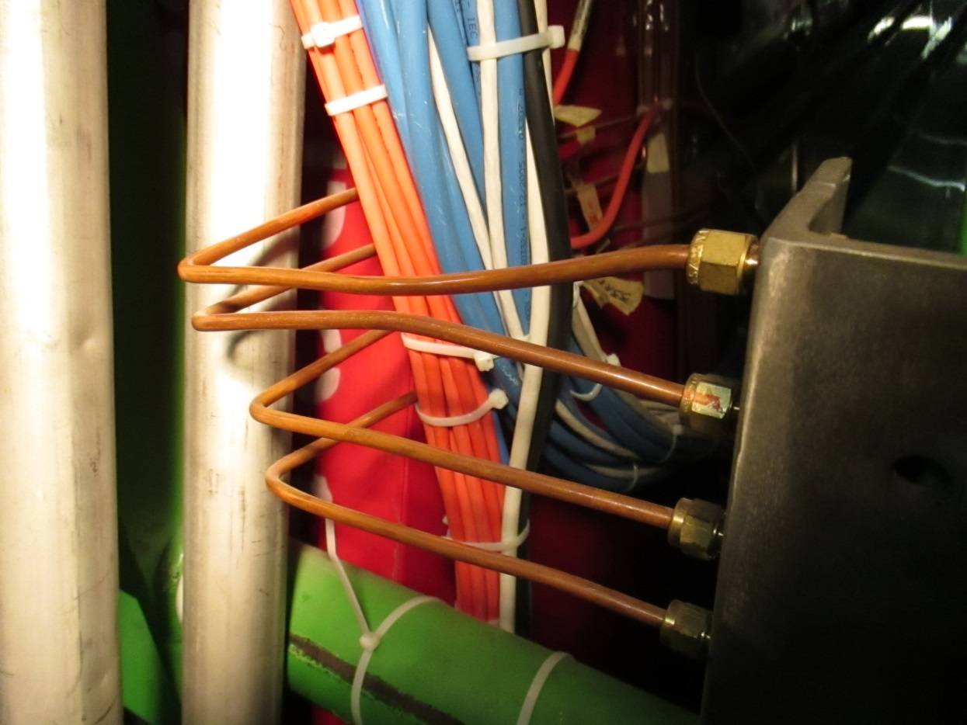

Link between type 2 and 3 showing “yellowing” of polymer pipe.

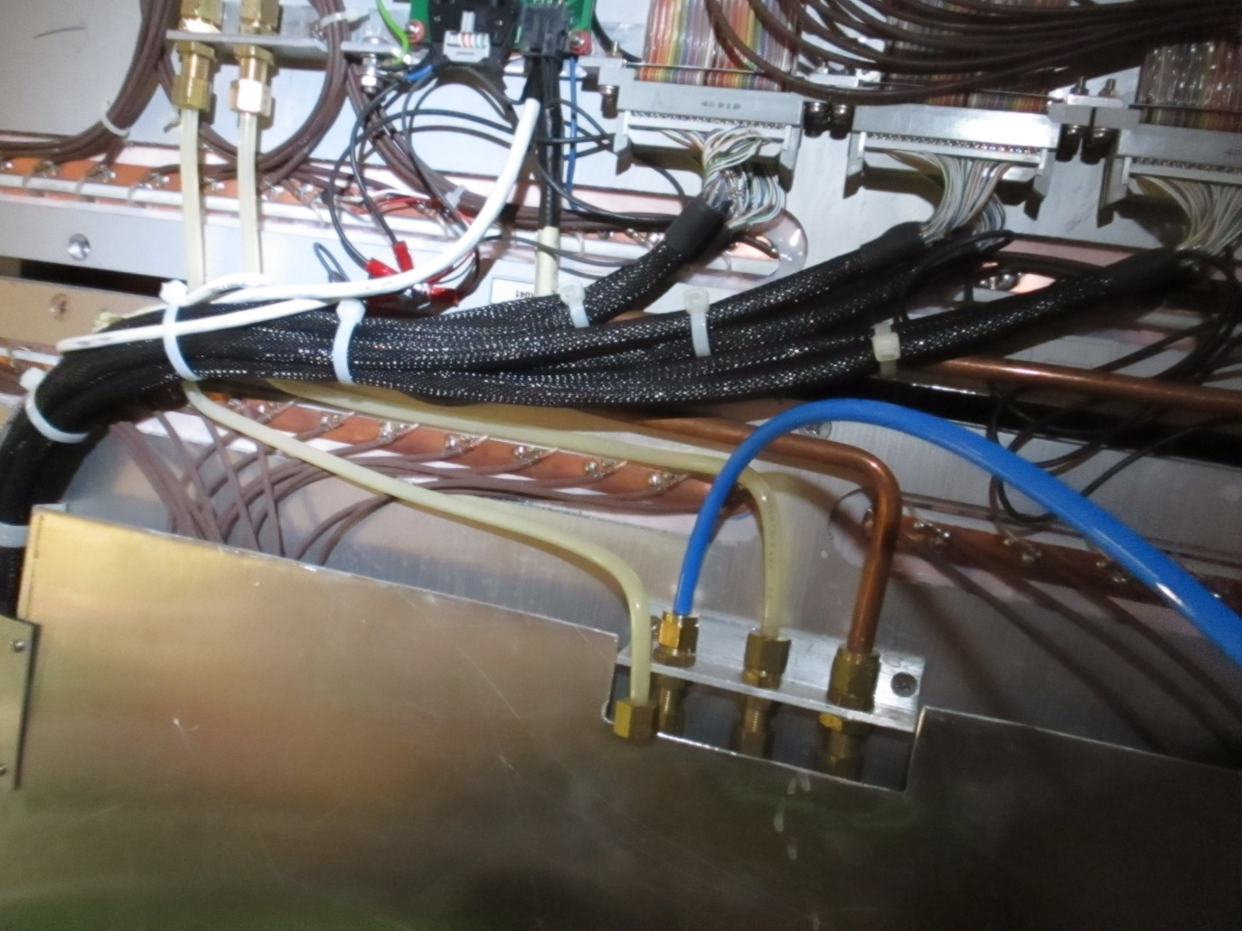

Inside chamber, gap entry at end of chamber.

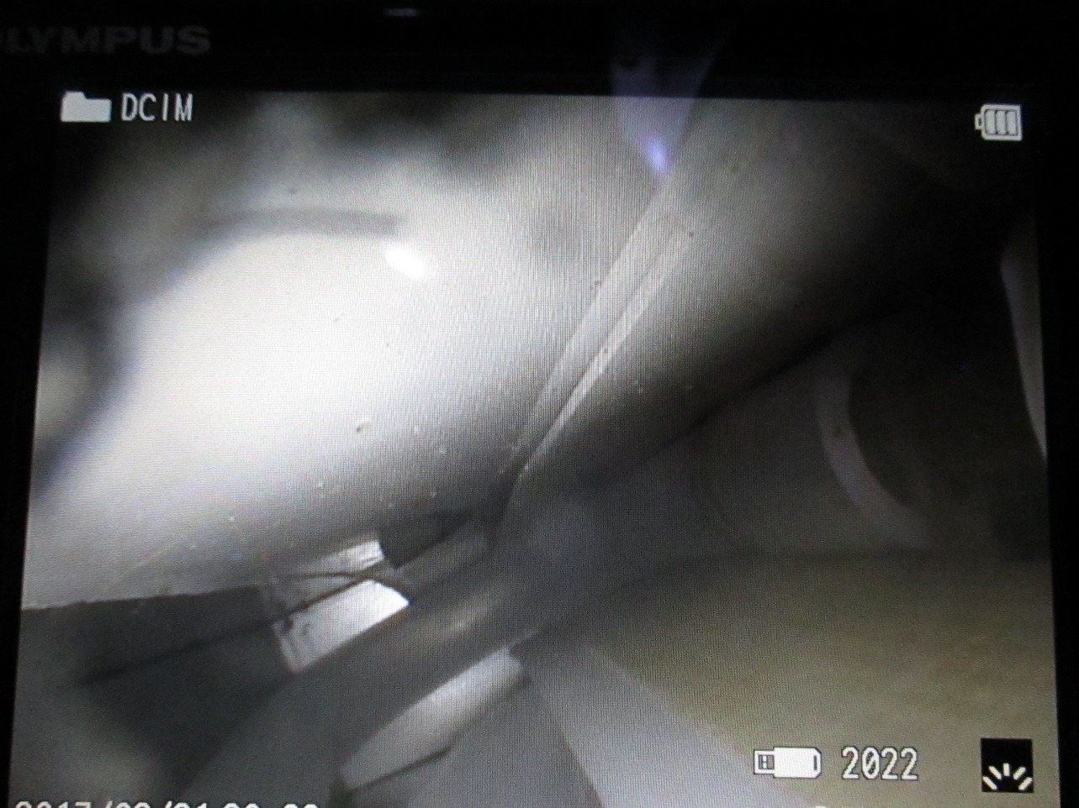

Close up of pipe on barbed gap inlet showing very slight crazing just before diameter increase.

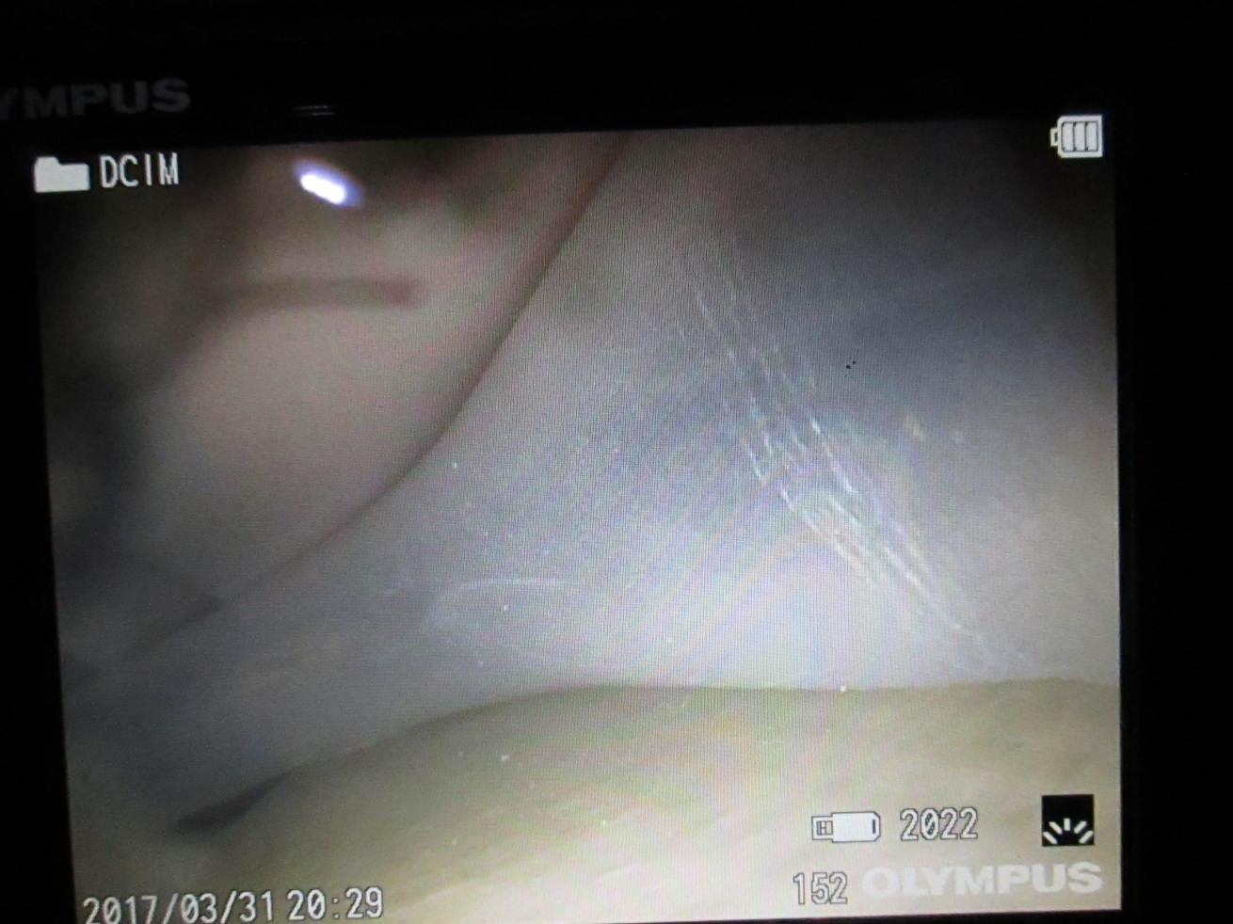

Plugged up corners on top and bottom gaps.

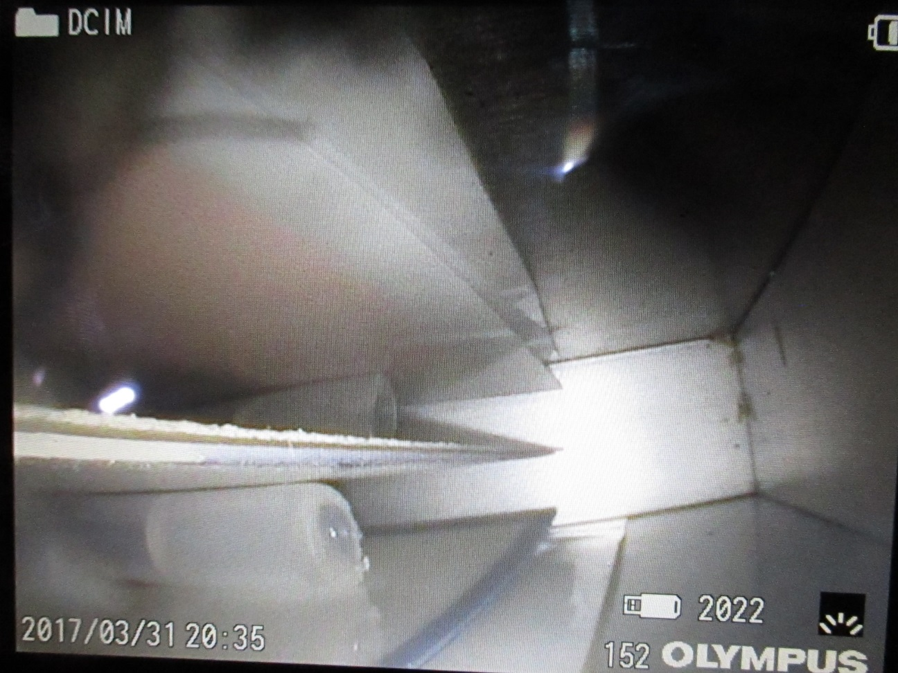

Shrinkage of hot melt in plugged up ends ? or 0.25mm slippage of plug ?

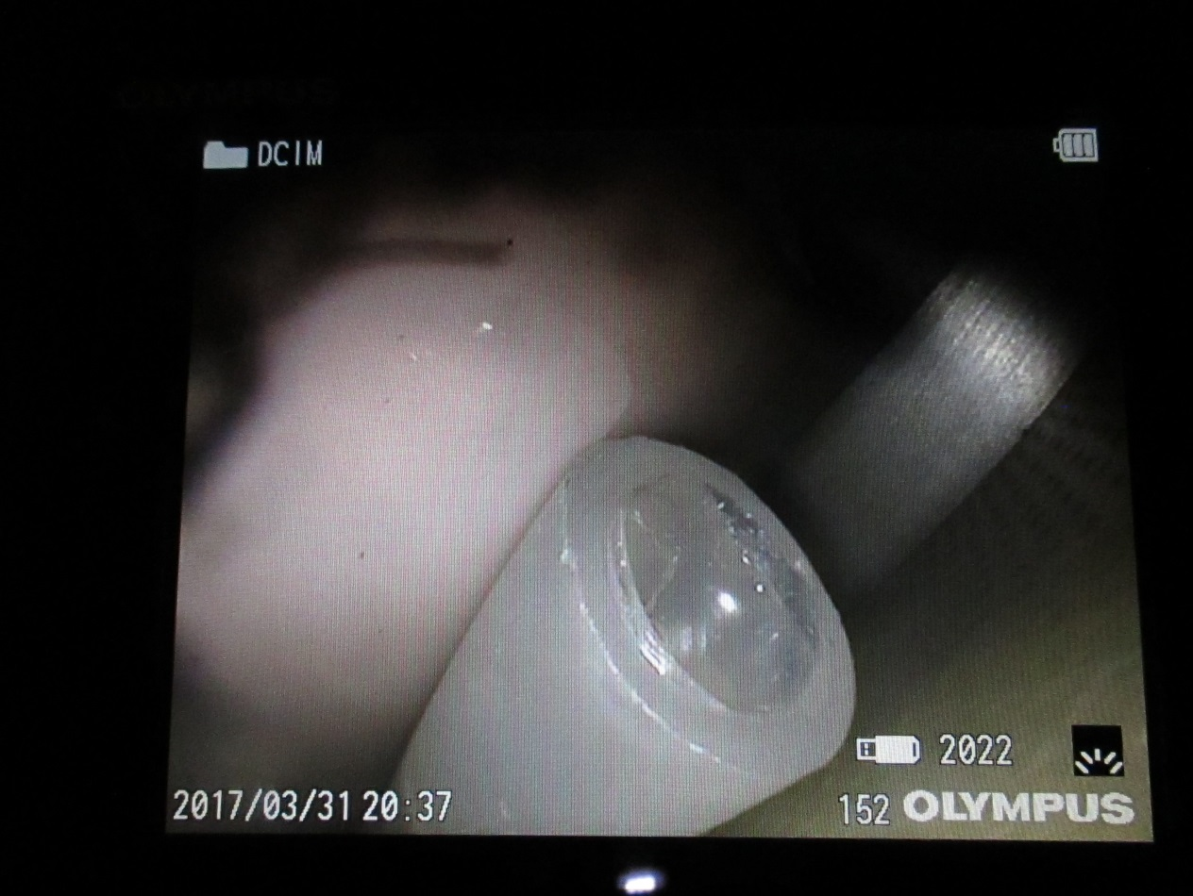

Superficial scratching and dust

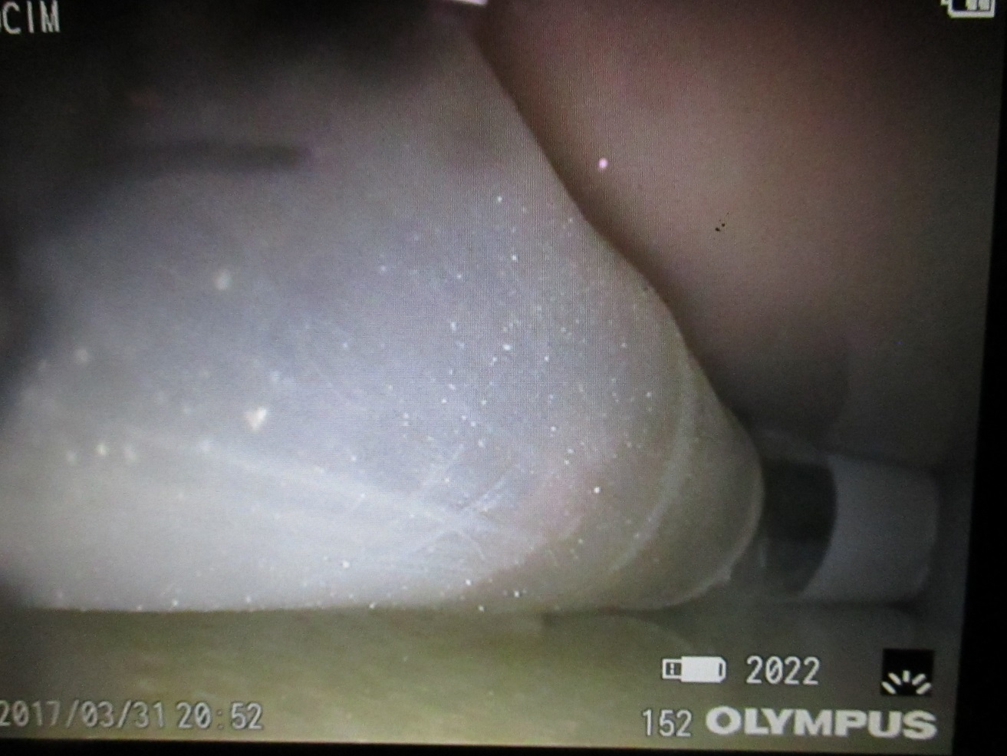

Increase in end diameter due to excessive heating

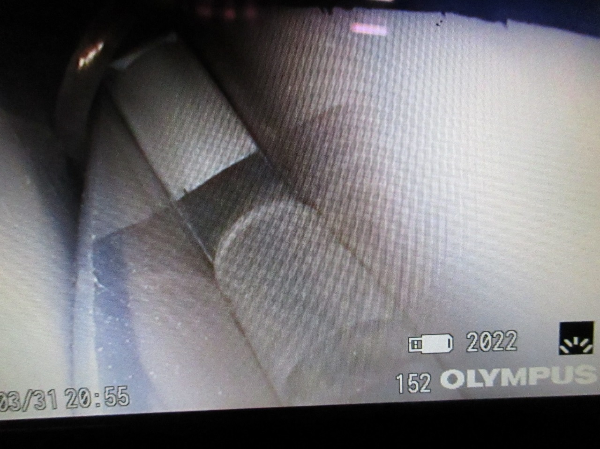

View of “U” between top gaps

