Intervention on 31 March and 1 April 2017 gas leaks

Transcription of notes made during intervention.

RE+3/2,3/31,32,33 (TOP) done on Friday by-pass done on RE+3/3/31 with Rilsan

RE+3/3,2,/01,02 03 (TOP) checked in Sat am Saleh and IC no leak (use biberon bubbler = BB)

RE+3/3,2/10,11,12 (TOP) “ We will do the same checks you did” but they had no bubbler ??

The Sagana unions on the peripheral bulkheads were over tight ! Was ZEC learning, I doubt as the unions were marked indicating they were taking care to tighten a specified amount was this amount too much for the small 6mm end of the 6 – 8mm union. The nuts were damaged in some cases !

When was Ar put on RE+3/3,2/10,11,12 (TOP) on Saturday morning ?

The excel sheet made out in 2009 for the assembly was not made available, leading to delay in finding and confirming the Bulkhead and channel.

There was no communication as to the status and then it became confusing as it was declared the channel was bubbling when in fact it had been opened at 2 places.

The Ar pressure was so small that it would not bubble in the BB over 12-15mm WC. So in the other tests was this a reason to believe that it was leaking ?

“We will do the same test as you” said by Anton around 11am Saturday once I had asked them why they are not checking the sector RE+3/3,2/10,11,12 (TOP). But they did not have a bubbler with them, did they ?

Friday abusive behaviour from Aleksandar , when I had had enough at 2115hrs, Saleh thought it was time to go and Andres had a RDV at 2200hrs.

Conclusion

The pipe used in the RE+3/31 between the type 2 &3 was NOT LDPE. It had gone hard and dirty yellow. See photos. Identification in progress.

Piping inside chamber appears to be in excellent condition, no discolouring, except perhaps for very slight crazing at the point of diameter increase where the pipe is forced onto the barbed gap fitting (gas gap inlet).

Do/did we really have 3 leaks in the endcap.

Can we depend on our instruments if one fancy Gas group device says it leaks and our BB shows it does not. This is a very serious problem that can lead to all sorts of erroneous conclusions.

What is the action to take on RE- if we have no confidence in the instrumentation/Gas leak box.

Are we just wasting CMS time and our time ?

We must all remain respectful of our colleagues even under stress.

I could have used the time to calibrate the IR sensors in situ. I was equipped for this intervention with equipment set up in X2 far.

Photos;

<http://project-cms-rpc-endcap.web.cern.ch/project-cms-rpc-endcap/rpc/Services/Gas/GasLeaksP5/RE/31March9april2017/Photos/REplus3/>

Bulkhead

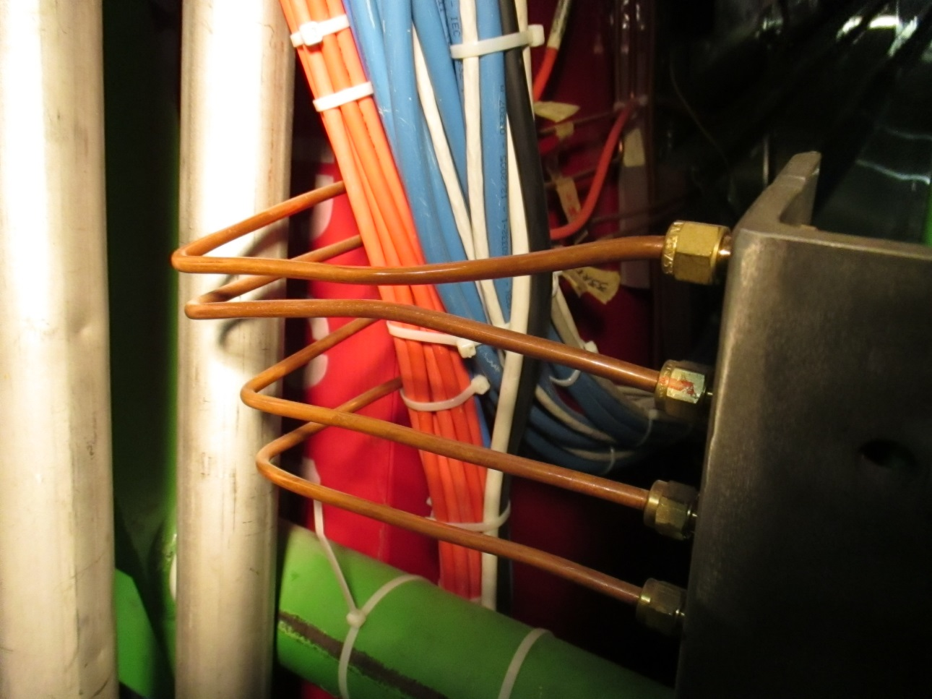

Link between type 2 and 3

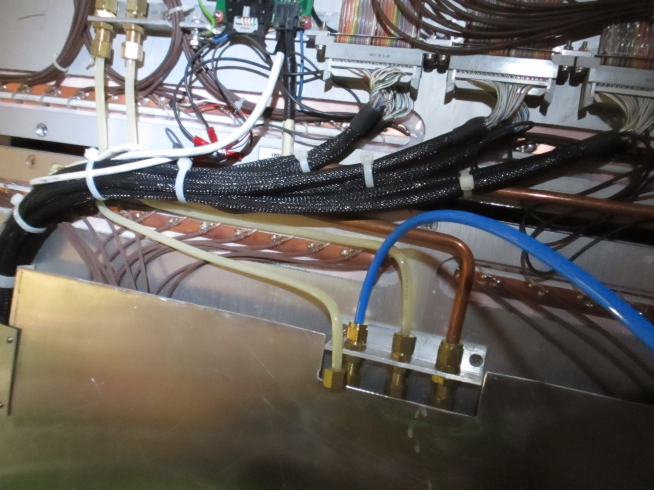

Inside chamber, gap entry

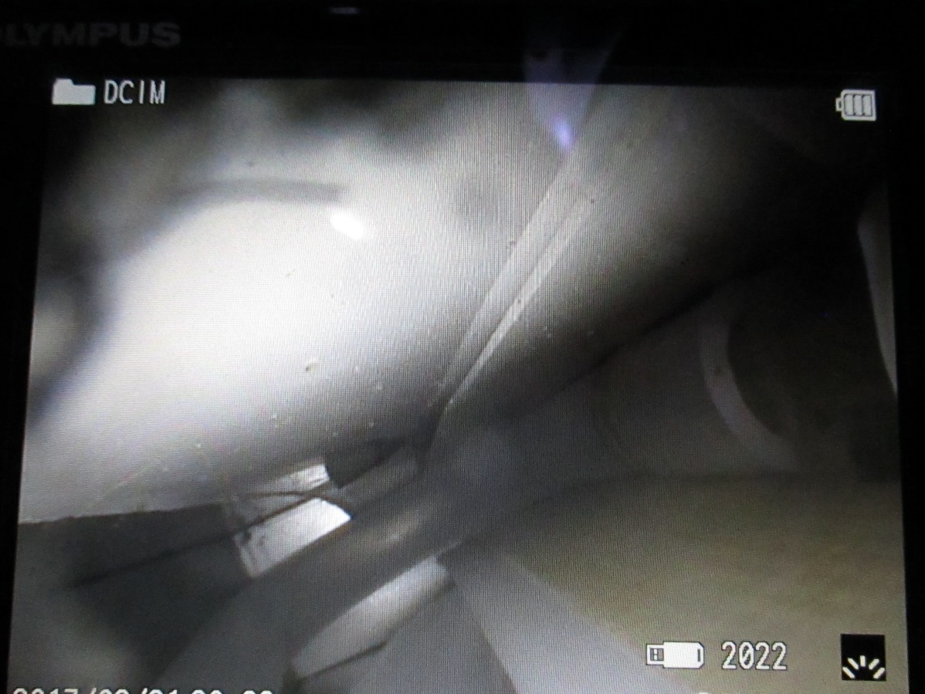

Close up of pipe on barbed gap inlet showing very slight crazing just before diameter increase.

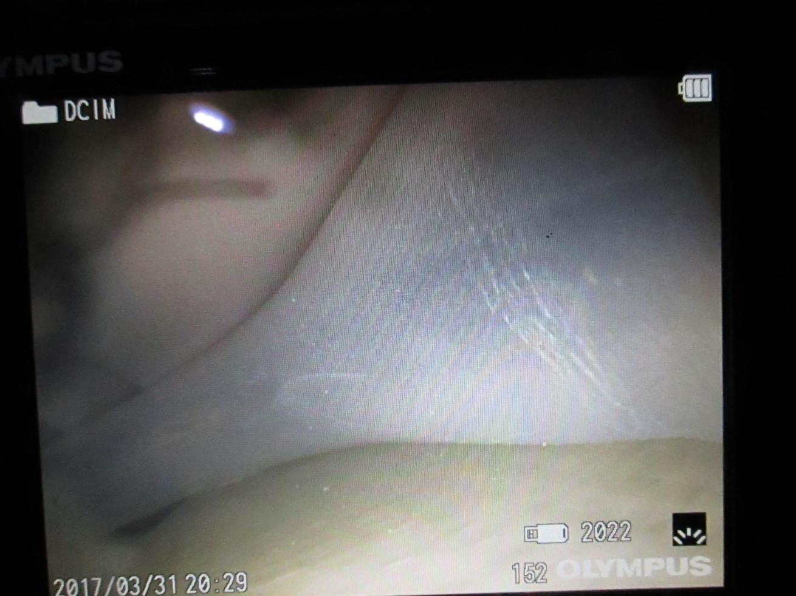

Plugged up corners on top and bottom gaps.

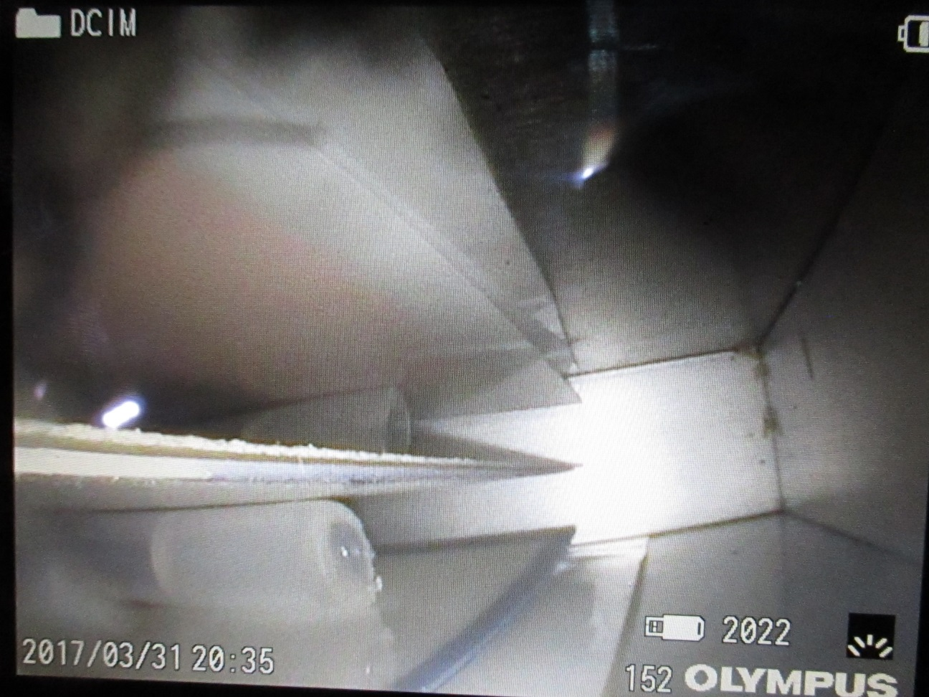

Shrinkage of hot melt in plugged up ends ? or 0.25mm slippage of plug ?

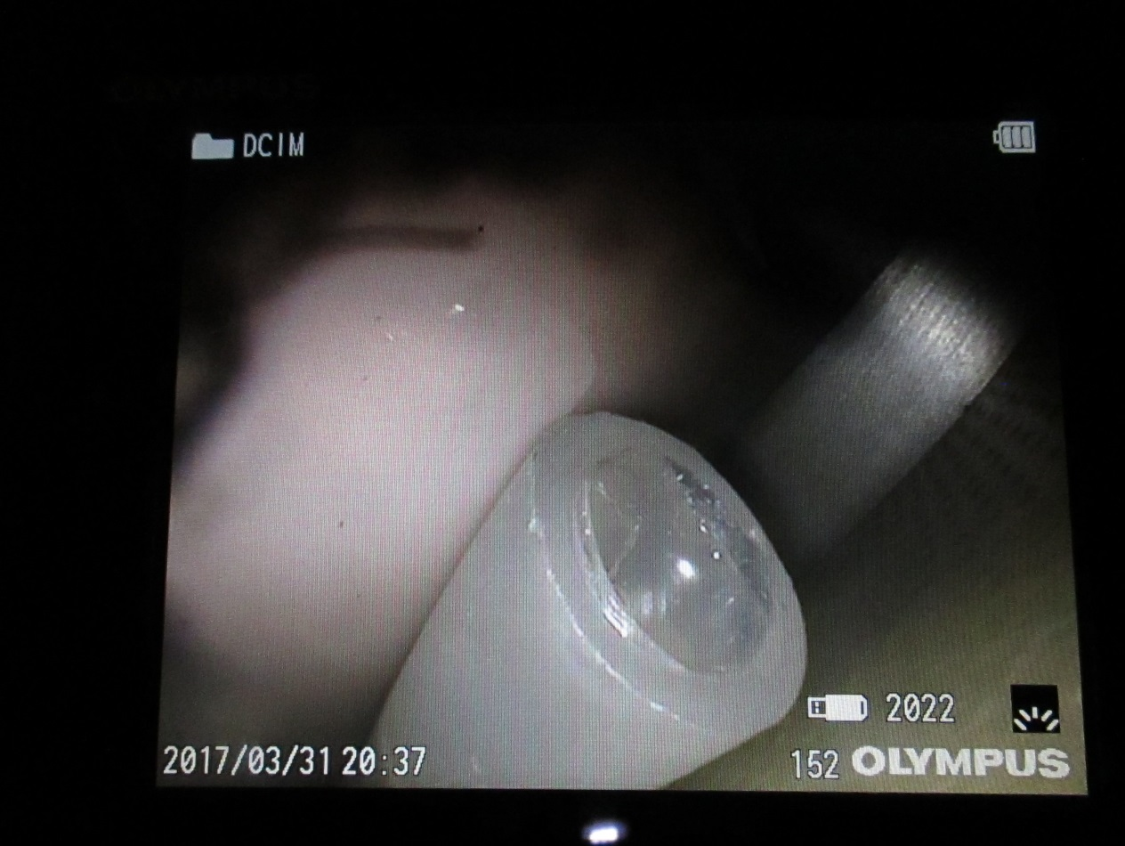

Superficial scratching and dust

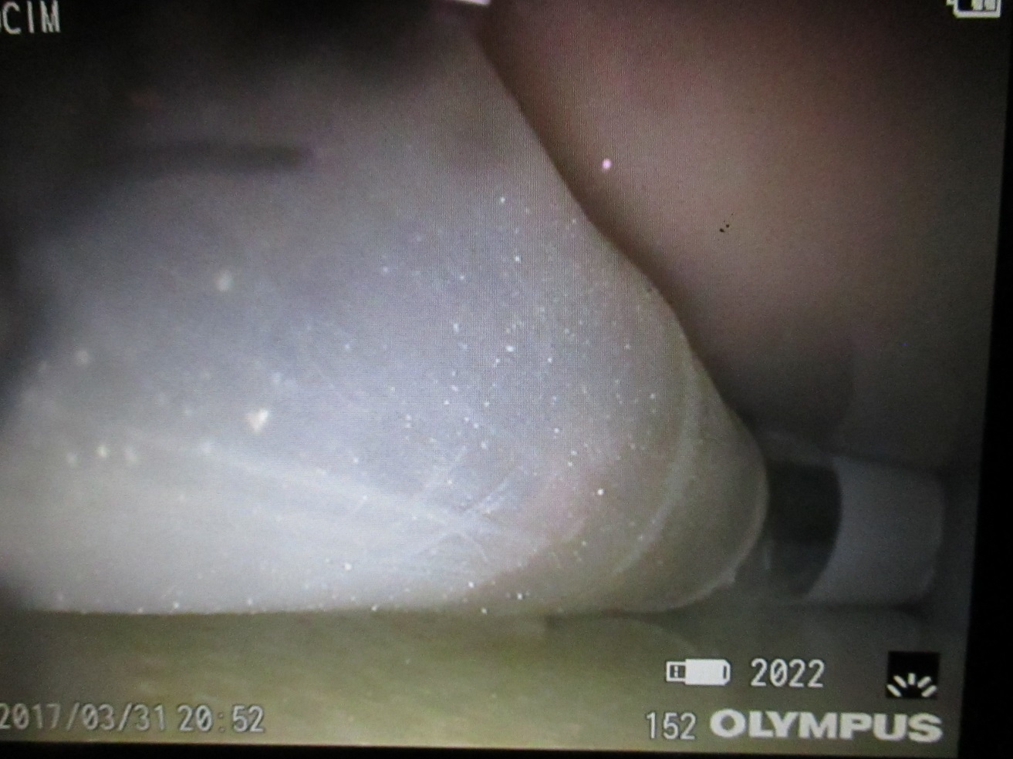

Increase in end diameter due to excessive heating

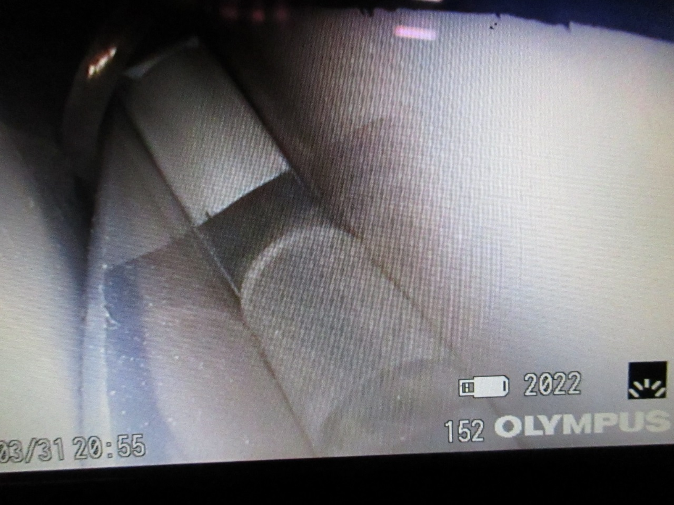

View of “U” between top gaps

