Broken Pies in RB

Ian Crotty 22 Feb 2017

“New” Material from Angst Pfister in Versoix

This material is the only one used in RE.

PE tube A03.758241.001 FT 12 1001 0604

CH 448 Chamber in P5 with leaks operating since XXX . Long sample taken from P5 and put in “large” plastic bag. Left in car overnight (~5degC) . In the morning the pipe was broken into many ( 10 pieces). These samples given to SS

CH206 in 904 was repaired after failure in P5 date XXX

` Many fragile zone on piping. Samples near Terminal block given to SS.

Long ~60cm unbroken with sample to SS with indication of 3 areas where cable ties were attached

CH150 in 904 . First chamber opened in Feb 2017

Need sample of this chamber as piping is different.

Photo of PE pipe with name. See below.

REXX Need sample of LDPE pipe from operational chamber in P5. Eg; the one that experienced 2Bar “test”.

Pipe types

CH150

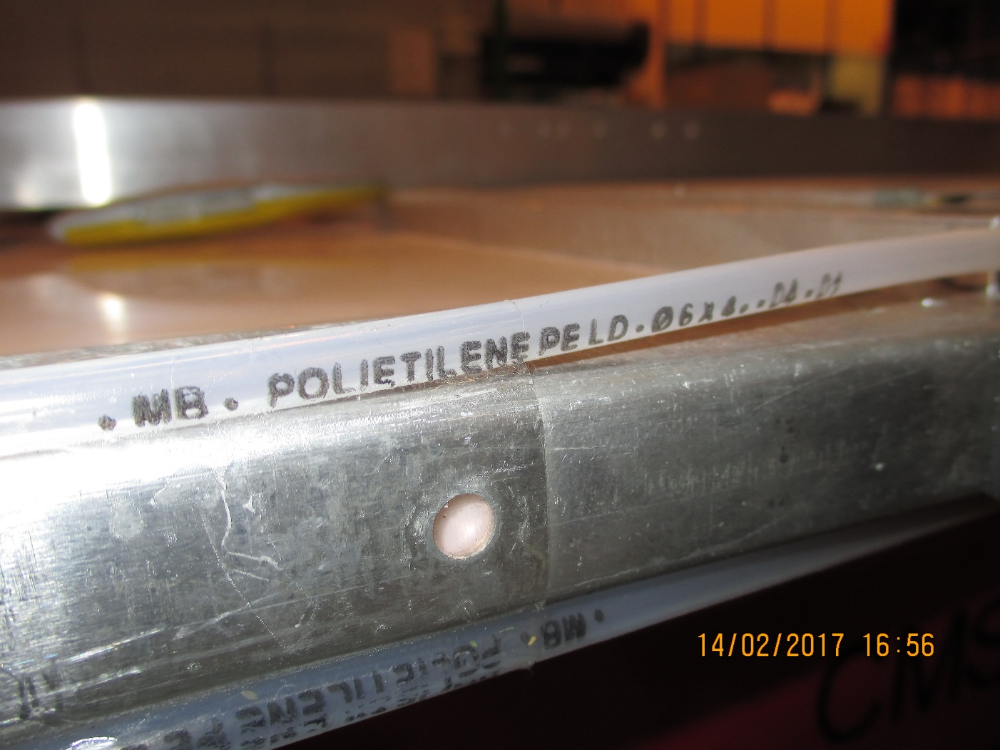

CH206

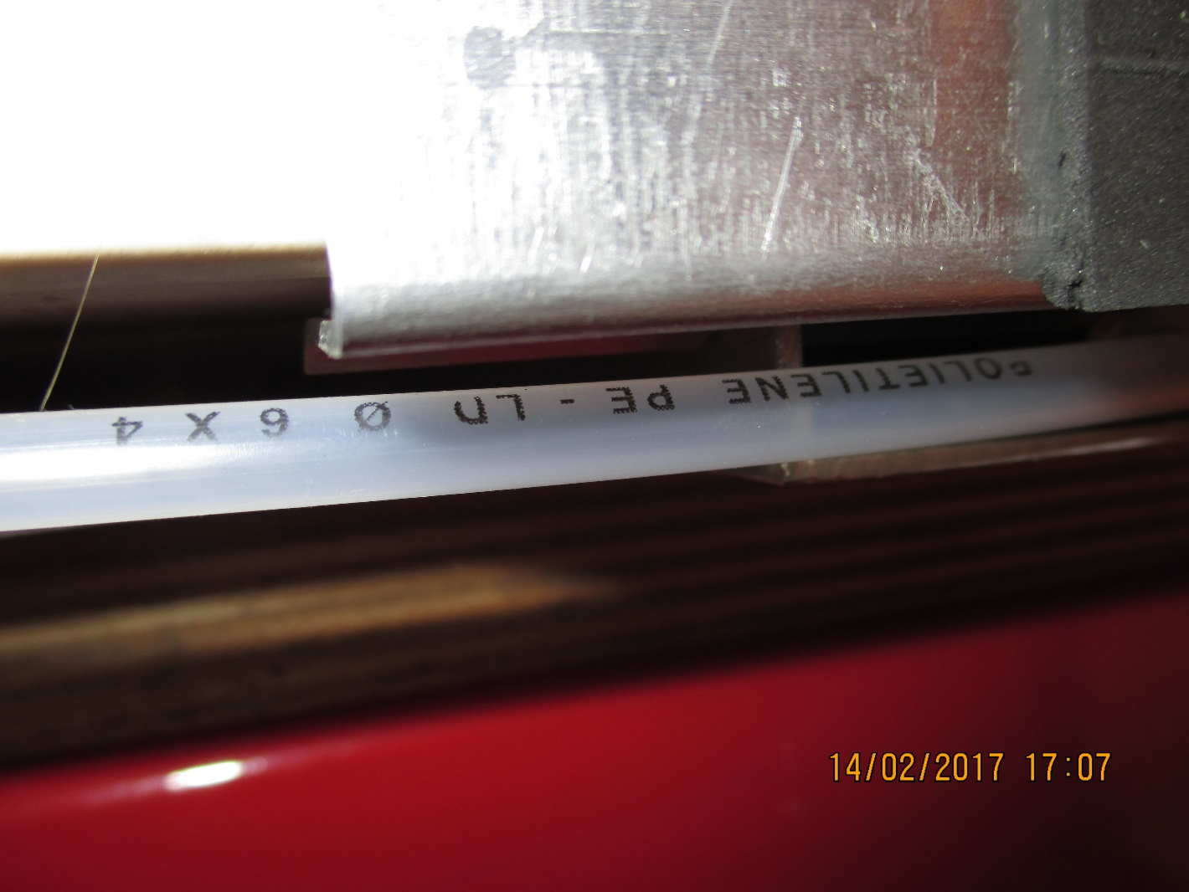

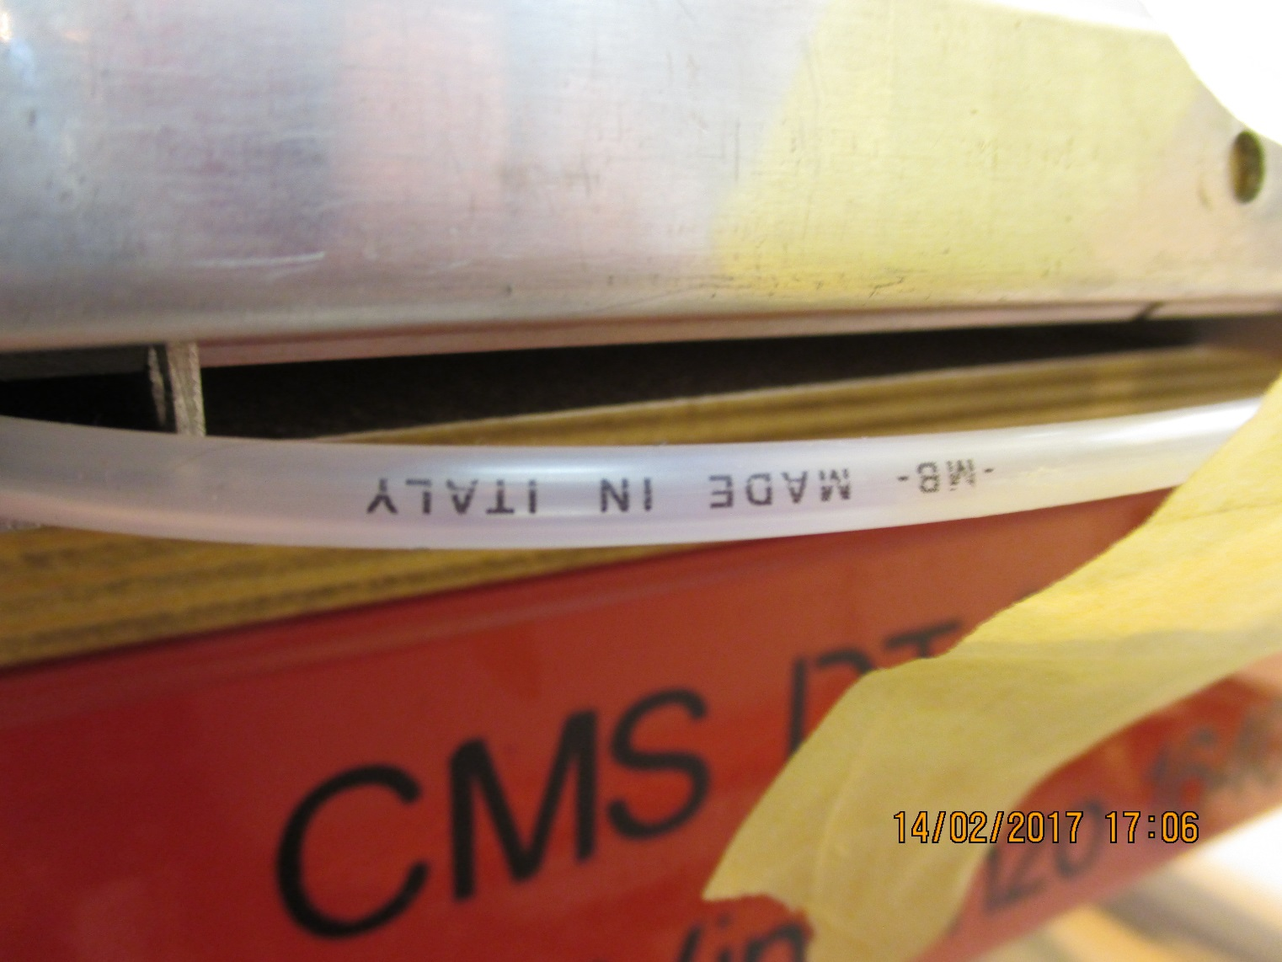

Angst Pfister

Photo here.