**1.Cooling**

The end cap region of the muon station in CMS experiment consists of different types of resistive plate chamber (RPC), depending on its location. During the operation of the RPC, there is a few miliwatts of heat energy dissipated into the front end boards; also there is an increase in the temperature of the Bakelite which has a bad effect on the dark current. So we need cooling system to be applied to the RPC and able to decrease the temperature of the front end board as well as the Bakelite surfaces. Different cooling systems were used for this purpose.

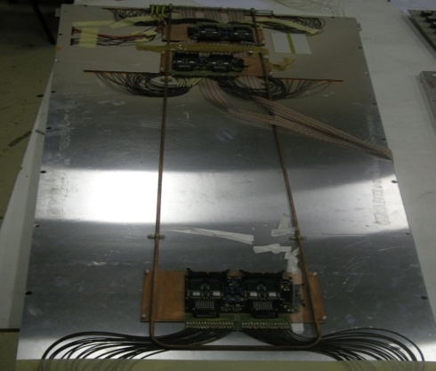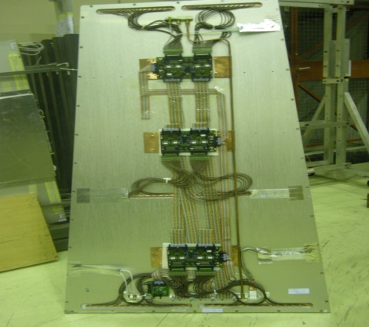

**Re1/2 Re2/2**

Figure 1 The cooling system in both RE 1/2 and RE 2/2.

As shown from Fig 1 the cooling system of RE 1/2 is simply cooper tube passing from one side of the RPC having U shape and get out from the same side so that the cooling liquid (water) passes through both sides of the front end boards (FEBs). On the other hand, the cooling system of RE 2/2 is just cooper tube enter from one side and out from the other side which mean that the cooling liquid takes the heat from one RPC to the next one. In this work, the variation of the temperature of the Front End Boards (FEBs) was recorded by using infrared camera (Varioscan 3021).

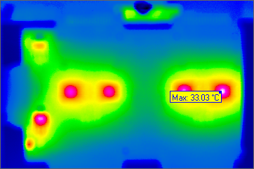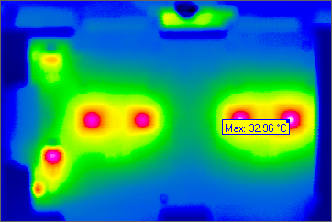

Fig 2 Front end board photos using infrared Camera.

Figure 2 shows two photos of the FEB taken by infrared camera. The figure indicates the hot parts of the front end board by the red spots.

**2. Method**

1- We put the chamber RE 1/2 on the gas for one day and then switch on the (FEB). Record the variation of the FEB temperature with time without cooling. Start cooling at 16 oC and also record the variation of temperature with time.

2- Switch on the High Voltage (9 KV) with the FEB on and record the variation of the FEB temperature with time without cooling and then with cooling at 16 oC.

3- Put the chamber RE2/2 on the gas for one day and switch on the FEB. Record the variation of the temperature with time with the cooling (16 oC) off and then on.

4- Switch on the High Voltage (9KV) with FEB on. Record the variation of the FEB temperature with time with cooling (16 oC) off and then on.

1. Repeat the previous four steps for both chambers RE1/2 and RE2/2 but with cooling at 20 oC.

## 3.Results

As shown in Figure3, the temperature of the FEB increases till it reaches plateau1 and when we apply cooling (16 oC) it starts to decrease till it reaches also plateau2.

For both RE1/2 and RE2/2 the effect of applying the high voltage is to increase the plateau1 temperature and leave the plateau2 temperature nearly the same. One possible



Figure 3. The variation of the FEB temperature with time for both RE1/2 and RE2/2 with HV on and off and cooling (16 oC) off at the first part of the graph and on at the second part.



Figure 4. The variation of the FEB temperature with time for both RE1/2 and RE2/2 with HV on and off and cooling (20 oC) off at the first part of the graph and on at the second part.

reason of this increase in temperature is that when we apply high voltage to the chamber, there is a gas gain so it works more.

Chamber RE1/2 reaches lower temperature than RE2/2 after applying cooling so that the cooling system in RE 1/2 is more efficient than that in RE2/2. By comparing the results shown in Figs 3 and 4 we found that the cooling at 20 oC is not efficient since at the end of the curve the temperature start to increase again in spite of the presence of cooling.

**4. Simulation of the new cooling system**

Since it is known that the U shape cooling scheme is more efficient, it is supposed to be used in the upgrade of the RPC. The second part of this study it to test the ability of the new cooling system to cool not only the front end board but also the surfaces of the Baklite.

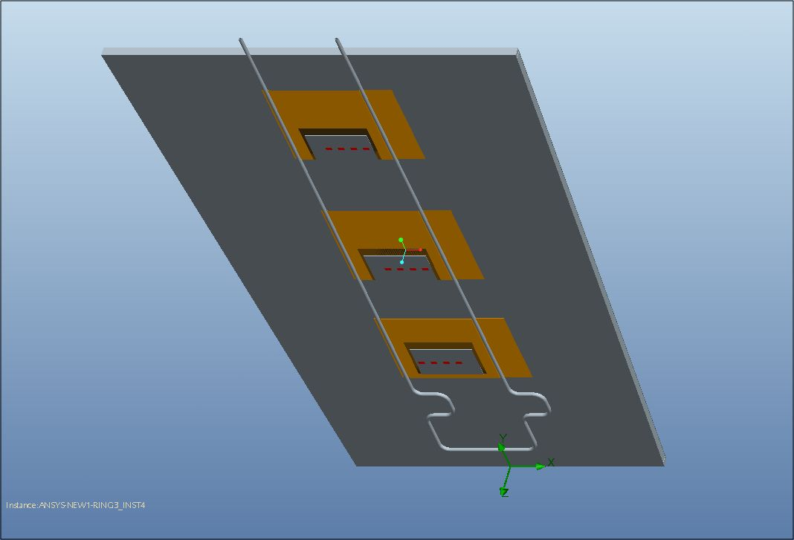

Figure 5 The cooling scheme for RE4

As a first step, simulation study was performed on the distribution of the heat on the different sides of the honeycomb panels as well as the top side of the copper plates. From simulation it is seen that the temperature of the copper plates (figure 6) fluctuated between 17.7 C and 21C except the positions of the four ICs which reach 23 C. So the copper plates are well cooled.

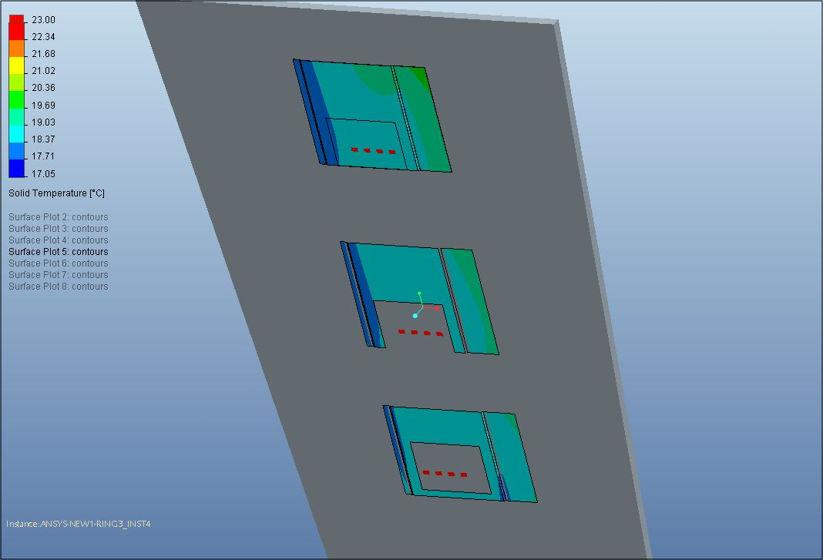

6 Temperature distribution on the copper plates (simulation).

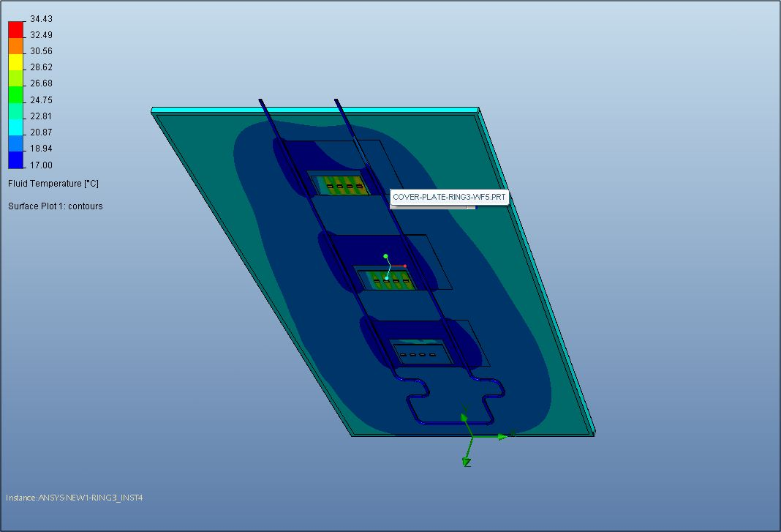

Figure 7 Temperature distribution of the top side of the honeycomb panel (simulation).

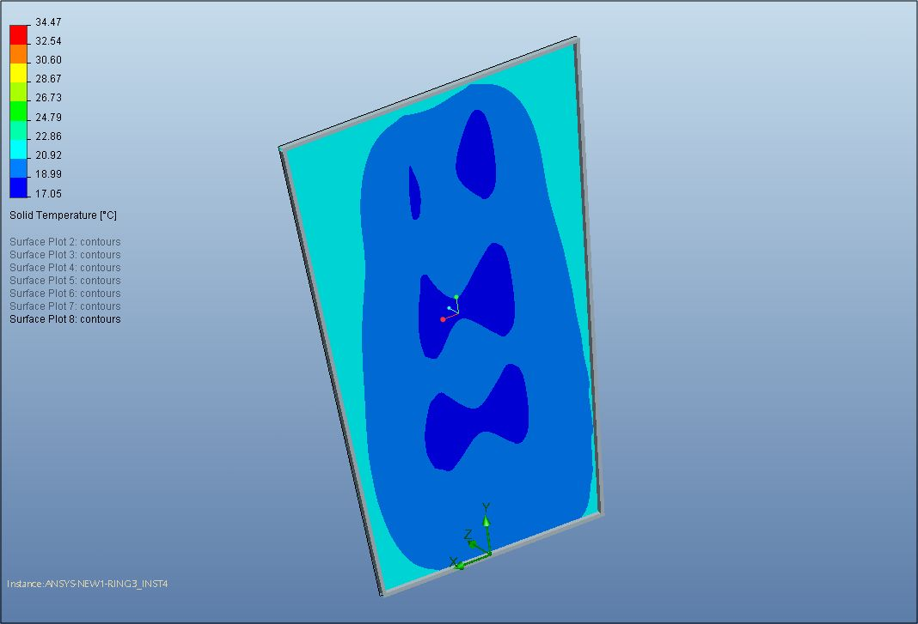

Figure 8 Temperature distribution on the bottom side of the top honeycomb panel (simulation)

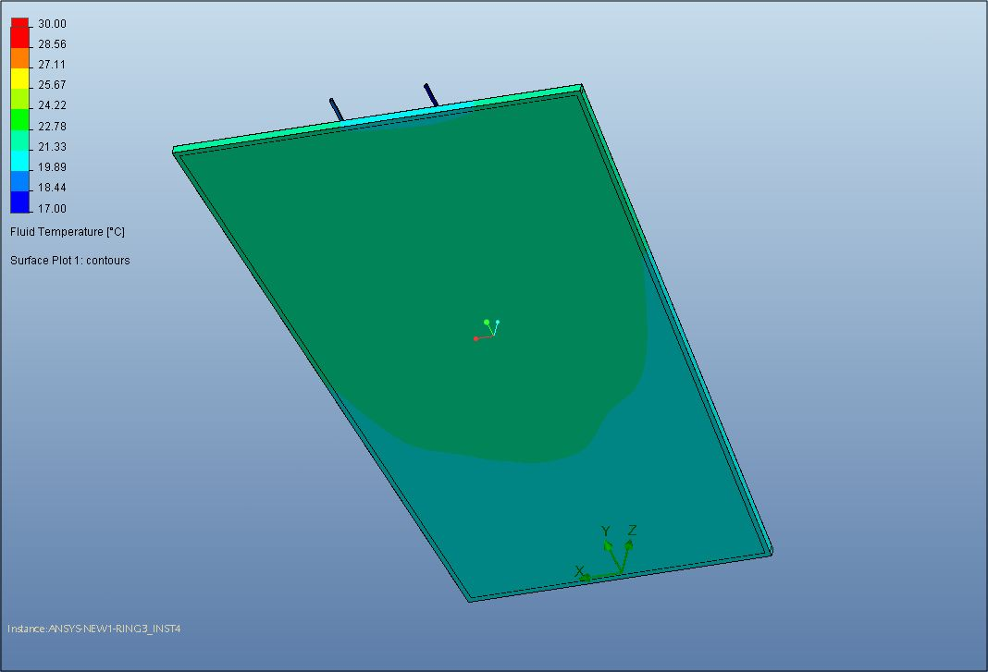

Figure9 Temperature distribution on the top side of the bottom honeycomb panel (simulation).

It is shown from figure 7 that the temperature of the top side of the top honeycomb panel is fluctuated between 17 and 20.86 which reflect the good efficiency of the cooling. The temperature of the bottom of the top honeycomb plat (figure 8) reach 22.66 C in the worth case while that of the top of the bottom honeycomb panel (figure9) reach 25C. The next step is to try to repeat the previous result experimentally and compare experimental data with simulation.

**5. Experimental setup**

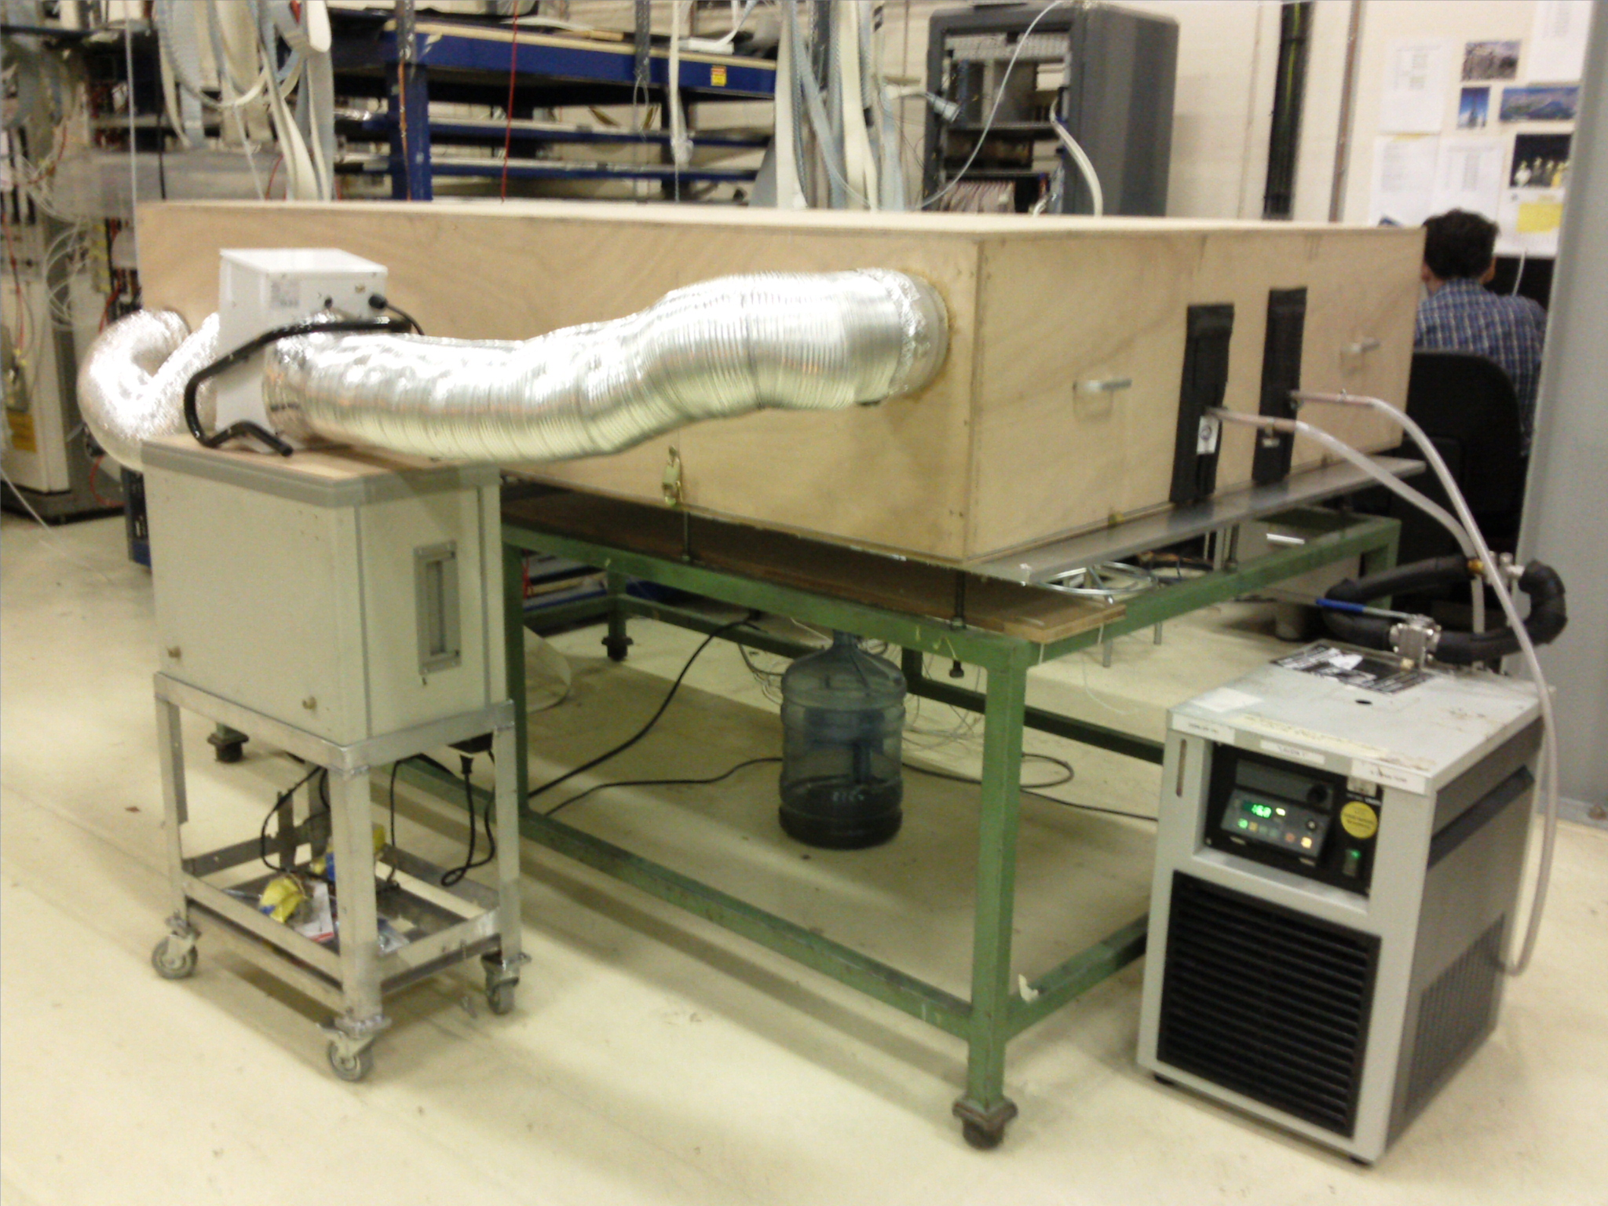

Chiller

Fan

Water output

Water input

Air output

Air input

10 Setup used for cooling study.

The setup consists of one RPC on which the cooling system to be tested was fixed. The sensors PT100 (that means they measure 100 Ohm at zero degrees C) were fixes in different point of the RPC. The RPC with the sensors were covered with wooden box as shown in figure 10 to control the environmental temperature of the RPC. Two more sensors were put outside the wooden box to measure temperature of the ISR. Fresh air were flushed inside the wooden box using a fan to mix the air inside and got homogeneous temperature. The temperature inside the box was increased my mean of normal electric 100W bulb. Water were used as coolant and flushed into copper pipe of the cooling system by means of chiller by which the temperature and the rate of flaw of the water were controlled.

* + 1. Experimental results

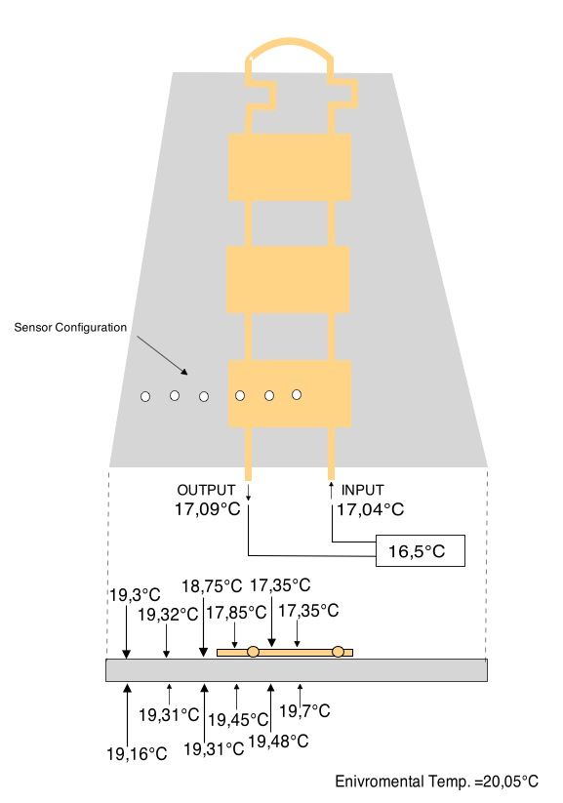 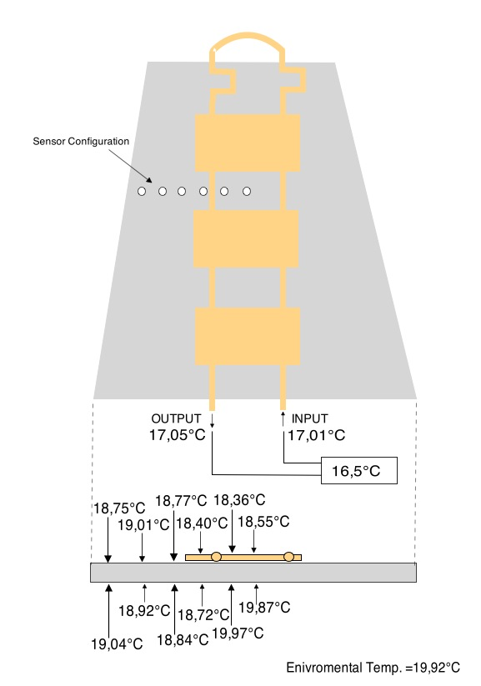

Figure 11 Temperature of the outer surfaces of the honeycomb in two deferent regions of the RPC.

It is shown from figure 11 (left) that the temperature of copper plate ranges from 17.35C and 17.85C which is consistence with the simulation if we take into account that the front end board was off here. The temperature reaches 19.3 C at the top edge while in the bottom the temperature fluctuated between 19.16C and 19.7C. In the second region (right) where there is no copper plate the temperature were fluctuated between18.36C and 19.01C on the top and between 19.04C and 19.87C on the bottom which is in good agreement with simulation (see figure 7).

The position of the sensors was changed to be on the top surface of the top gap (figure12). The temperature was fluctuated between 17.87C and 18.9C when the cooling temperature was 17C and the ambient temperature was 20.2C. These measurements mean that the surface of the Baklite was cooled by the new cooling system. This is an essential aim of this system. The next step is to start to play with the environmental temperature of the wooden box and the rate of flow of the water.

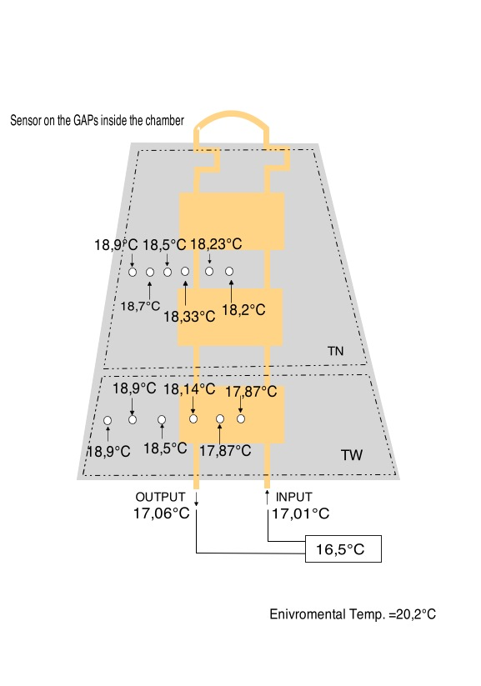

Figure 12 Temperature of the top surface of the top Baklite gap.

3 4 5 6 7

8 9 12

Bottom Gap Top Gap

Figure 13 Positions of the sensors with respect to bottom and top gaps.

During the last part of this work, eight sensors were fixed on given positions (see figure 13), one sensor inside the wooden box to monitor the controlled temperature and one sensor outside the box to monitor the uncontrolled temperature of ISR. The temperature was monitored for given period of time to ensure the stability of temperature measurements. For the CMS P5 parameters, the cooling temperature of water is around 18oC, the rate of flow is 1l/min and the environmental temperature depend of the period weather and range from 20-25oC. In figure 14 the parameters were adjusted to be consistent with that of CMS, box temperature=22oC, rate of flow = 1l/min and chiller temperature =18oC. The temperature of the top of the top gap ranged from 20.25oC to 21.6oC which mean that the far edge of the gap was cooled. The temperature of the bottom of the bottom gap (worse case) fluctuated from 20.9oC to 21.6oC which reflect the fact that the new cooling system is sufficiently efficient to cool all points of the two Baklite gaps.

To be more satisfied with the new system, the temperature inside the box was increased to 24oC and the rate of flow 2l/min and 1l/min while the cooling temperature were kept unchanged (18oC). In figure 15, the box temperature=24oC and the rate of flow =2l/min. In this case, the temperature of the top of the top gap ranged from 20.5oC to 23.3oC which mean that in worse case there is 0.7oC less then the temperature of the wooden box. The temperature of the bottom of the bottom gap fluctuated from 22.3oC to 23.4oC so that three is 0.6oC difference between the bottom gap temperature and the temperature of the wooden box. In figure 16, the box temperature=24oC and the rate of flow =1l7min. The temperature of the top of the top gap fluctuated between 21.2oC and 23.5oC which mean that there is still 0.5oC difference in temperature between the worse point on the top gap and the wooden box. The temperature of the bottom of the bottom gap fluctuated between 22.6oC and 23.6oC so the difference between this temperature and wooden box temperature is 0.4oC. From the above measurements it was concluded that the new cooling system is efficient for all the studied cases.

Figure 14 Temperature of the sensors for cooling at 18oC and flow rate 1l/min.

Figure 15 Temperature of the sensors for cooling at 18oC and flow rate 2l/min

Figure 16 Temperature of the sensors for cooling at 18oC and flow rate 1l/min

**Conclusions**

The cooling scheme used in RE1 is more effective than that used in RE2 and RE3. Switching on HV increase the temperature of the FEB by 1 degree Celsius and Cooling at 20 oC is not effective in both RE1 and RE2 (or RE3). The new cooling system that will be used in RE4 is sufficiently efficient to cool the front end boards, the surfaces of the honeycomb panel and the surfaces of the Baklite gaps.