Dew point conditions in Experimenta at CERN

The dew point is a very relevant value in both the gas and ambient conditions for detectors that are made from polymeres that inherently adsorb water notably RPCs made from HPL normally Melamine/Bakelite.

Values taken in october 2015 are;

ATLAS 6000ppm

CMS 7300ppm was 8000ppm (anton changed) DP2.7degC @20degC RH30%

GIF 6.3 to 9.8 DPdegC = 12000ppmv

DP8degC= 10700ppmv

DP7degC= 10000ppmv

DP6degC= 9300ppmv

DP5degC =8700

DP4degC= 8100

DP3degC = 7500

DP2degC = 7000

DP1degC = 6500

DP0degC = 6000ppmv

ATTENTION THESE are ppm volume values NOT weight !!

[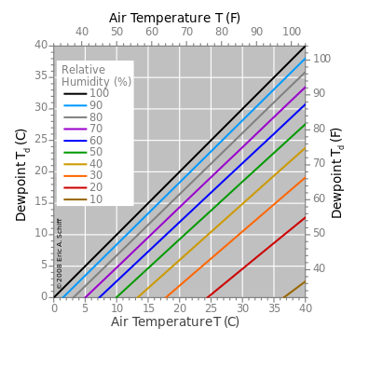](https://www.google.ch/url?sa=i&rct=j&q=&esrc=s&source=images&cd=&cad=rja&uact=8&ved=0CAcQjRxqFQoTCOPHgOWXv8gCFQG8FAodZvUK_g&url=https://en.wikipedia.org/wiki/Dew_point&psig=AFQjCNE5ekbOQaXRUq-OYp8e4vpHZh7Vmw&ust=1444814906689923)

<https://en.wikipedia.org/wiki/Dew_point>

Good Calculators

<http://www.humidity-calculator.com/index.php>

<http://andrew.rsmas.miami.edu/bmcnoldy/Humidity.html>

<http://www.rotronic.com/humidity_measurement-feuchtemessung-mesure_de_l_humidite/humidity-calculator-feuchterechner-mr>

Documentation

<http://www.vaisala.com/Vaisala%20Documents/Application%20notes/Humidity_Conversion_Formulas_B210973EN-F.pdf>

<http://sensing.honeywell.com/index.php?ci_id=49924>

<http://www.npl.co.uk/upload/pdf/Beginner's%20guide%20to%20humidity%20measurement%20(draft%20for%20comment).pdf>