EUROPEAN ORGANIZATION FOR NUCLEAR RESEARCH
COMPACT MUON SOLENOID EXPERIMENT

Gas leak test report

IDENTIFICATION
Date | 08.03.2005
Barrel / Endcap ID | YE-1
Circuit System | ME manifold and cooling circuits
Test preformed by | Soteb
CERN representative supervising | Lasse Isaksen
Initial test pressure | 14 bar
Time test pressure maintained | 22 Hours 43 min
Pressure drop during test period | 1300 mbar
Pressure drop during 1 hour | 58.06 mbar/hour
Volume | 230 liter
Leak rate with temperature correction | 3.72 mbar*l/sec

DECISION
DECISION
Contractors decision |  | Requester’s decision
Reject Approved |  | Rejected Approved
Name |  | Name
Date |  | Date

Summary:

Test was preformed once with no correction of leaks.

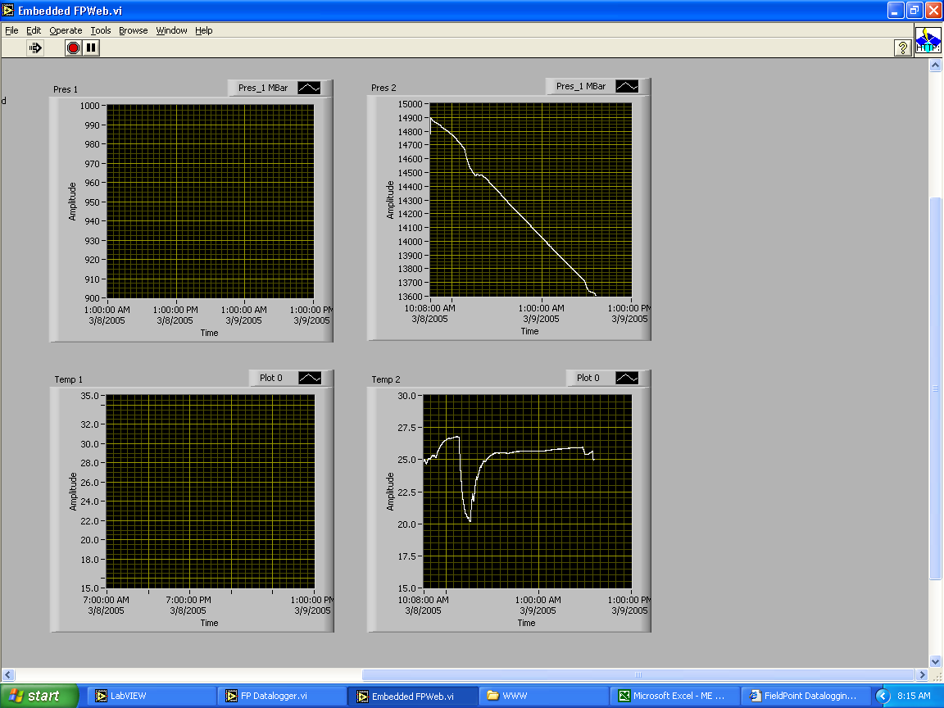
Figure.1: Capture of computer screen at end of test.

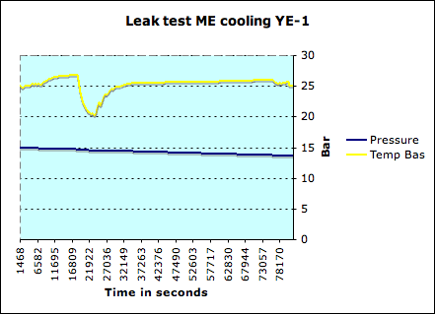
Figure.2: Graph created from test data.

Leak test ME cooling YE-1
fuite 0.05806 bars par heure
1.302 bars en 22.43 heures
Key data in stabil time zone
Max temp Haute
Min temp Haute
Delta T
Max temp Bas |  | 25.957886
Min temp Bas |  | 25.477226
Delta T |  | 0.48066
Max press bar |  | 14.318
Min press bar |  | 13.685625
Delta bar |  | 0.631875
Delta mbar |  | 631.875
Volume liter |  | 230
Time in stabile Zone h |  | 11
Total time test h |  | 22.40
Leak rate stable time zone mbar*l/sec |  | 3.670
Leak rate total test time mbar*l/sec |  | 3.717
Max press bar total test time |  | 14.8959375
Min press bar total test time |  | 13.59281
Delta P bar total test time |  | 1.3031
Delta P mbar total test time |  | 1303.125
T1, Start temp in stable zone |  | 298.50927
T2, End temp in stable zone |  | 298.541313
Temp correction factor T2/T1 |  | 1.000107343
Leak rate with temp correction |  | 3.717149341

Table.1: Data used for calulation.

