***Leak search and Chamber repair***

Ian Crotty

8 Jan 2016

*Fix present leaks*

*Fix collateral chamber damage*

*Understand origine of leak and fix globally*

Leak identification, on or off chambers, is possible in situ or requires chamber/SM removal eg; RE1/2 this occurred two years ago, Feb 2014!

Chamber damage assessment. Detected or visual.

Options to repair damaged/compromised chambers

Will they fail in the future, if thought possible cut off cooling. Remove cover to improve cooling ?

Consequences of leaks, all below….

Other leaks, not yet consequential..( see leak definition)

Long term considerations, do gas leak test to look for weaknesses. Do full inspection.

Deduction from failure analysis of the different failure modes.

*Harmful leak definition.*

A leak that causes damage is a leak, at a point , those leak rate exceeds the local ambient evaporation rate. Or. A leak that causes damage but is not, yet , apparent is one whose rate is less than the evaporation rate within an area that is not visible !

*Planning leak Fix.*

Finding one leak on RE+4.

1 day to obtain access and identify the leak by observation (H2O), decision with ZEC on what action.

If not found, ½ day to find leak with alternative leak test method.

1 day to fix the leak either on the perimeter or on chamber access with ZEC, Start leak test.

1 day to finalise the leak test after overnight test with water

Finding one YE+1 leak.

1 day to remove all panels around the HE nose, in parallel leak search (H2O or gas)

1 day to fix leak or make a short cut. Start leak test.

1 day to finalise the leak test after overnight test with water.

*Planning to fix collateral damage*

Removing a chamber RE1/2 or RE1/3

Remove 3 or more ME1/2s or ME1/3s 2 days ?

Remove 1 or 3 RE1/2 or 1/3 1 day

Reinstall RE1s and commission 3 day

Reinstall MEs and commission 5 days

Removing a SM RE4.

Assuming that the YE4 is pushed back and spare SMs are in the TX.

Remove 1 or 3 SMs 2 day

Replace the SMs 2 days

Recable/pipe & Recommission 2 days

Both of these estimates are without contingency.

*Leak Rate measurement, gas and water*

Argon @ 12 Bar pressure drop <20mBar/hr

Water @ 12 Bar pressure drop <50mBar/hr

*Leak location*

Use Inficon EcoTec II or our H2N2 leak detector (See ZEC) or “Snoop’

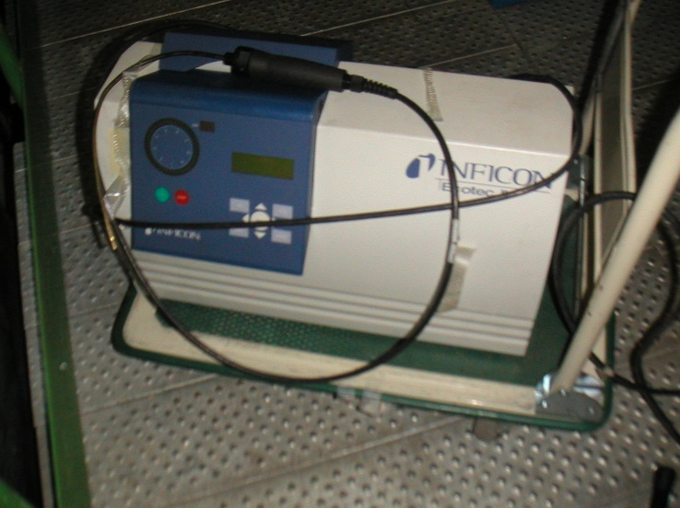

Latest News the Inficon is down and will not be repaired !

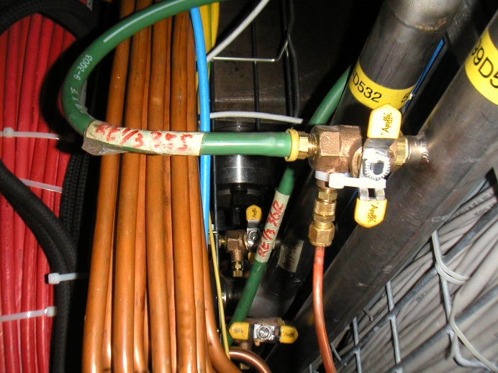

Argon injection through gland

Components

Spares possibly needed

SM RE4/chambers x6

RE1/2 & RE1/3 x3 RE1/2 and x6 RE1/3 that must be rebuilt first !

Unions, Sagana and Legris (904)

SM piping Some old pipes available in 904

Flexible hoses and their fittings. With ZEC in P5.

Tools

Lights

17mm Spanners x2

14mm spanners x2

Lifting tools RE4

Leak detector Inficon or H2N2 (Ours) Snoop

Gas (Argon)

Water and high pressure pump.

CSC Lifting fixture and adaptor tooling RE1/3.

*Conclusion*

Fixing leaks or short circuit, if we agree, should be quite quick.

What caused the leak ?

What is the most important, changing damaged chambers OR fixing generic cooling weaknesses?

References;

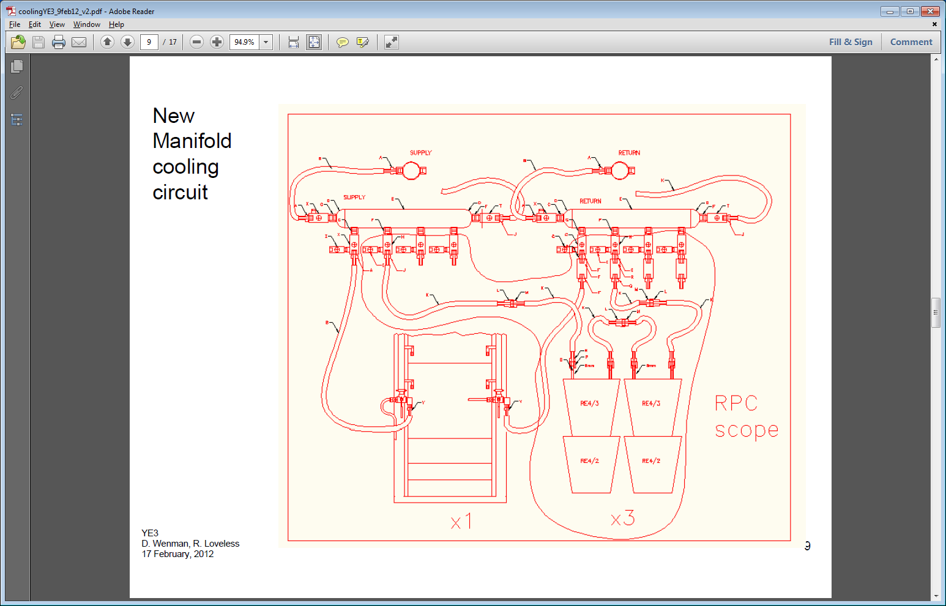

YE1 RPC Cooling elements.



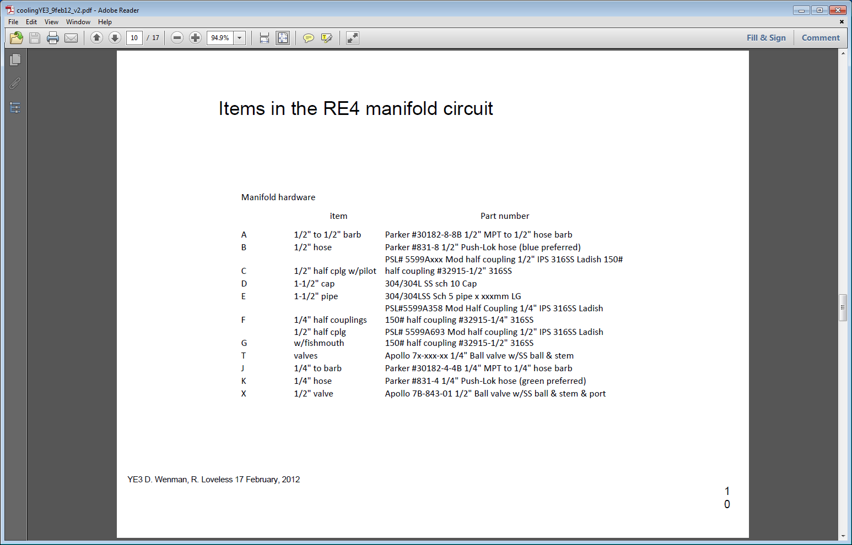

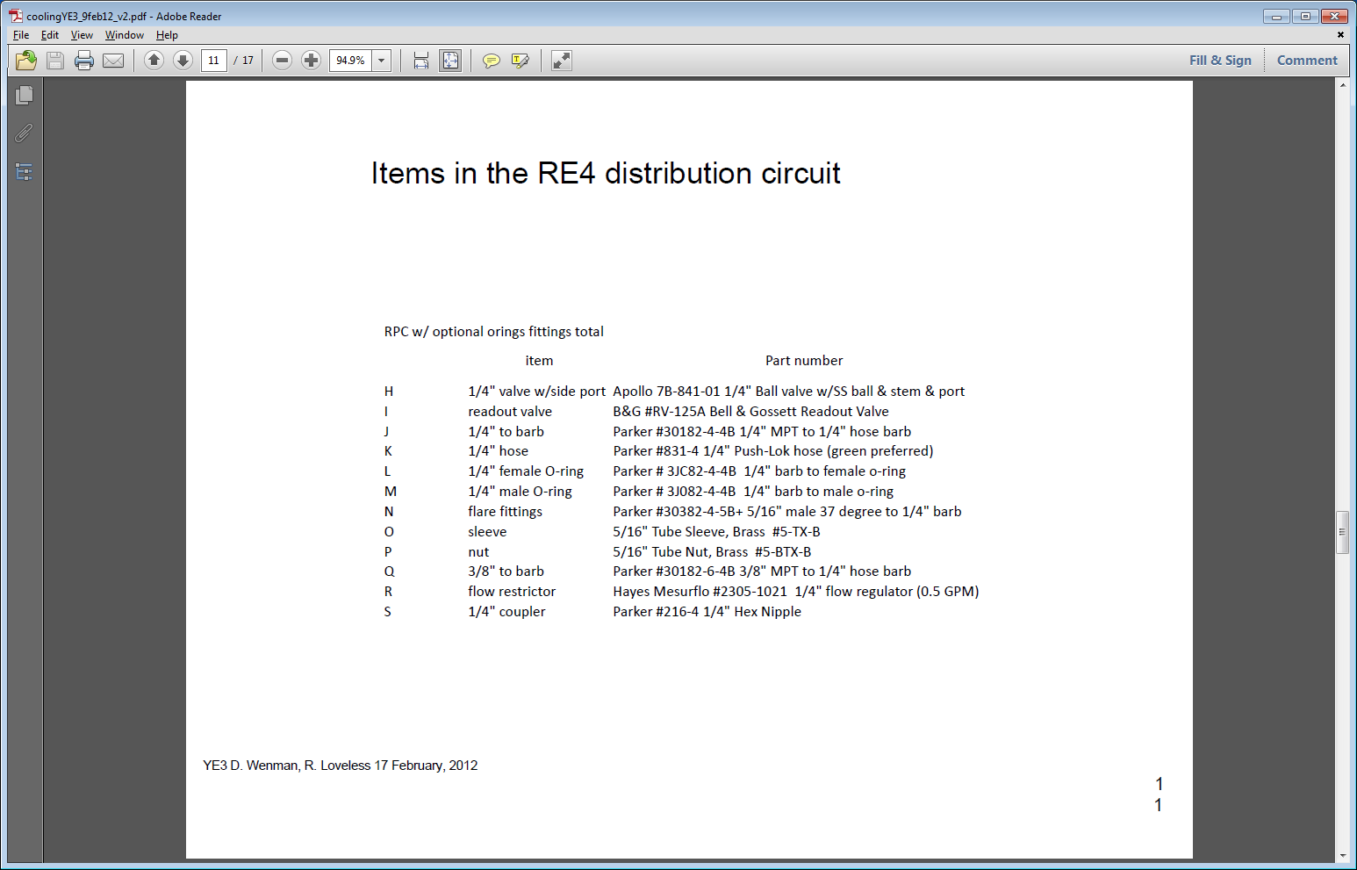

Pressure drops and Leak rate calcs for RE4



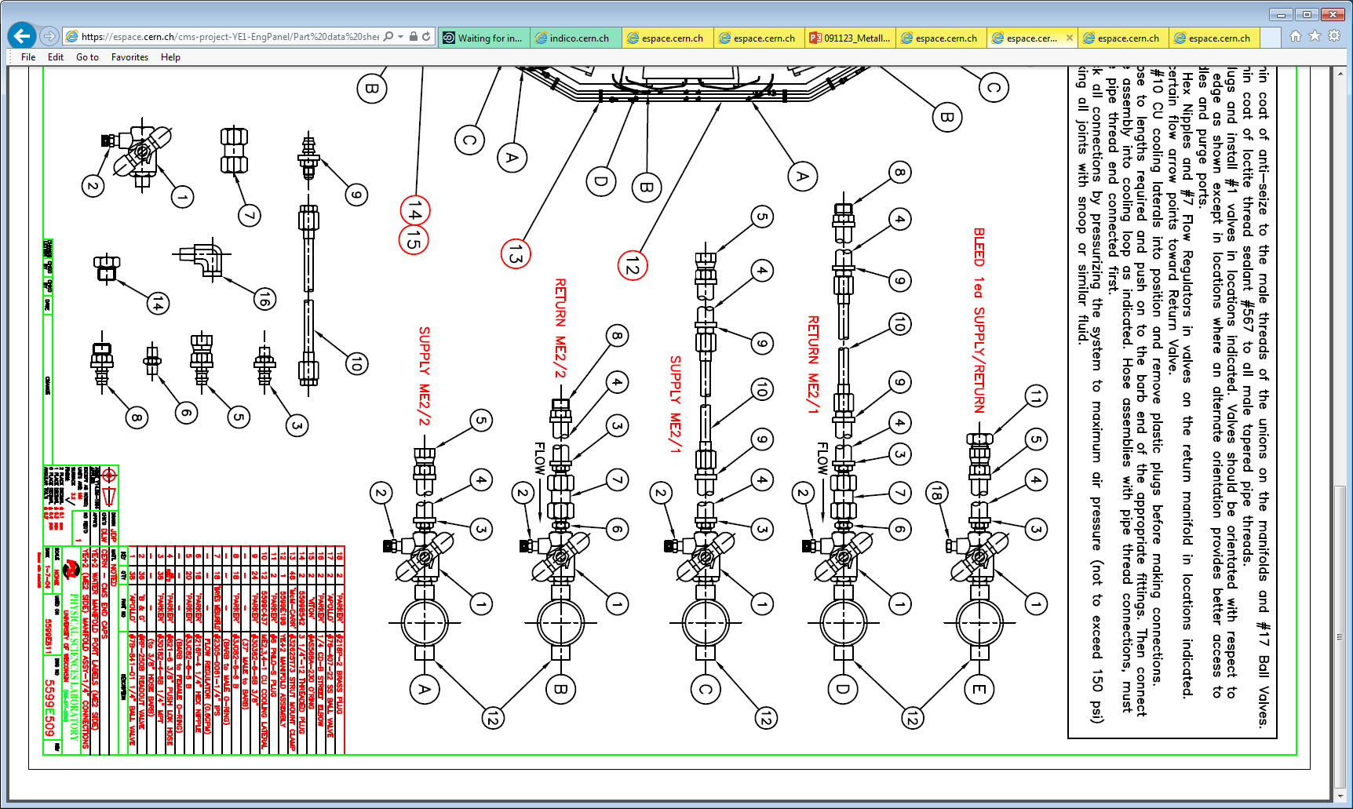

https://indico.cern.ch/event/486430/contribution/0/attachments/1214726/1773309/YE1_non_IP.pdf



