**Vogtlin Flow meters conversion from Gas to Water.**

Collated by I. Crotty

31 Oct 2017

Calibration calculations made by Christoph Frei

<https://edh.cern.ch/edhcat/Images/308611/59.70.57.SIMPLIFIE.FTEN.pdf>

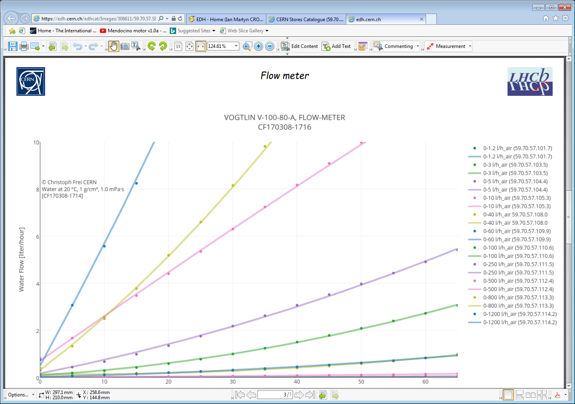

There are 4 such plots covering ranges from 0 – 45, 0 – 10, 0 – 1 and 0 – 0.1 [l/h]

See plot below

Data taken by Christoph in the lab.

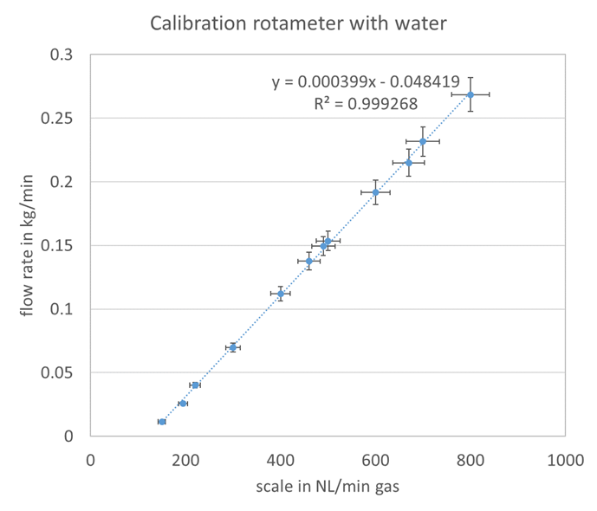

With the original data it may be possible to correct calculated plots and produce a better estimate of H20 flow rate versus “scale in NL/min gas” rather than H2O flow rate versus an insufficiently defined millimetre scale, it changes from column to column,.