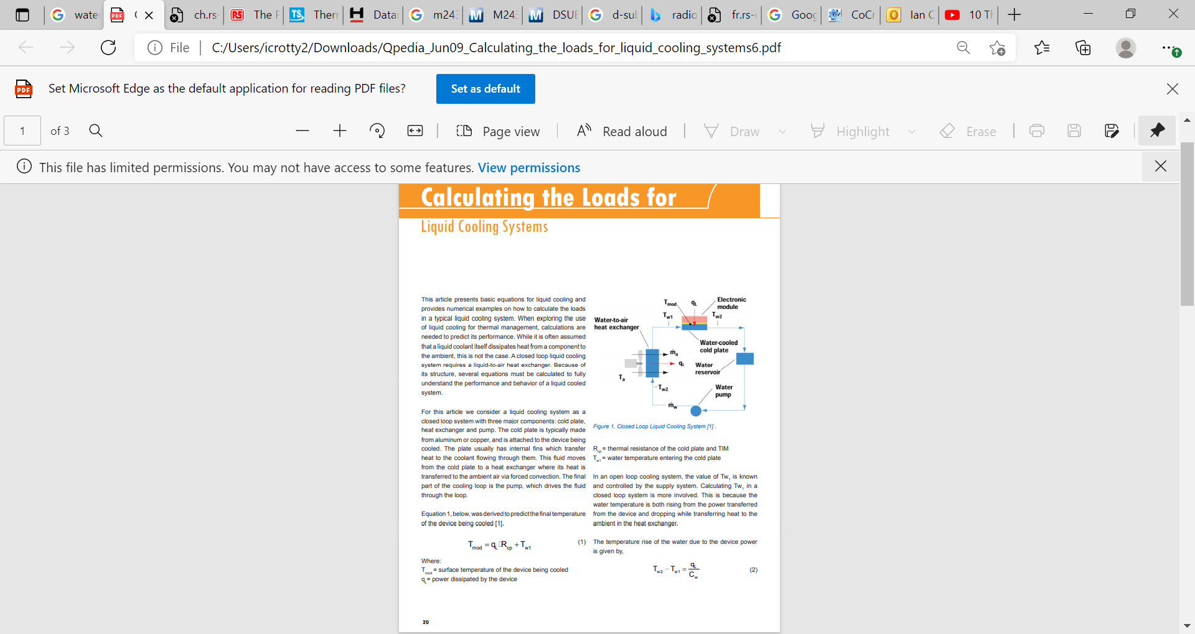
https://www.google.ch/url?sa=t&rct=j&q=&esrc=s&source=web&cd=&ved=2ahUKEwj4r7nq2tPxAhVOnaQKHQ2zDWUQFjAKegQIGRAD&url=http%3A%2F%2Fwww.qats.com%2FDownload%2FQpedia_Jun09_Calculating_the_loads_for_liquid_cooling_systems6.ashx&usg=AOvVaw2LmBb1rh8rPb7enFljYD-e

