CSC Chiller

http://www.lytron.com/Tools-and-Technical-Reference/Fans-Pumps/Cooling-System-Pumps

Model MCS40J02BC1

Serial 768594-01 date 05/30/06

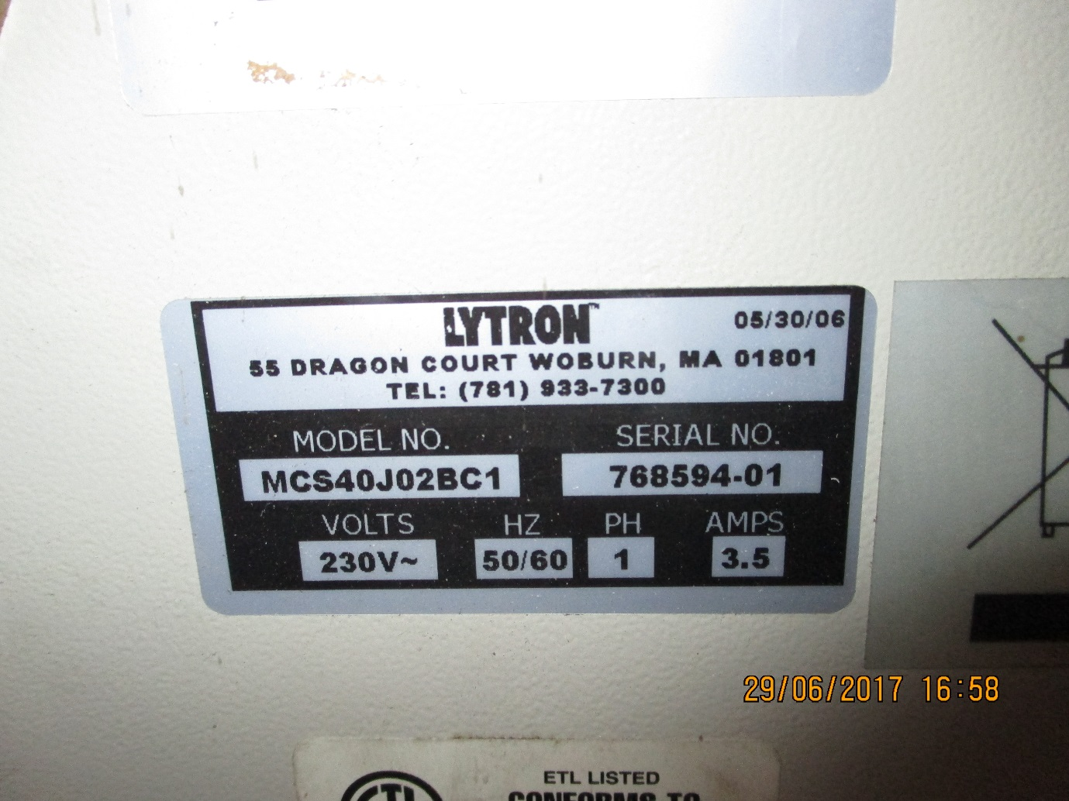

With Fluidotech.it pump

<https://www.fluidotech.it/en/technical-support/technologies/direct-drive-rotary-vane-pumps/>

with either of two pumps;

Pump, PD Brass 1.8 GPM 60 PSI (BC) [ 2GPM = 480l/hr = 0.13l/s ]

Or

Pump, PD Brass 2.3 GPM 60 PSI (BE)

They appear identical with another Italian make;

<http://www.nuert.com/>

which equipe an English chiller

<http://betta-techcontrols.co.uk/products/>

I repaired one of these with this EDH order, pump and motor

Pump was 175GBP not direct from supplier

<https://edh.cern.ch/Document/SupplyChain/DAI/5872708>

Dircet from Itlay with motor

<https://www.nuert.com/en/pumps-by-technology/pumps-with-mechanical-seal/pr-series-standard-pumps/#cta>

PTO

Pump and motor

