Flat Cable Timing of on Chamber cables RE1/2

Cables of 50 and 150cm were selectd from the two types used in the manufacture of RE1/2 chamnbers. Is ther a recored of which chambers were made with which. Is the timing is insignificantly different then this is irrelevant.

The FEB LVDS driver was used to pulse the cables so simulating the CMS asa close as possible.

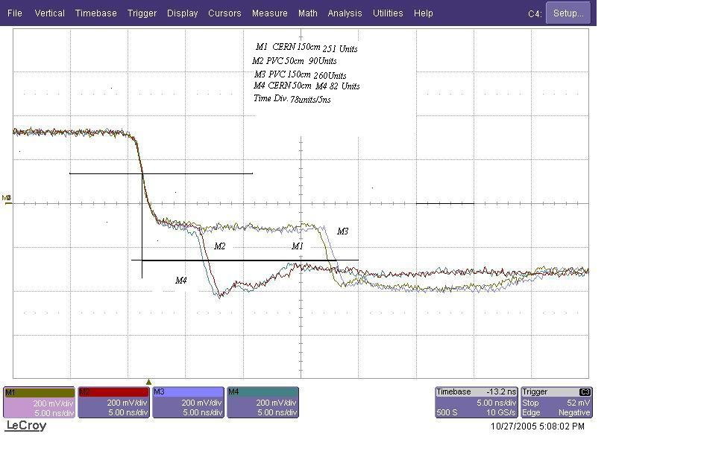

78 Units /div/5ns 78/5 = 15.6 Units/1ns

M1 – M4 (251/15.6 = 16.1ns/2 = 8.05ns/1.5m)-(82/15.6 = 5.26/2 = 2.628 ns/0.5m) = 5.422ns/m

M3 – M2 (260/15.6 = 16.67/2 = 8.33ns/1.5m)-(90/15.6=5.77ns/ 2 = 2.89 ns/0.5)m = 5.44ns/m

Conclusion
- The difference in time is insignificant between cable types China and 3M..

- The length to be added to the FEB ‘A’ and ‘B’ cables going to the LBC is 1.04m to compensate etheir shorter length on the chamber

Ian Crotty 28 Oct 05

