Incident with Z stop and L cable to X3S51 rack and RE-3/2,3/27.

16 Feb 2015 when was it closed ?

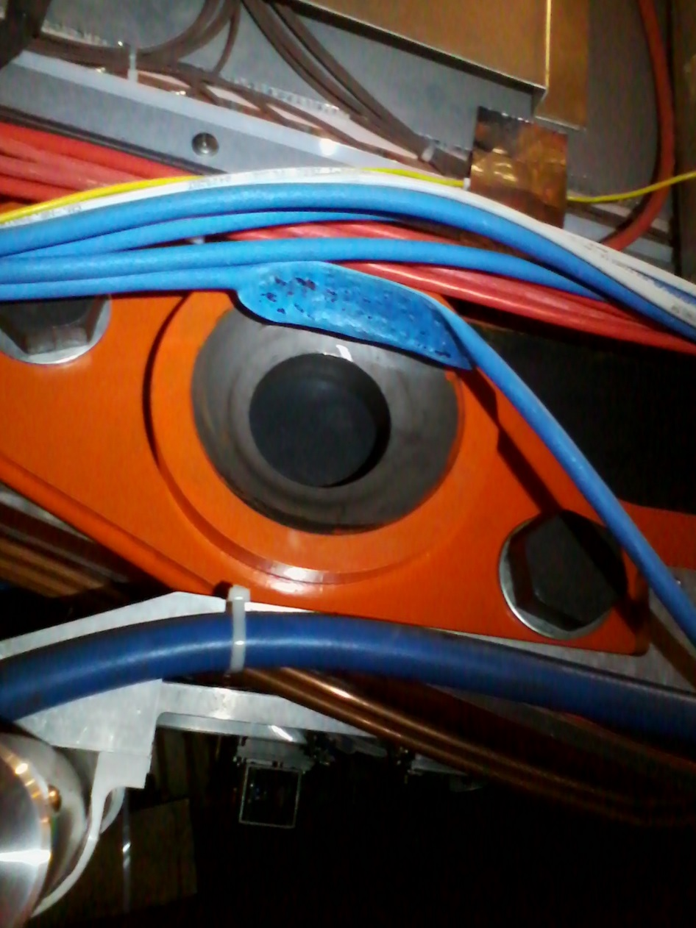

Reported by Anton 1928hrs on 16Feb 2015

Ian Crotty

17 feb 2015