**LV cables for Institutes and GIF**

***Molex Connectors.***

X2 Molex 8 pin connectors Ian Crotty 21 July 2016

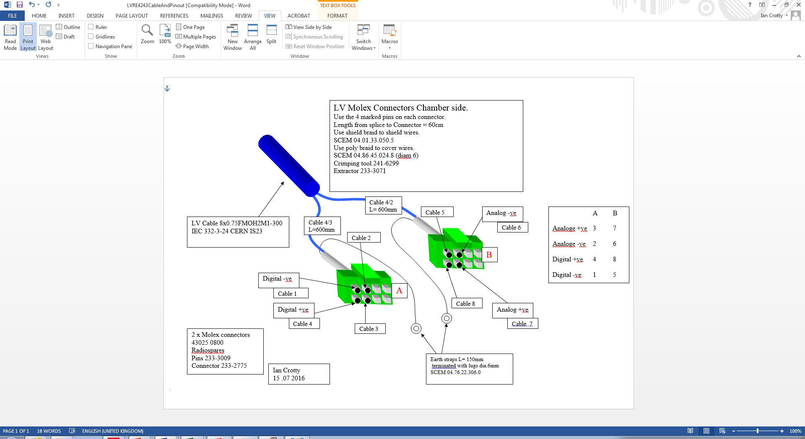

Molex, conductive braid, polymer braid, ground wire and lug.

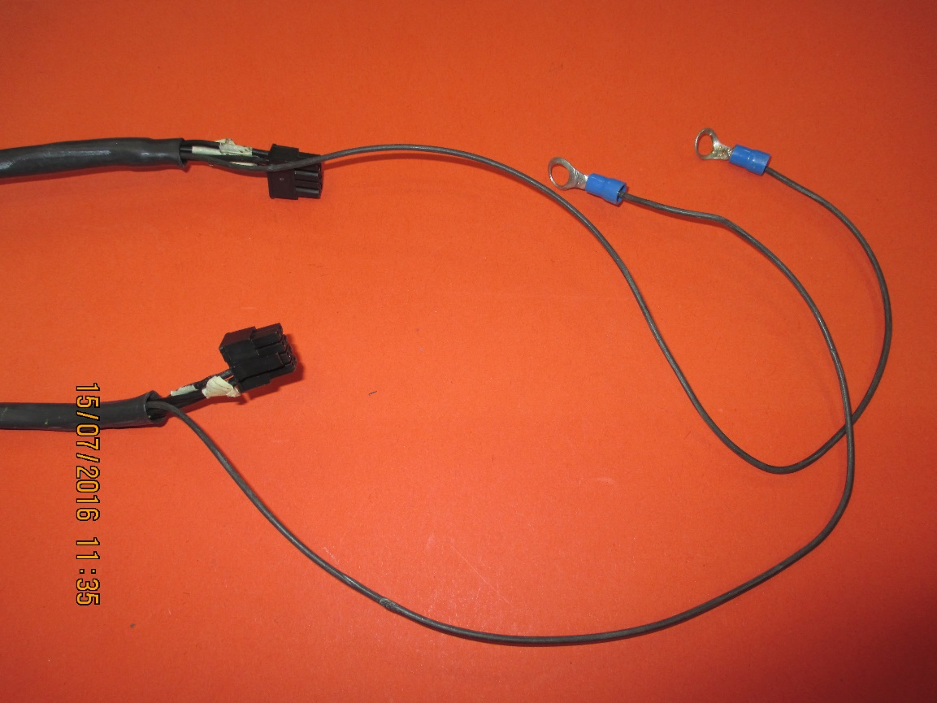

Molex with ground wire connected to conductive braid.

Heat shrink dia 9-3 mm

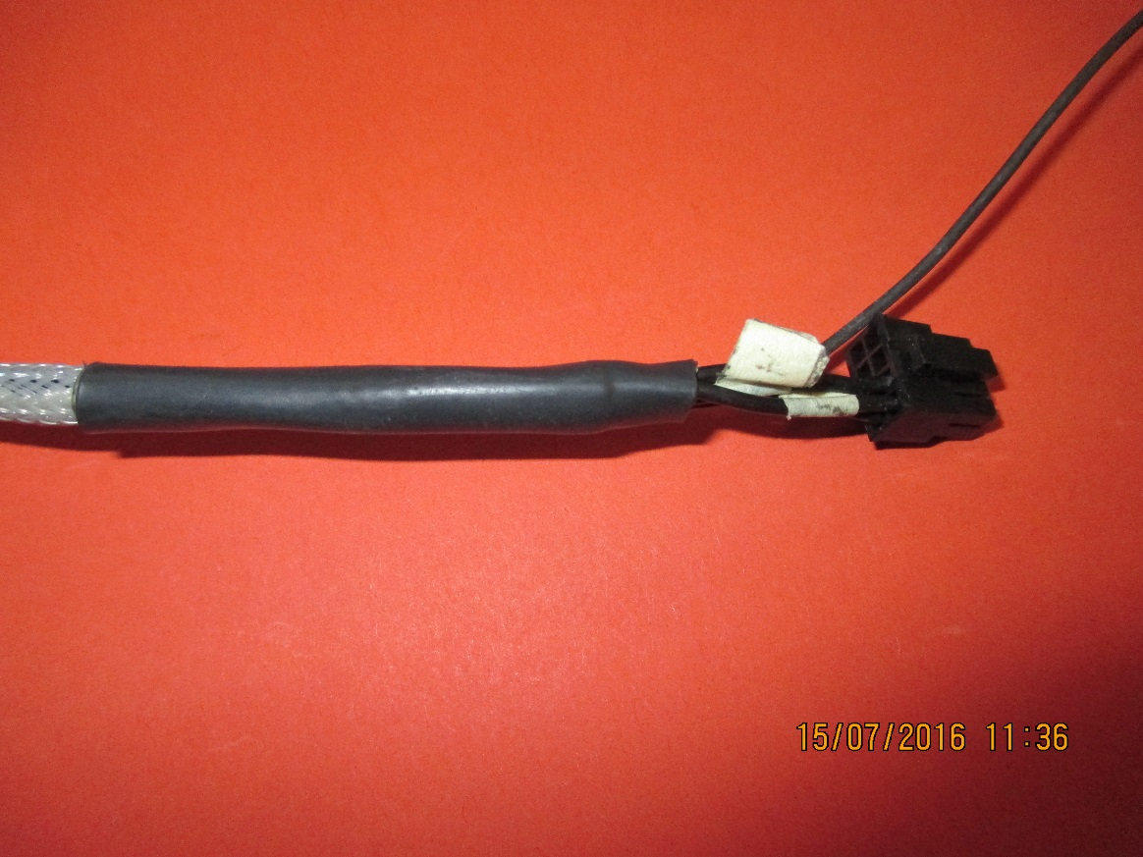

The 4 pins in the Molex body

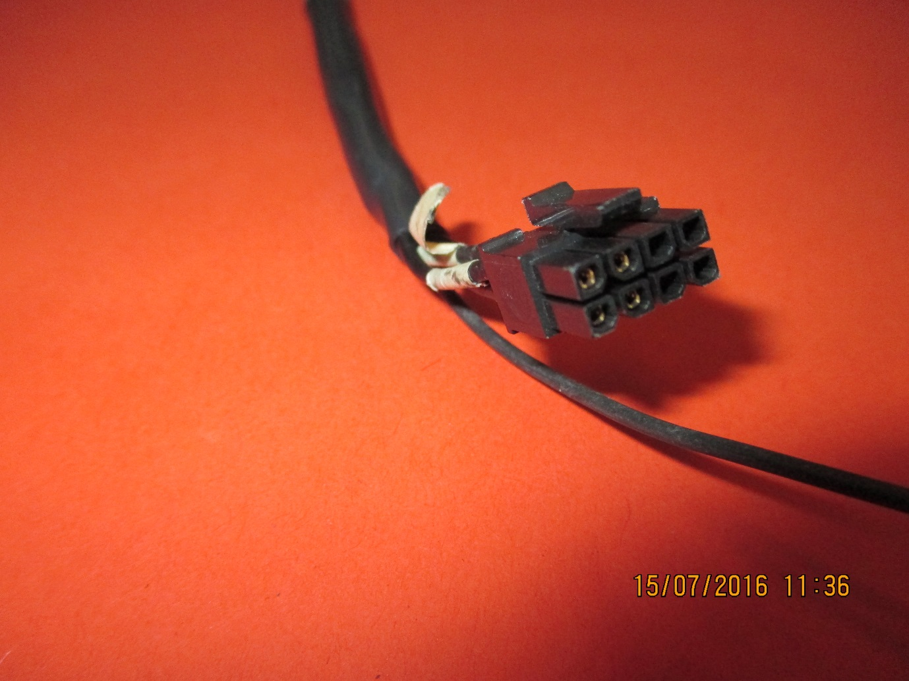

Splice and Transparent heat shrink to cover labels

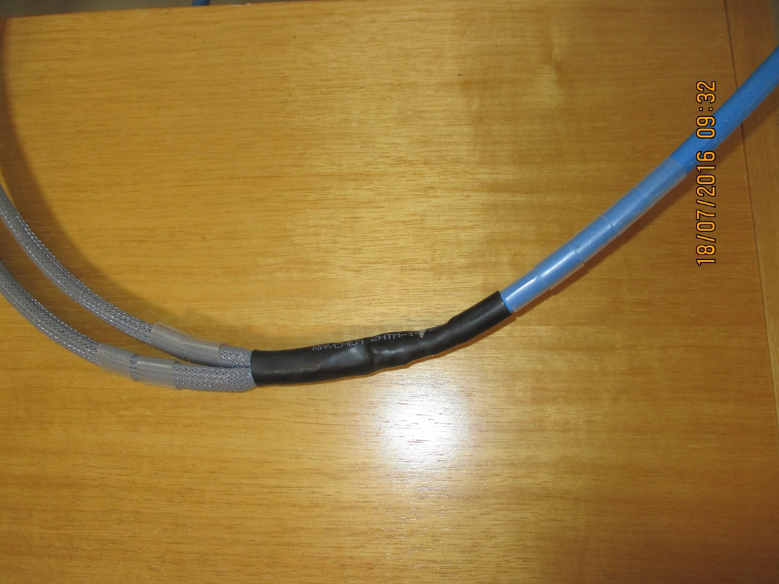

Transparent heat shrink to cover labels

Splice 600mm from Molex connectors

Heat shrink dia 12-4mm

***D “Sub” connector***

37 pins

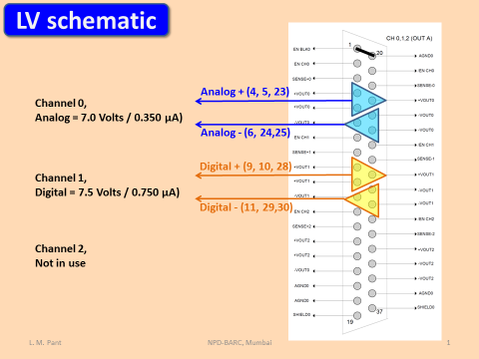

Cable Nos

Molex Con. A B

3 7

2 6

4 8

1 5

“D” Sub housing.

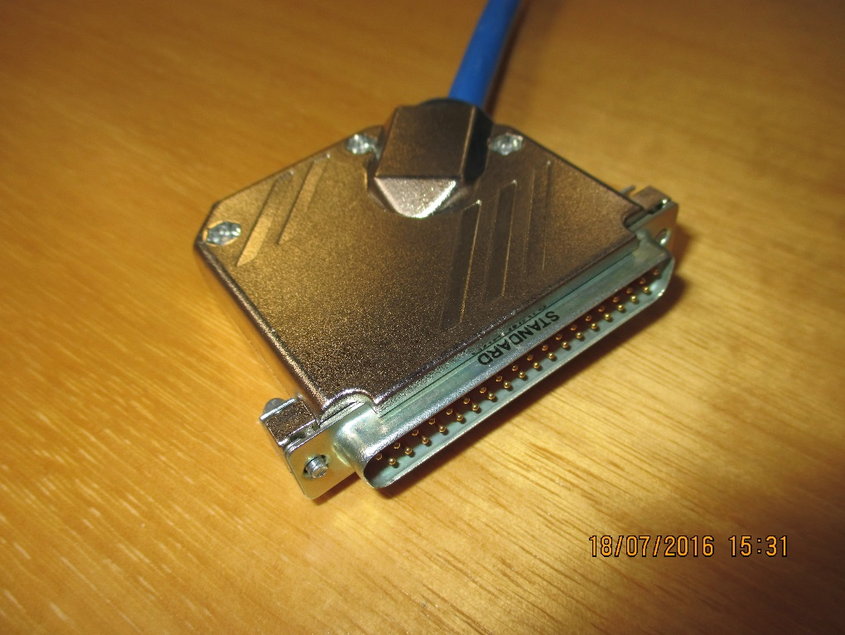

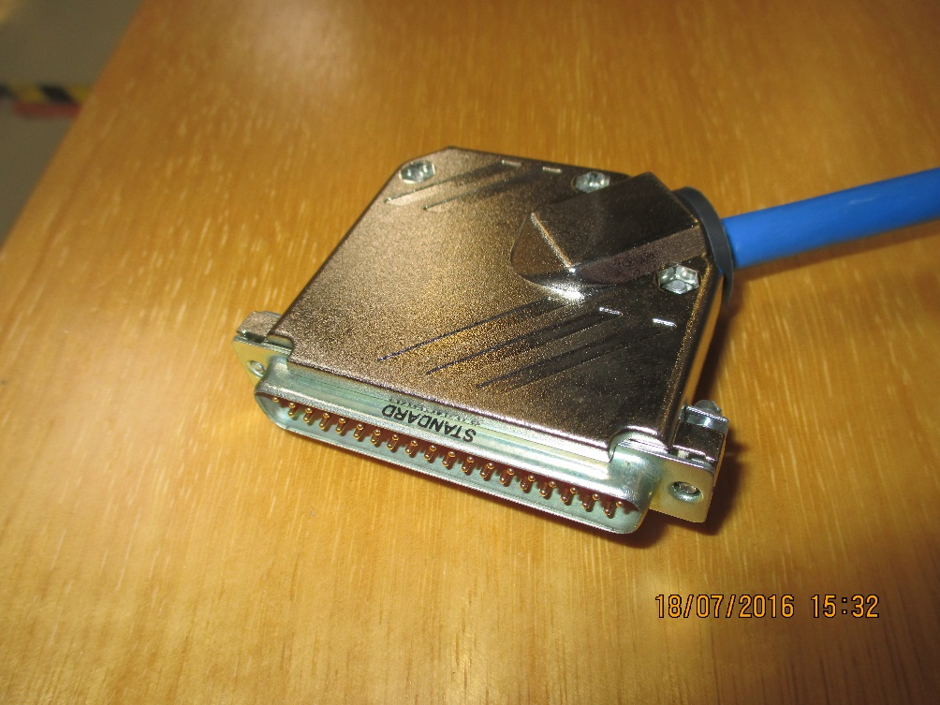

Component List

1. Heat shrink dia 9-3 mm
2. Heat shrink dia 12-4 mm
3. Transparent heat shrink (for labels) dia 12mm

x5 on D Sub

x5 on each of Molex end.

1. Polymer braid dia 6mm
2. Conductive braid dia 6mm
3. Molex connectors
4. “D” Sub connectors 37c
5. Ground wire (0.5mm2) black
6. Lug dia. M6 for ground wire

Full component list is available here;

http://project-cms-rpc-endcap.web.cern.ch/project-cms-rpc-endcap/rpc/Services/Cables/HV&LV/LV/GenericLV/Components.xlsx

D Sub Connector SCEM 09.21.20.460.4

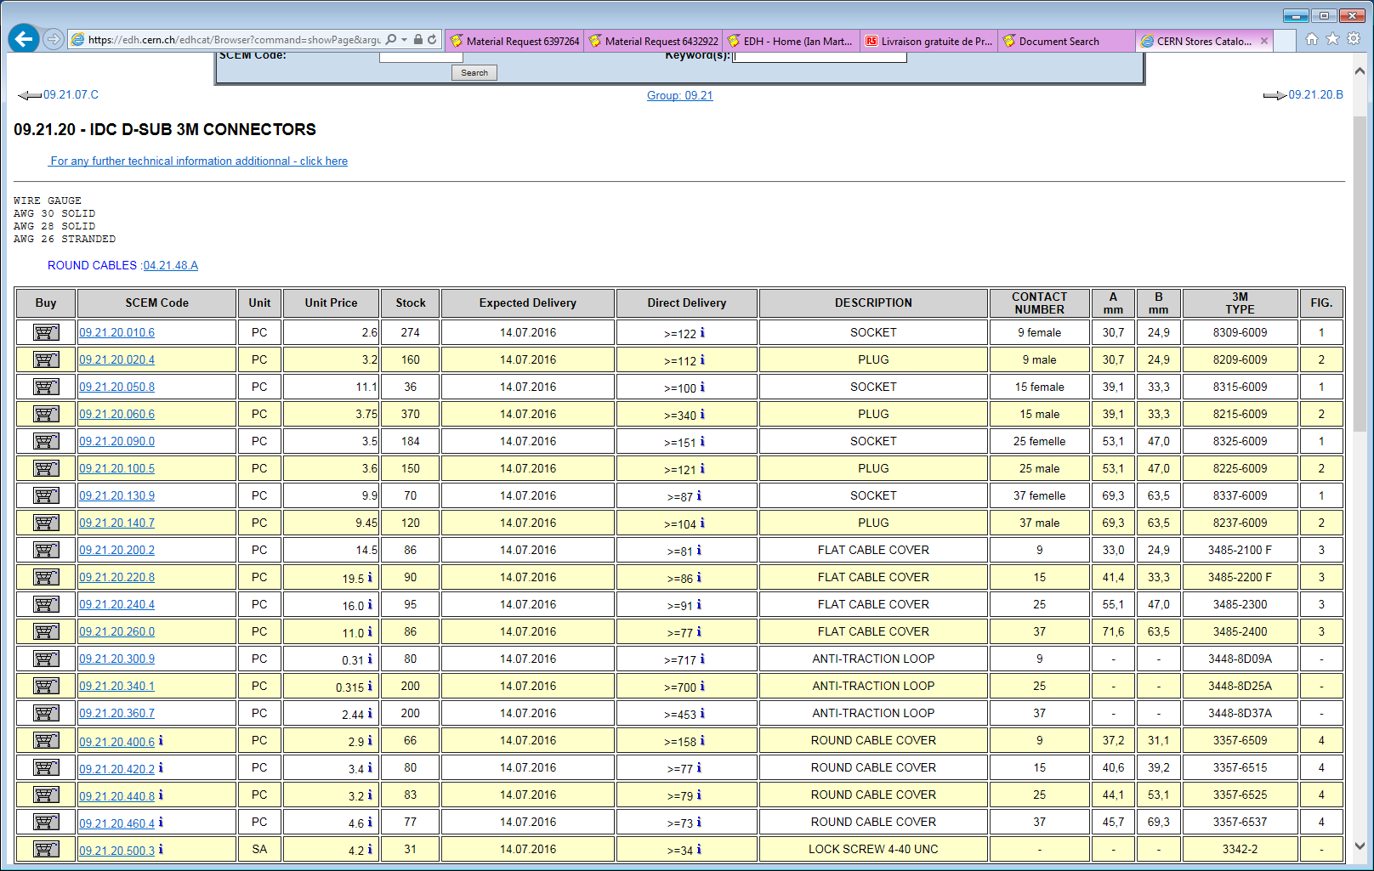

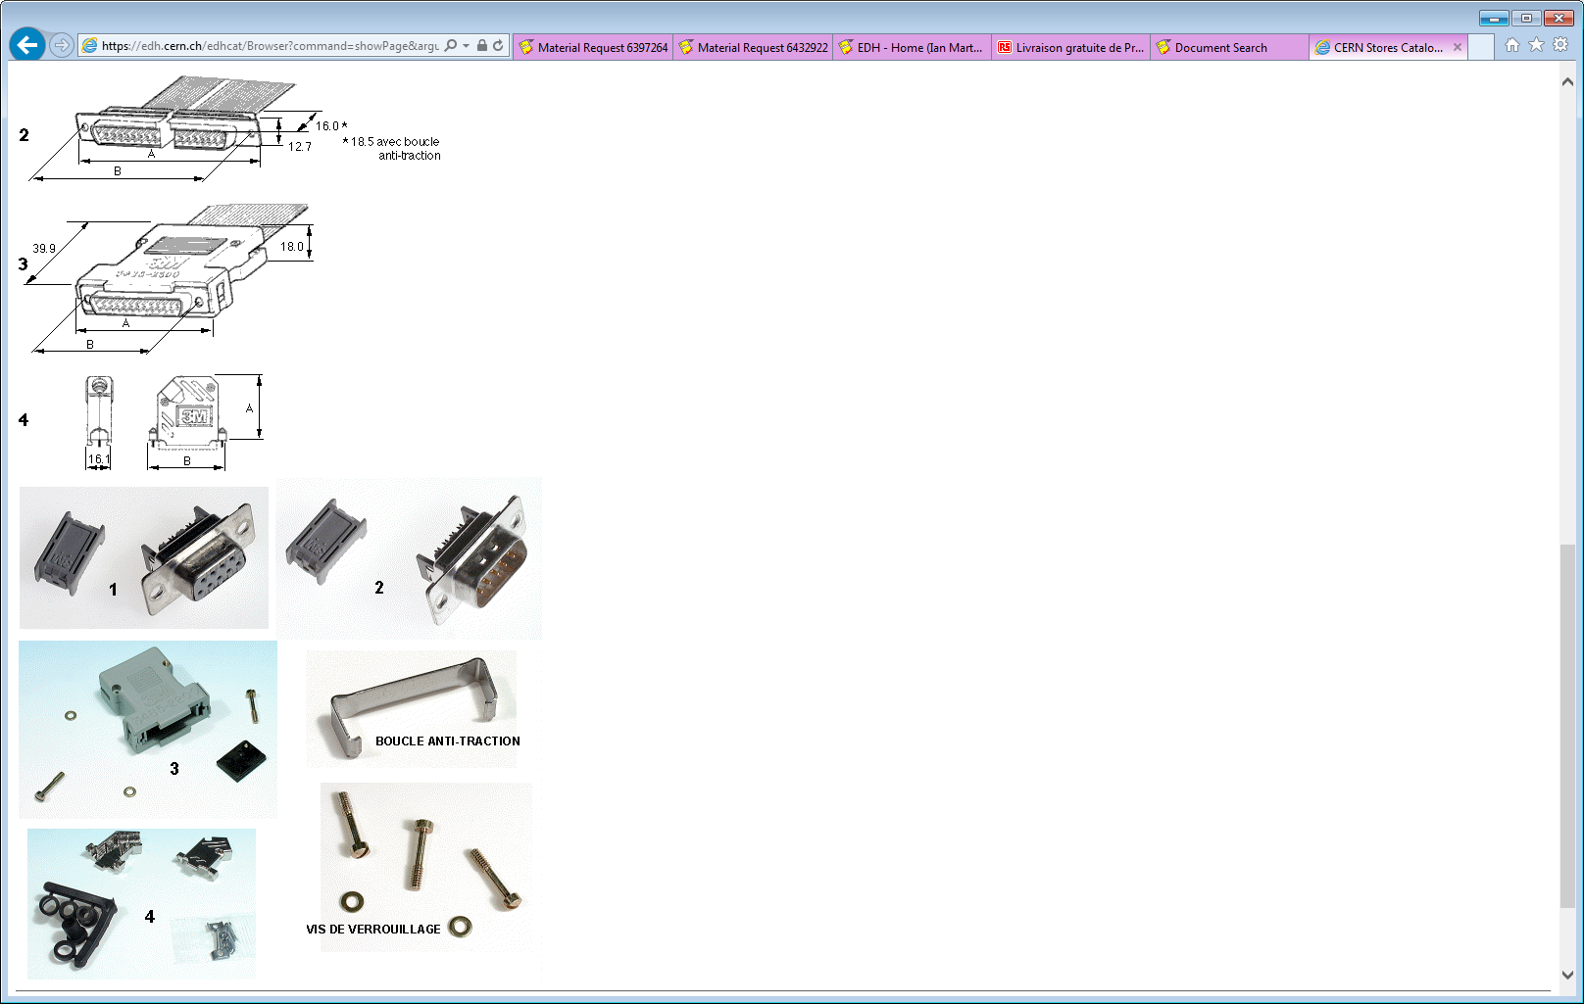

Optional;

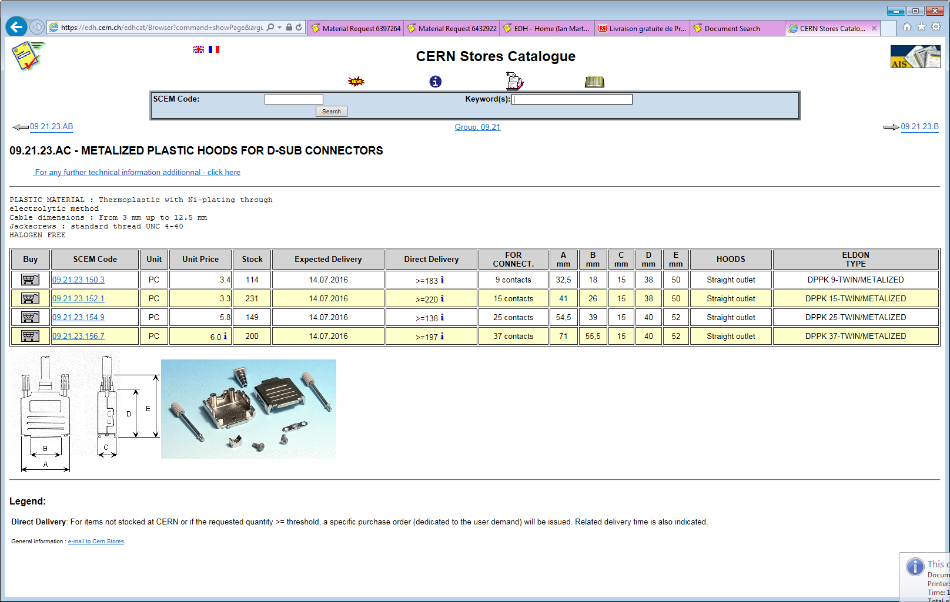

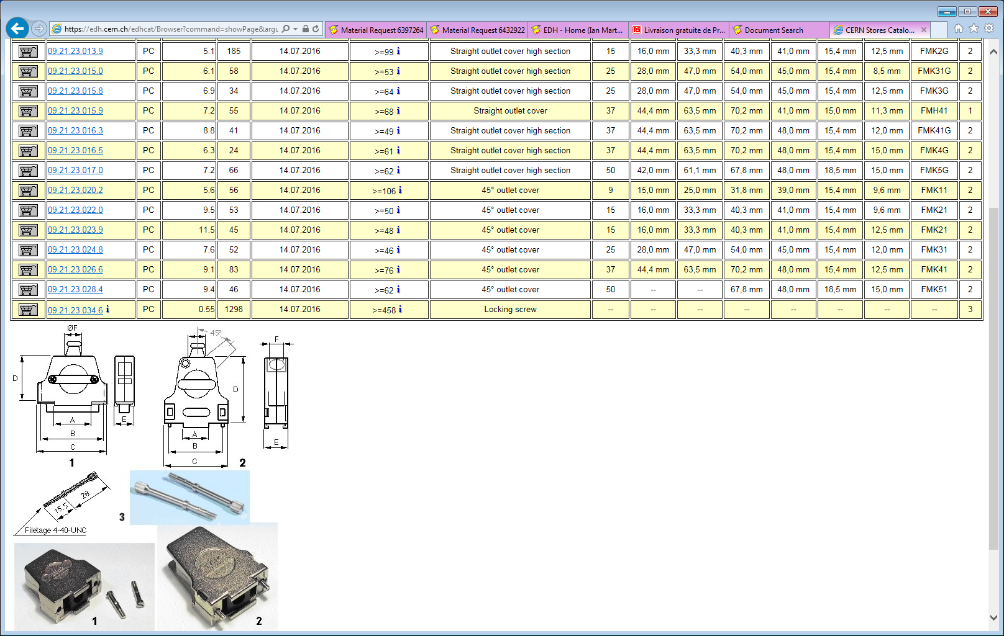

Molex and pins;

Molex pin

Radio Spares Ref 237-6747

9.70Euro for more than 25 (Prices from 2004)

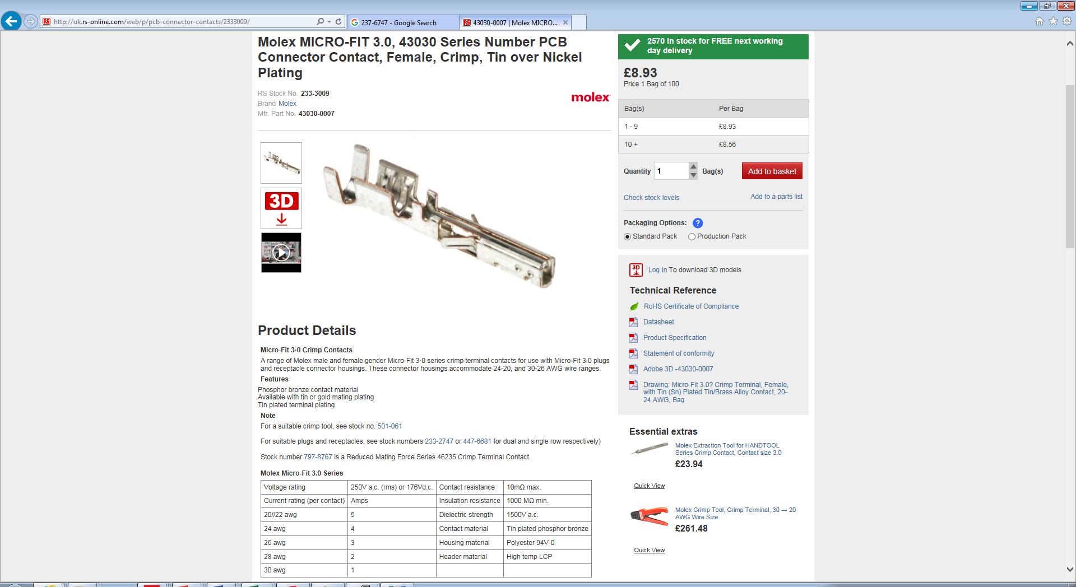

Molex 8 pin body

233-2775

Series Number 43025 ( printed on body)

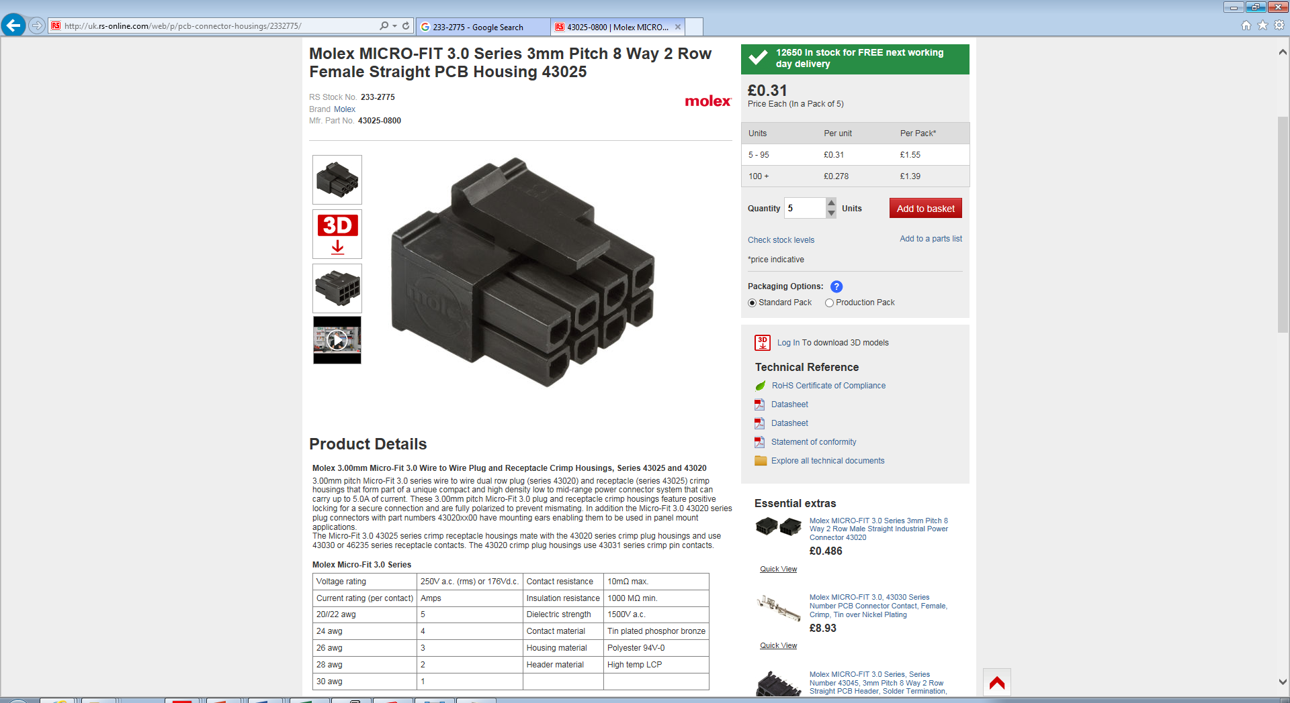

<http://rpc-cms-re4-upscope.web.cern.ch/rpc-cms-re4-upscope/RPC/GIFPlusPlus/Services/LV/CAENA1513Adoc/LVSchematic.pptx>

This doc is available here;

<http://project-cms-rpc-endcap.web.cern.ch/project-cms-rpc-endcap/rpc/Services/Cables/HV&LV/LV/GenericLV/LVCablesGIFandInstitutes.pdf>